附件4
Attachment 4

北京市第三代社保卡退休人员线上申领操作说明

Online Operating Instructions for Retirees Applying for Third-Generation Social Security Cards in Beijing

一、通过北京市人力资源和社会保障局官网进行退休人员申领第三代社会保障卡
I. Application for Third-Generation Social Security Card by Retirees via the Official Website of Beijing Municipal Bureau of Human Resources and Social Security
登录北京市人力资源和社会保障局官网，依次点击【热点服务】-【我要办社保卡】，进行申领操作。
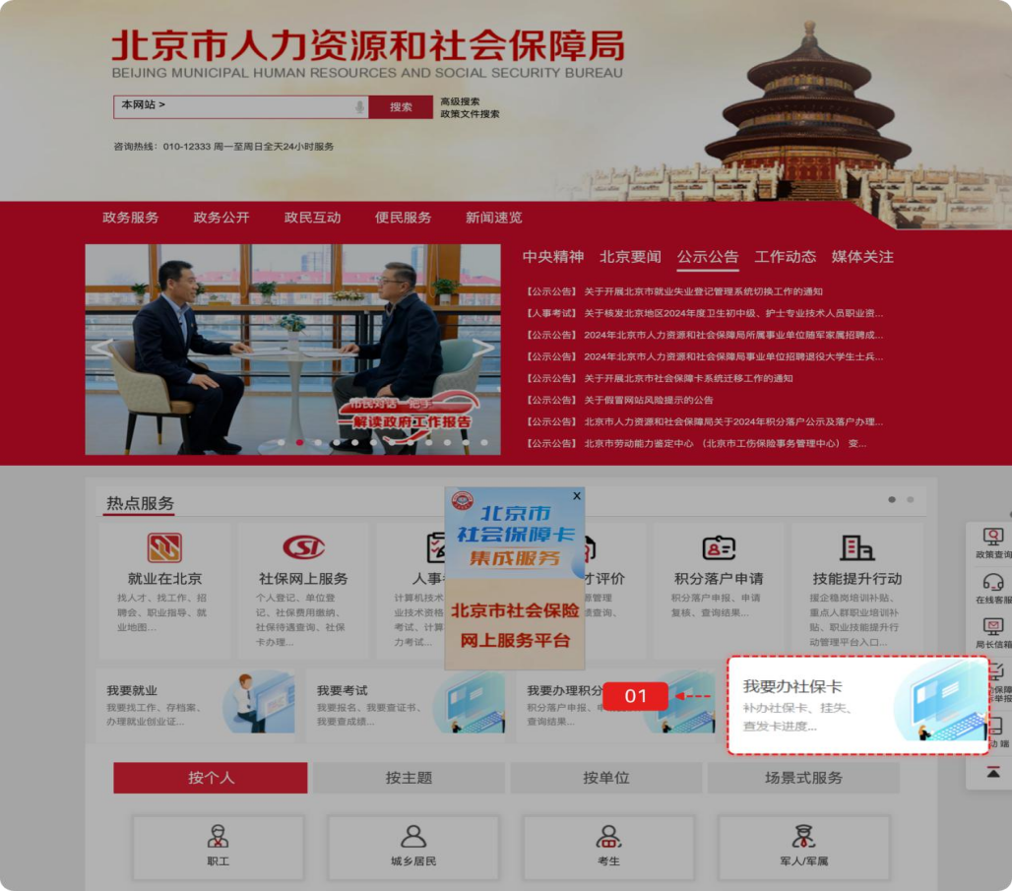
Log in to the official website of the Beijing Municipal Bureau of Human Resources and Social Security. Click "Most-requested Services" (热点服务) - "I want to apply for a social security card" (我要办社保卡) to start the application.
登录方式包括如下几种：
The login methods include:
- 扫码登录
(1) QR Code Login:
用户可选择扫码登录，使用微信、支付宝或百度端“京通”小程序扫码登录，如下图：
Users may choose QR code login. Use the "Jingtong" (京通) Mini-Program on WeChat, Alipay, or Baidu app to scan the QR code for login as follows.
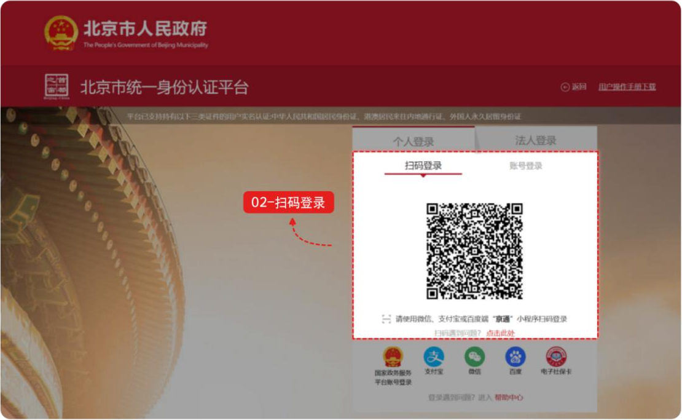
- 账号登录
用户可选择账号登录，输入用户名/手机号/身份证号、密码和图形验证码，点击【登录】，如下图：
(2) Account Login:
Users may log in through an account. Input the username/mobile number/ID number, password, and graphical verification code, then click "Login" (登录) as follows.
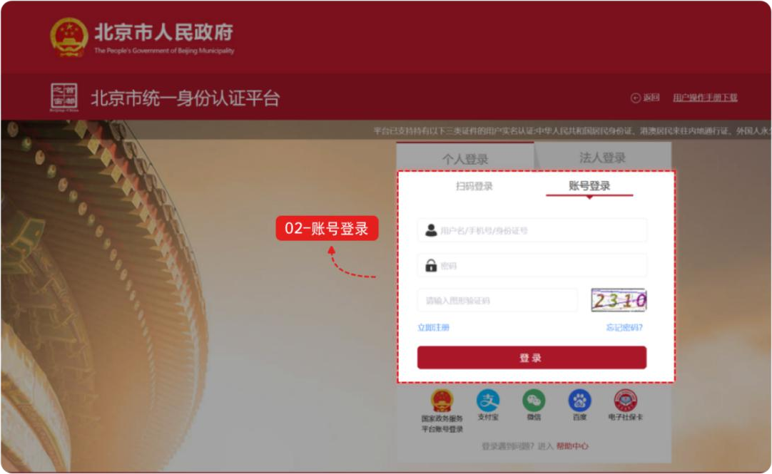

- 其他渠道登录
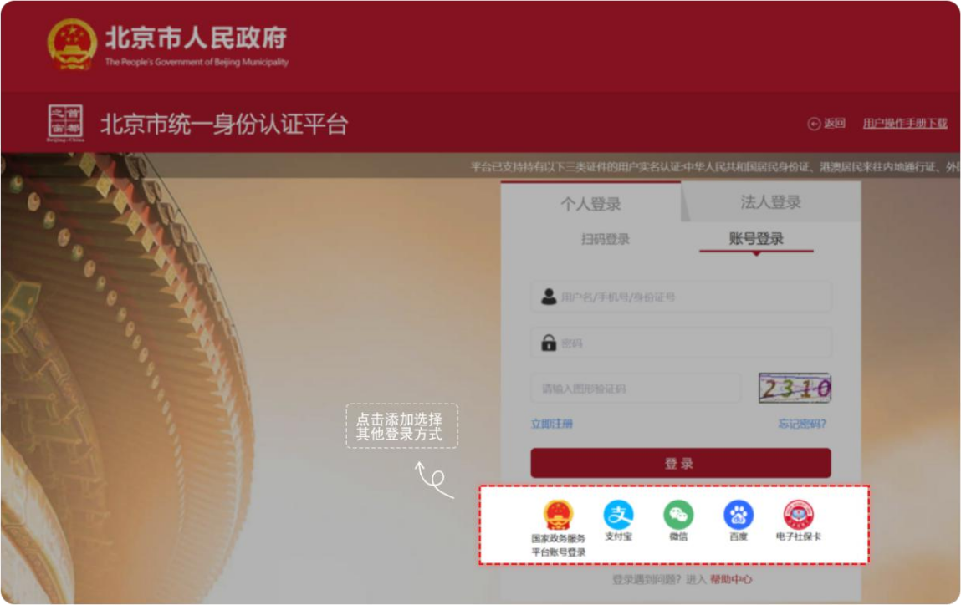
用户可选择国家政务服务平台账号登录，或者支付宝、微信、百度、电子社保卡进行登录。
(3) Login Through Other Channels:
Users may log in with a National Government Service Platform account, or via Alipay, WeChat, Baidu, or Electronic Social Security Card.

登录网厅后，点击【本人申请社会保障卡】，出现免责声明弹框。免责声明阅读后勾选【我同意】，点击【确定】按钮。
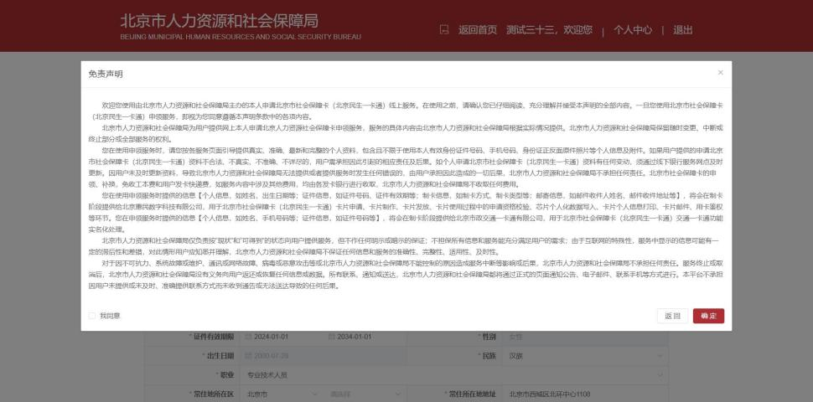
After logging in to the web portal, click "Apply for My Social Security Card" (本人申请社会保障卡). A disclaimer pop-up box will appear. After reading the disclaimer, check "I Agree" (我同意), and click the "Confirm" (确定) button.
点击【确定】按钮后，进入本人社会保障卡申请信息填写页面。
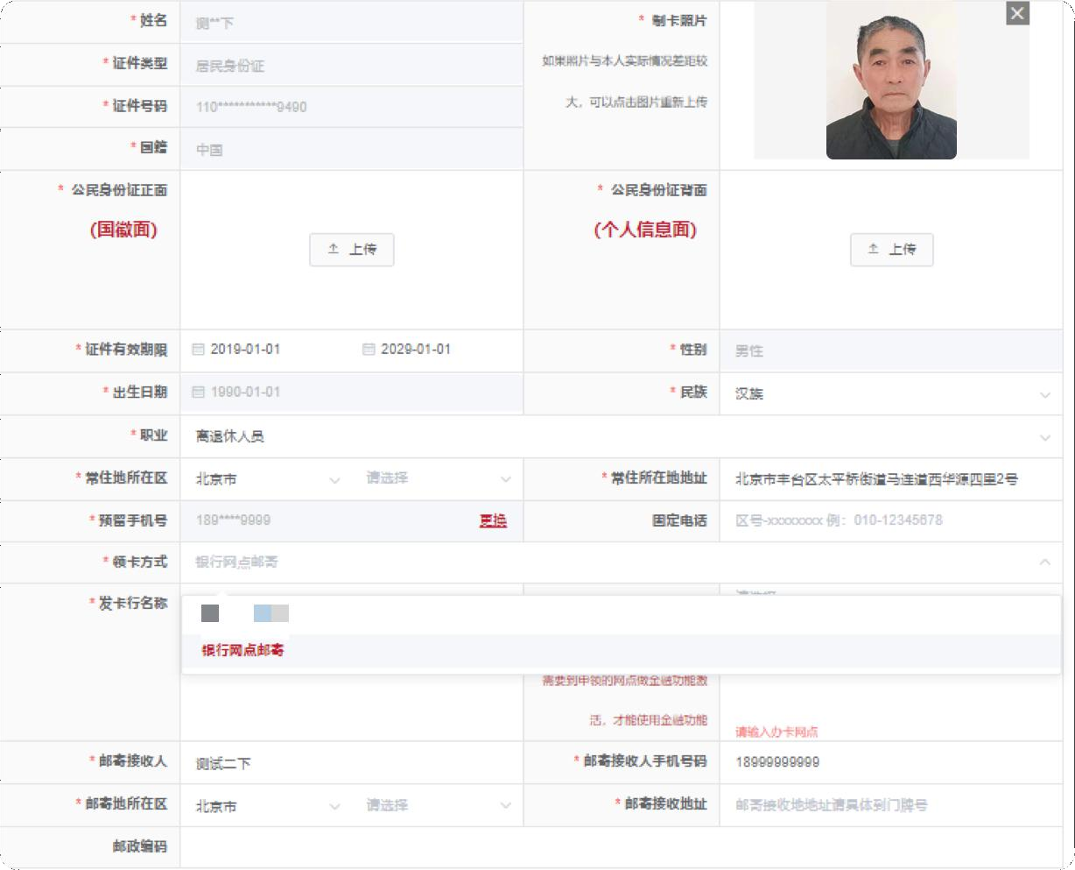
After clicking "Confirm" (确定), enter the information filling page.
根据提示录入相关信息，涉及制卡照片、本人身份证正面原件照片、身份证背面原件照片。
Input relevant information following the prompts, involving the photo for card-making and the photos of the front and back of the applicant's ID card.
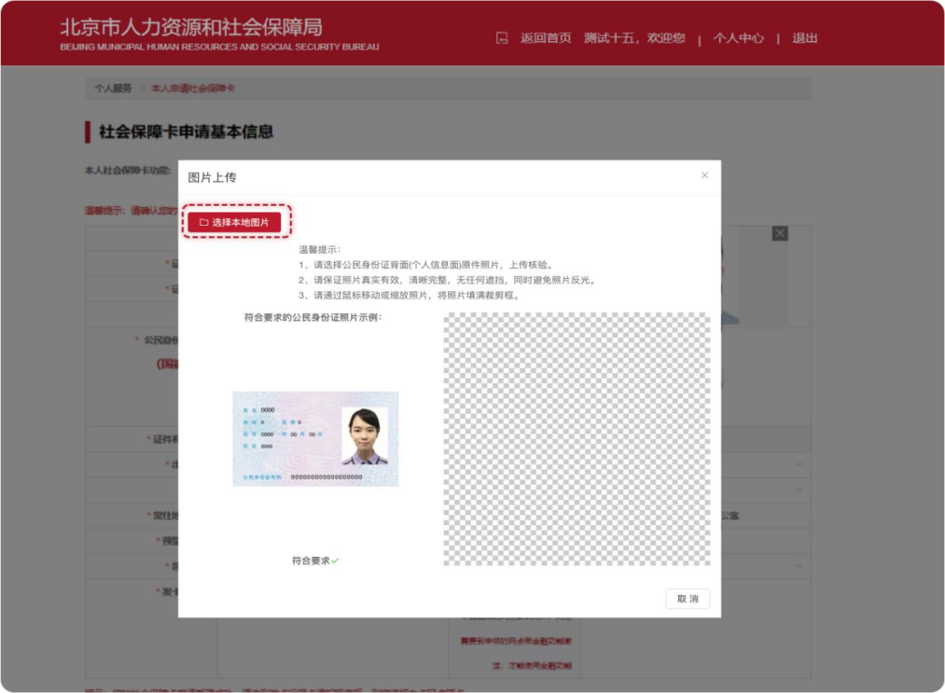
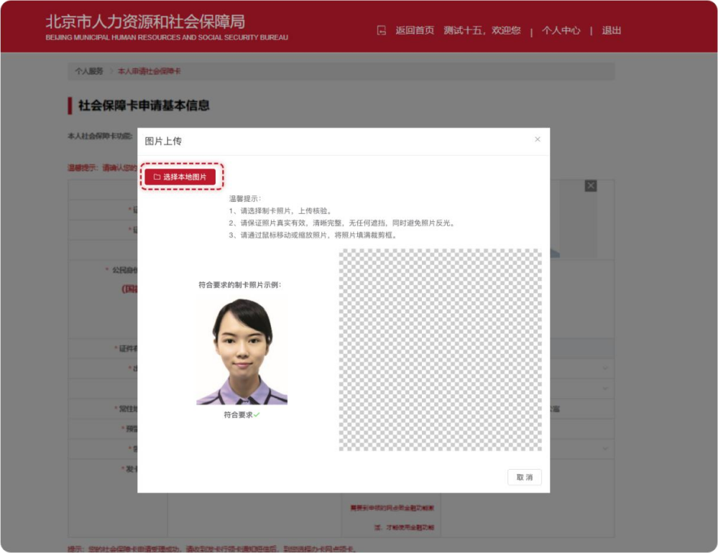
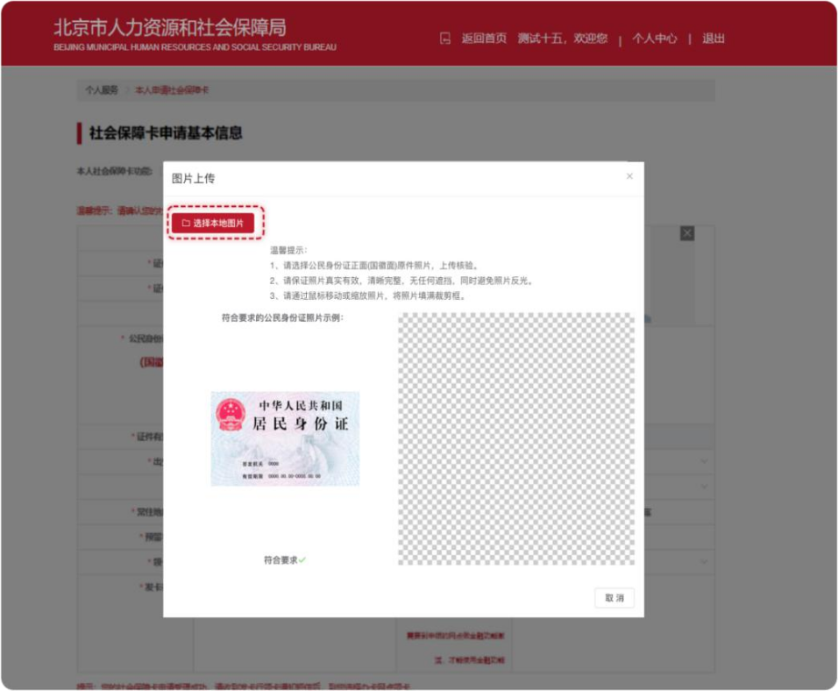
输入补录信息：职业（系统默认为“离退休人员”，可进行修改）、常住地所在区、常住地所在地址、发卡行名称及办卡网点（退休人员首次申领第三代社保卡的办卡银行和开户行网点与当前养老金代放行一致，无法修改）等信息。
Input the supplementary information: Occupation ("Retired Personnel" (离退休人员) by default and can be modified), the district of permanent residence, the permanent residence address, the name of the card-issuing bank, the card-application branch, etc. It is notable that for retirees applying for the third-generation social security card for the first time, the card-application bank and account-opening branch are consistent with the current pension- disbursement bank and cannot be modified.
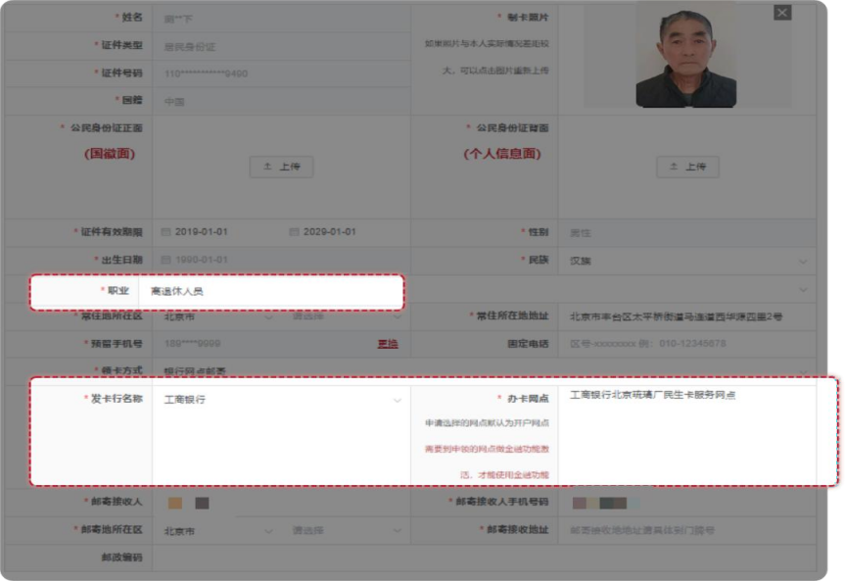
选择领卡方式，退休人员领卡方式目前只支持银行邮寄，需完善邮寄接收人、接收人联系电话、邮寄接收地址等。
Select the card-collection method. Retirees can only collect the card through delivery by the bank. It is necessary to complete the information of the recipient, the recipient's contact number, and the receiving address, etc.
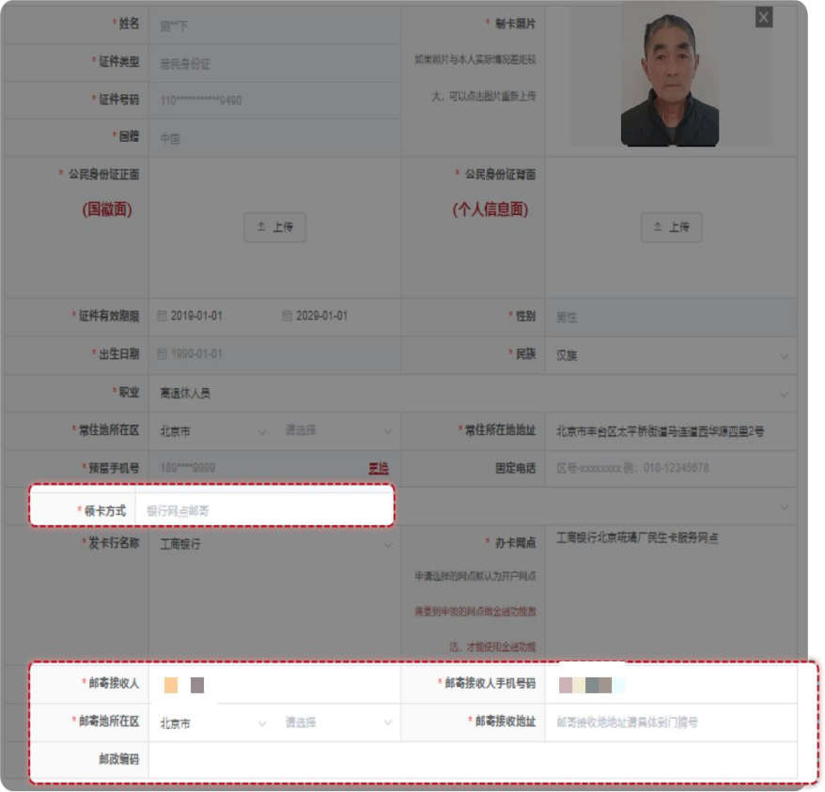

信息全部完善后勾选【我已阅读并同意】，点击【提交】本人申领社保卡信息。
After all information is completed, check "I have read and agree" (我已阅读并同意), and click to "Submit" (提交) the personal information for social security card application.
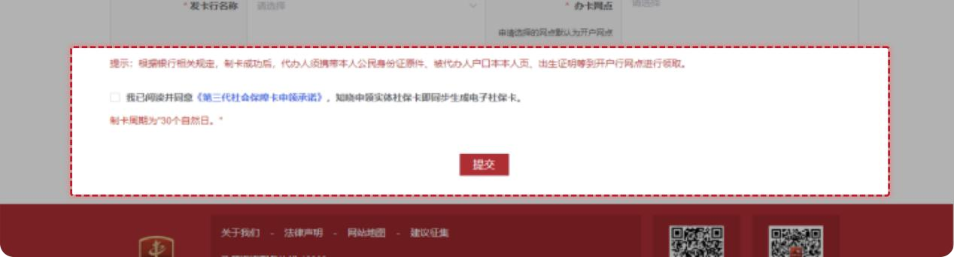

点击【提交】后，出现二次弹框确认提示：是否确认提交个人申领，选择【确定】后，页面提示：您已完成个人申领业务办理，请在个人中心我的办事中查看办事进度。
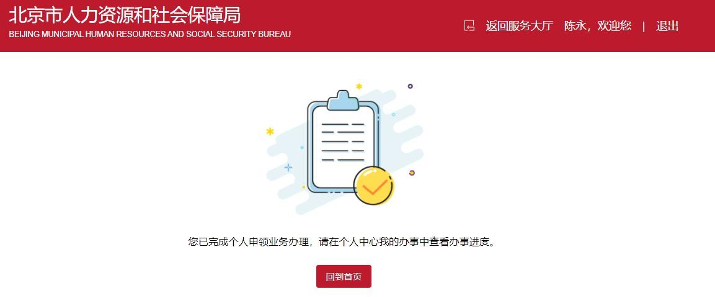
After clicking "Submit", a secondary pop-up will appear, indicating whether to "Confirm submission of personal application". After selecting "Confirm" (确定), the page prompts: "You have completed the personal application operation. Please check the progress in 'Personal Center' (个人中心) - 'My Affairs' (我的办事)".

二、通过“京通”小程序进行退休人员申领第三代社会保障卡。
II. Application for Third-Generation Social Security Card by Retirees via "Jingtong" (京通) Mini-Program
第一步：通过微信、支付宝、百度搜索京通，进入京通小程序或者直接扫描下方二维码进入京通-第三代社会保障卡专区。
Step 1: Search for "Jingtong" (京通) on WeChat, Alipay, or Baidu app to enter the Jingtong mini-program, or directly scan the QR code below to access the "Jingtong - Third-Generation Social Security Card" section (京通-第三代社会保障卡专区).



京通-第三代社会保障卡专区

Jingtong – Third-Generation Social Security Card Section
微信：WeChat
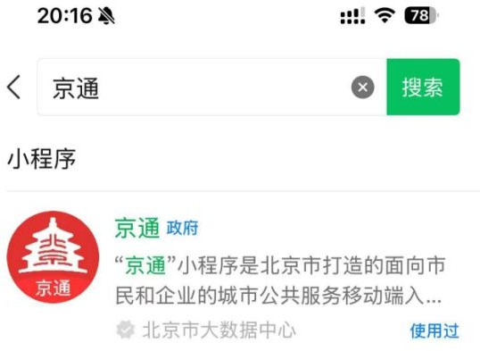

支付宝：Alipay


百度：Baidu
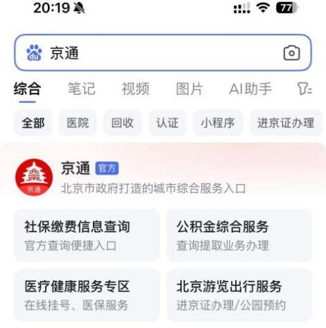

第二步：进入京通小程序后，首页特色服务找到第三代社会保障卡图片，点击【第三代社会保障卡】图片。
Step 2: On the Jingtong homepage, find the "Third-Generation Social Security Card" image in the Featured Services section and click it.
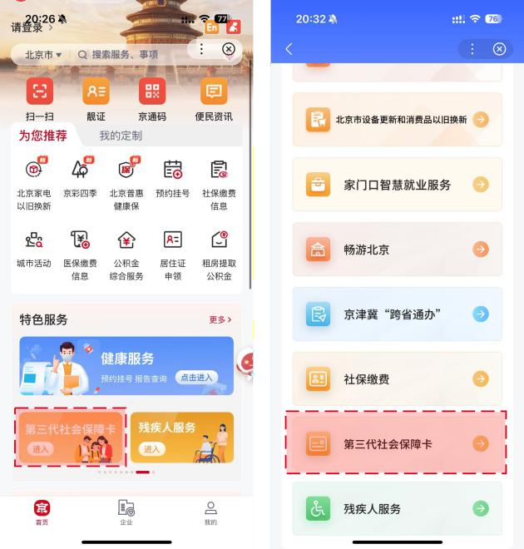
- 登录：第三代社会保障卡页面需要登录认证后进入，在此页面【勾选】同意，点击开始人脸识别，识别成功进入第三代社会保障卡页面。
Login: To enter the Third-Generation Social Security Card section, login and authentication are required. Check the agreement box on this page and click to start facial recognition. Upon successful recognition, enter the Third-Generation Social Security Card section.
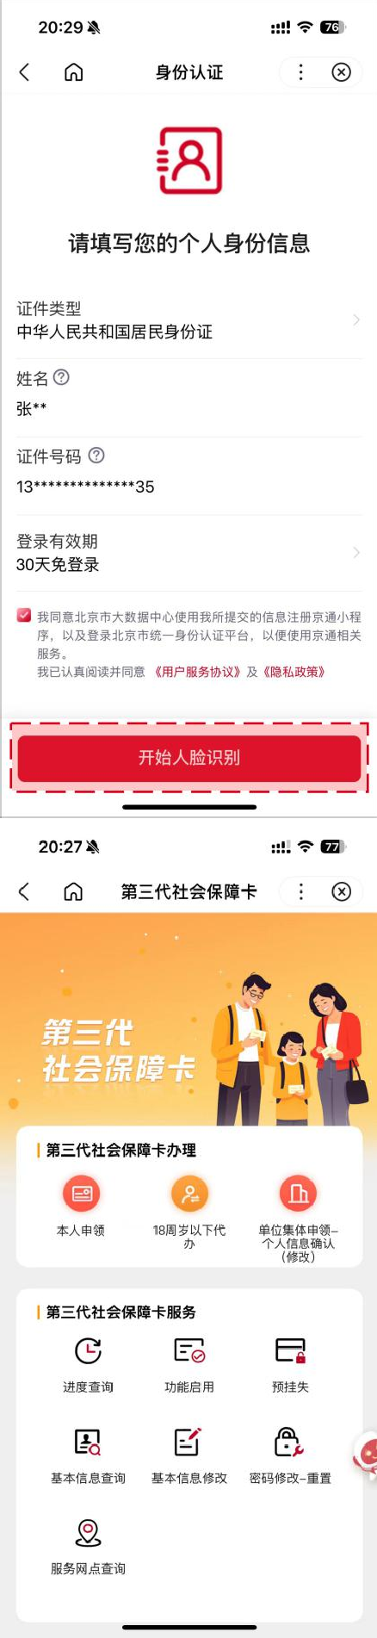

第三步：完成登录进入页面的用户，点击【本人申领】按钮，进入免责声明页，阅读后勾选【我同意】并点击【确定申领】，进入第四步本人申请信息填写页。
Step 3: Users who have completed login and entered the page may click the "Apply for Myself" (本人申领) button and enter the disclaimer page. After reading it, check "I Agree" (我同意) and click "Confirm Application" (确定申领). Enter Step 4 to fill in the personal information for application.

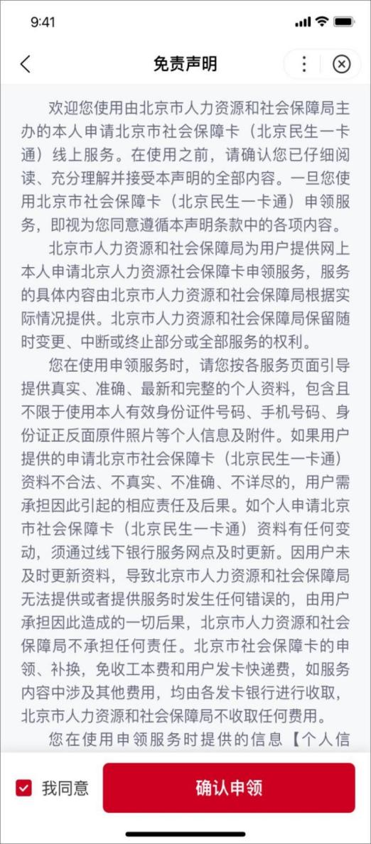
第四步：申领人姓名、证件类型、证件号码显示，勾选
【访问授权】，点击【开始资格校验】按钮，校验人员是否可以进行申领。
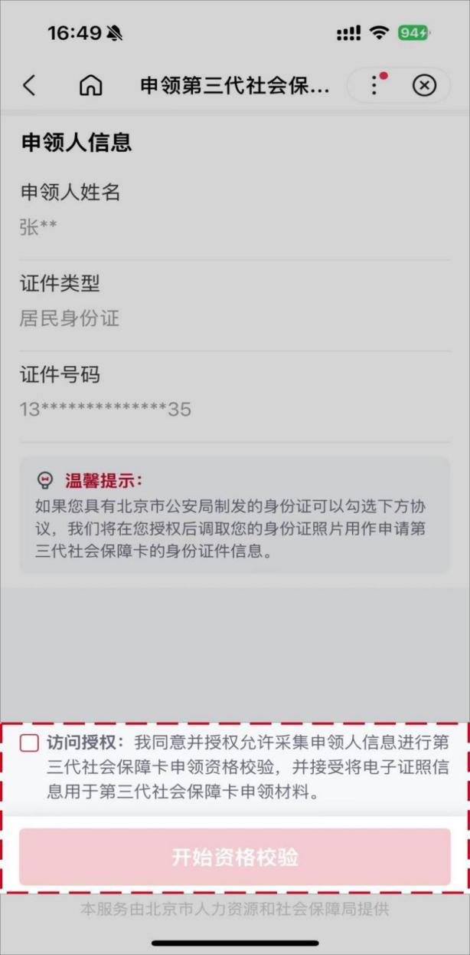
Step 4: The applicant's name, ID type, and ID number are displayed. Check "Access Authorization" (访问授权), and click the "Start Eligibility Verification" (开始资格校验) button to verify whether the individual is eligible to apply.

第五步：用户个人基本信息（姓名、证件类型、证件号码、证件有效期限开始日期、性别、出生日期、国籍、常住所在地地址、卡预留手机号），检查反显信息是否正确。
Step 5: The user's personal basic information (name, ID type, ID number, start date of the ID validity period, gender, date of birth, nationality, permanent residence address, and card reserved mobile number) is displayed. Check whether the displayed information is correct.
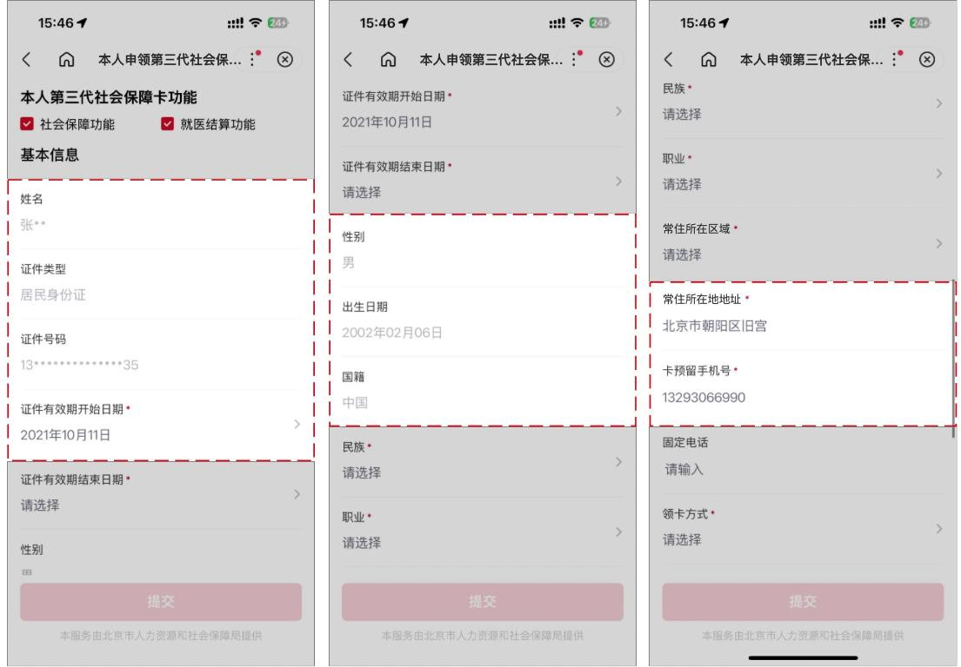

第六步：民族、职业（系统默认为“离退休人员”，可进行修改）、常住地所在区等信息。
Step 6: Select the ethnicity, occupation (system defaults to "Retired Personnel" and can be modified), district of permanent residence, and fill in other information.
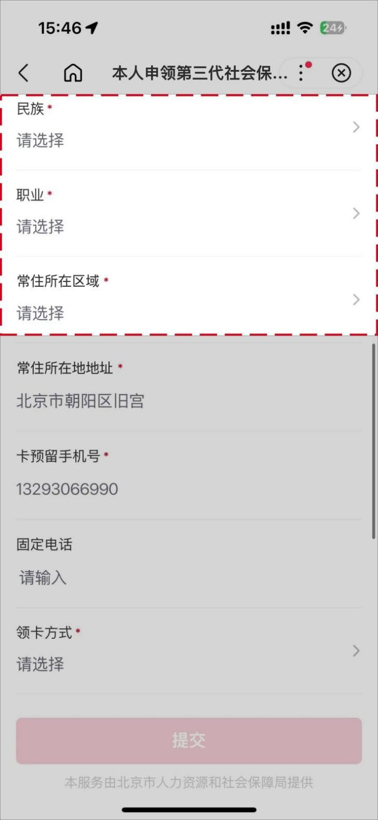

第七步：填写领卡方式（可选择本人“个人网点领卡”和“银行邮寄”，若选择银行邮寄需完善收件人人姓名、收件人联系电话、收件地所在区、邮政编码、收件地所在区、收件详细地址等），发卡行名称、办卡网点（退休人员首次申领第三代社保卡的发卡行名称和办卡网点与当前养老金代放行一致，无法修改）。
Step 7: Fill in the card-collection method (The applicant can choose from "self collection at a bank branch" or "delivery by the bank". If "delivery by the bank" is selected, it is necessary to complete the recipient's name and contact number, the postal code, the receiving district, and the detailed receiving address, etc.), the name of the card-issuing bank, and card-application branch (for retired personnel applying for the third-generation social security card for the first time, the the name of the card-issuing bank, and card- application branch are consistent with the current pension-disbursement bank and cannot be modified).
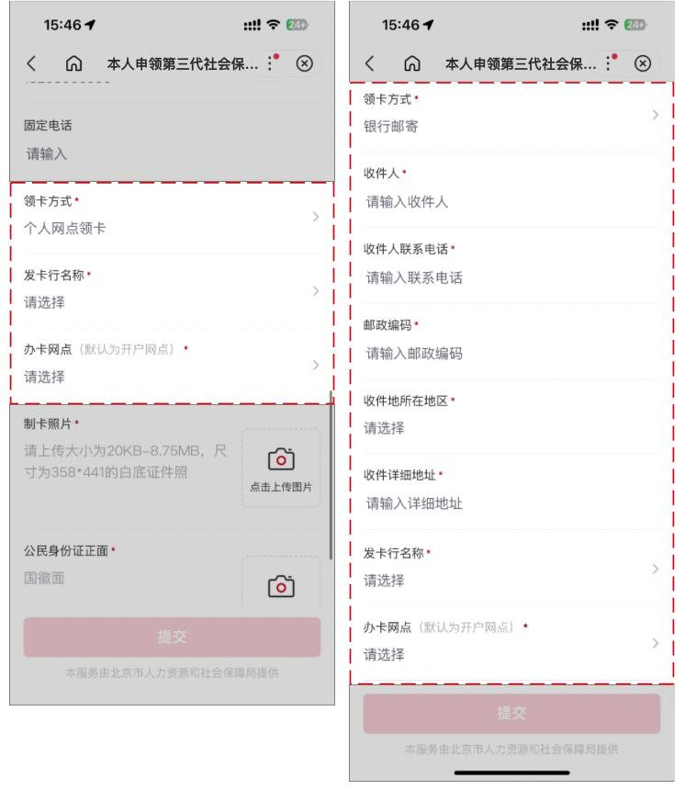

第八步：上传身份证正、反面原件照片，补充实体卡的制卡照片（照片要求：大小为 20KB-8.75M 以内，尺寸为 358*441）。
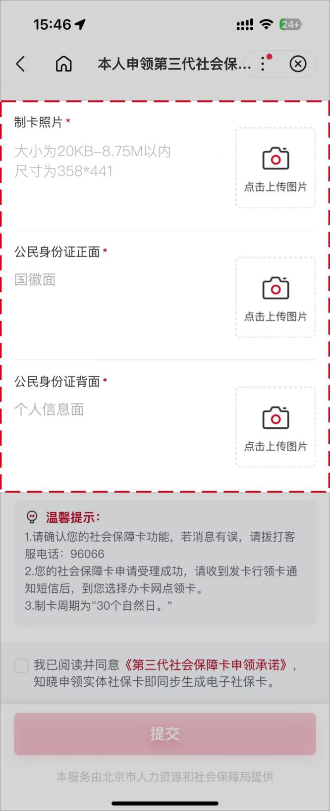
Step 8: Upload photos of the front and back of the ID card for physical card making (Photo requirements: Size within 20KB-8.75M, dimensions 358*441).

第九步：确认填写信息无误后勾选【我已阅读并同意】，并点击【提交】按钮，本人第三代社会保障卡申领操作。
Step 9: After confirming the filled information is correct, check "I have read and agree" (我已阅读并同意), and click "Submit" (提交) to complete the personal application operation for the third-generation social security card.
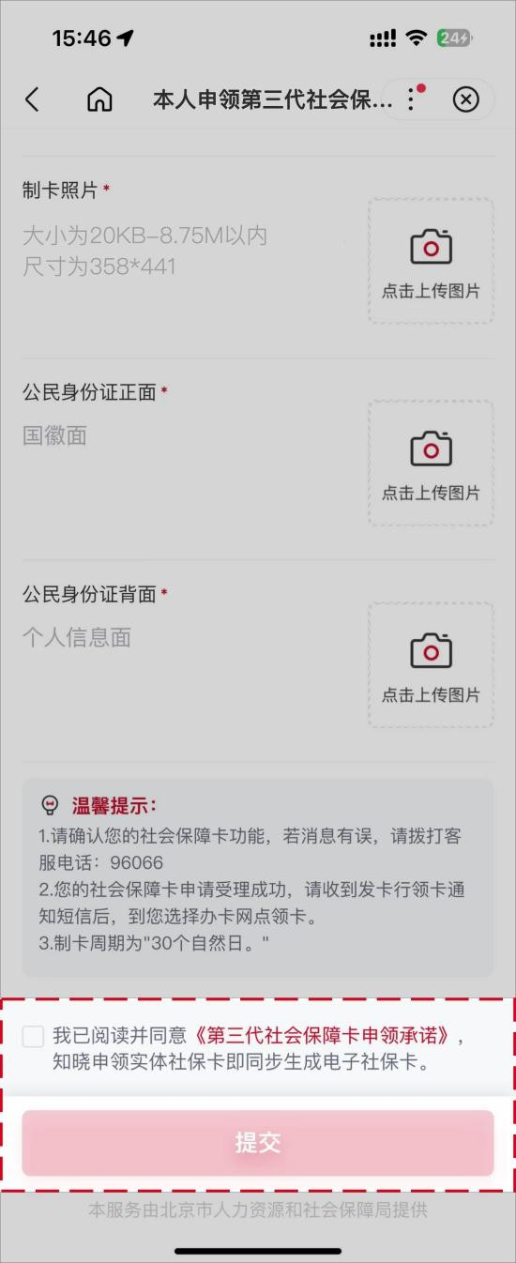
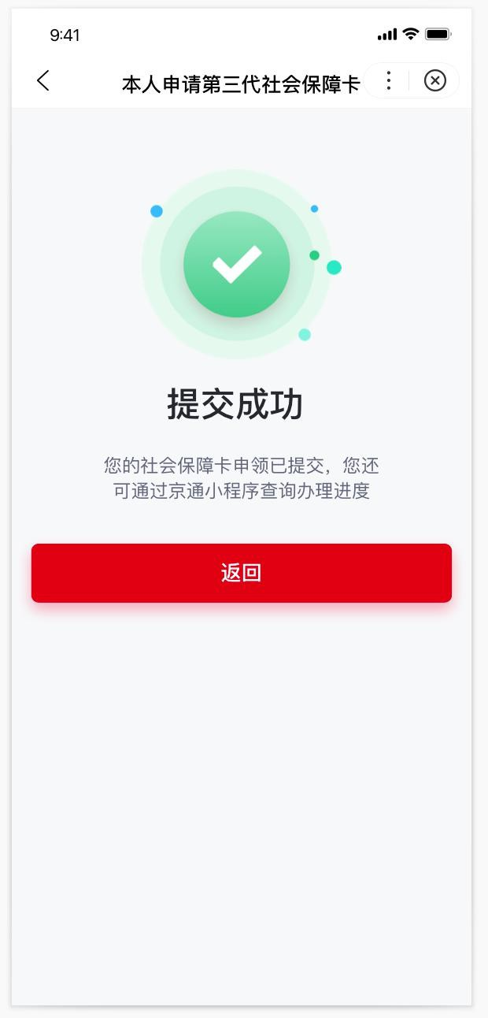

三、通过北京民生一卡通小程序进行退休人员申领第三代社会保障卡
III. Application for Third-Generation Social Security Card by Retirees via Beijing Minsheng Yikatong Mini-Program
第一步：通过微信扫描下方二维码或者微信搜索框选择小程序，输入“北京民生一卡通”，找到如下产品图标 icon，点击图标直接进入小程序。
Step 1: Scan the QR code below via WeChat or search "北京民生一卡通" to enter the mini-program.


北京民生一卡通微信小程序
Beijing Minsheng Yikatong WeChat Mini-program

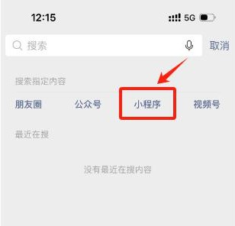


第二步：进入北京民生一卡通小程序后，进入首页社保卡页，找到长者版专区，点击进入长者版专区后，点击【申请本人社会保障卡】按钮进行申请。
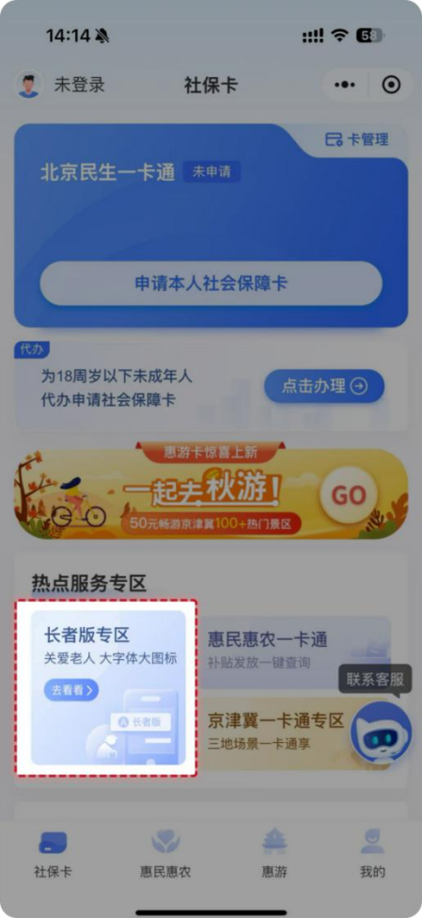
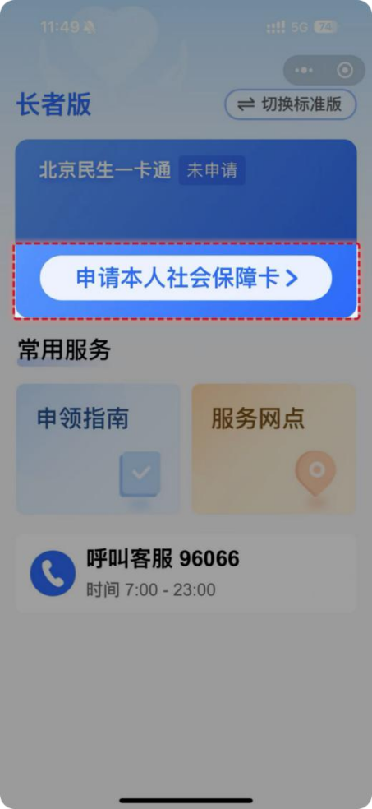
Step 2: After entering the mini-program, enter the Social Security Card page from the homepage, and find the Elderly Version special section. Click and enter the special section, then click the "Apply for My Social Security Card" (申请本人社会保障卡) button to apply.
申请第三代社会保障卡前，用户需要完成登录和实名认证，才可以进行第三代社会保障卡的线上申领；若用户已完成上述操作，无需再次进行登录和实名认证，直接进入第三步申领卡流程页。
Users need to complete login and real-name authentication before applying for the third-generation social security card. If the user has already completed the above operations, there is no need to log in and authenticate again; proceed directly to the card-application process page in Step 3 .
登录：目前支持微信授权用户手机号快捷登录和手机号验证码登录两种方式。
Login: Two login methods are currently supported: the swift login through a WeChat-authorized user's mobile number and the mobile number verification code login
.
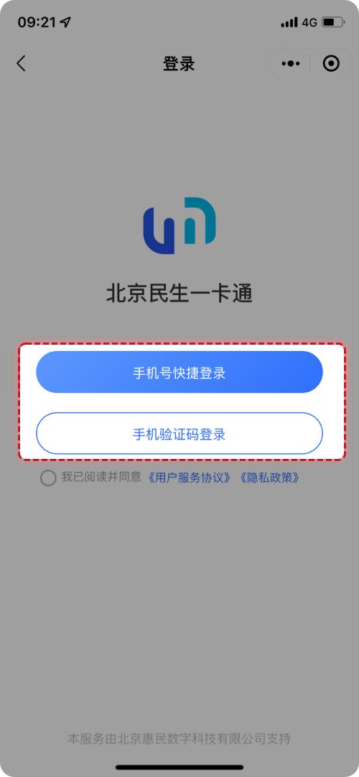

实名认证：需要输入姓名、身份证号并使用手机摄像头进行人脸核验，以上信息保持一致才可通过实名认证。
Real-Name Authentication: Facial verification requires inputting name, ID number, and using the mobile phone camera. The above information must be consistent to pass the real-name authentication.

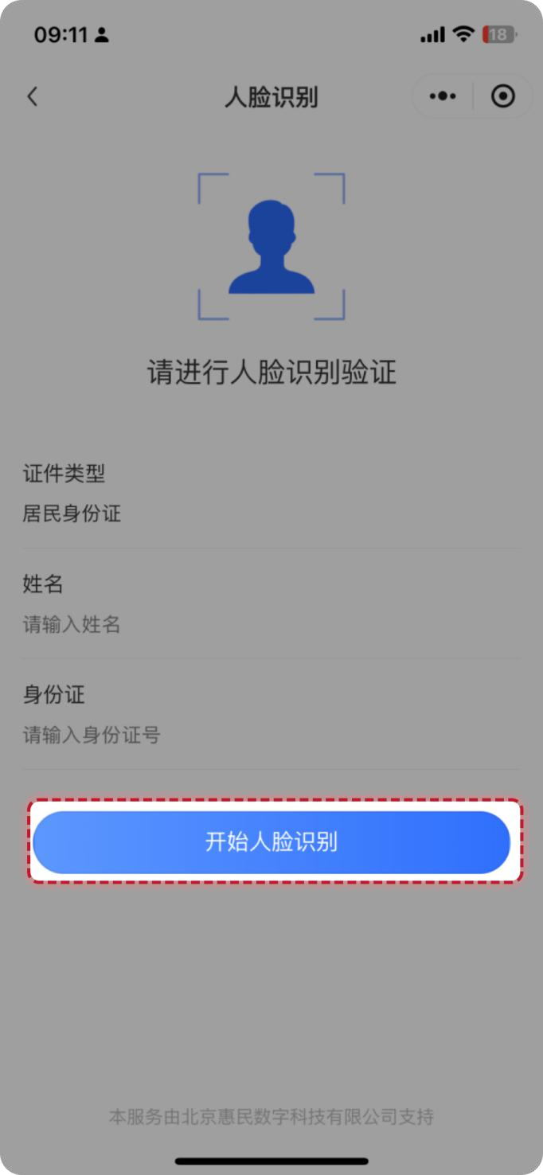

第三步：完成登录和身份认证的用户，点击【申请本人社会保障卡】按钮后，出现免责声明条款，阅读后勾选【我已阅读并同意免责声明】并点击【确定】，进入第四步本人申请信息填写页。
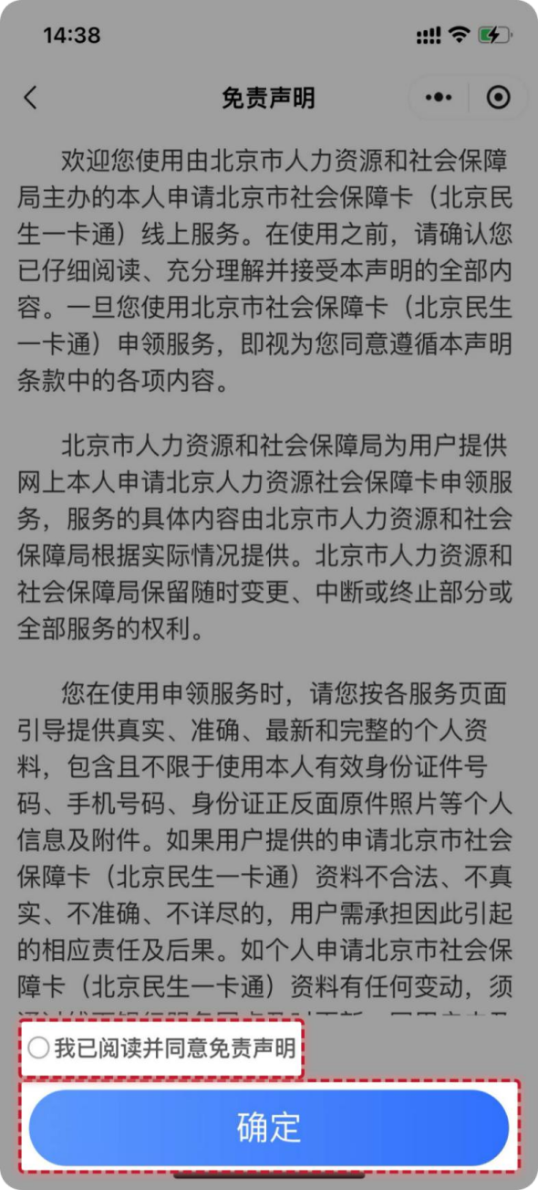
Step 3: After completing login and identity authentication and clicking the "Apply for My Social Security Card" (申请本人社会保障卡) button, the user will see a disclaimer appear. After reading it, check "I have read and agree to the disclaimer" (我已阅读并同意免责声明) and click "Confirm" to enter Step 4 for personal application information filling.

第四步：填写本人申请信息依次是身份识别、基本信息、制卡信息和领卡方式。
Step 4: Fill in the personal application information sequentially, including identity recognition, basic information, card-making information, and card-collection method.
（1）本人的身份识别页面，需要上传身份证正、反面原件照片，系统会自动识别上传的身份证照片中的姓名、民族、证件有效期等信息进行填充回显到页面中。核对无误后，点击【确定，下一步】进入下一步。
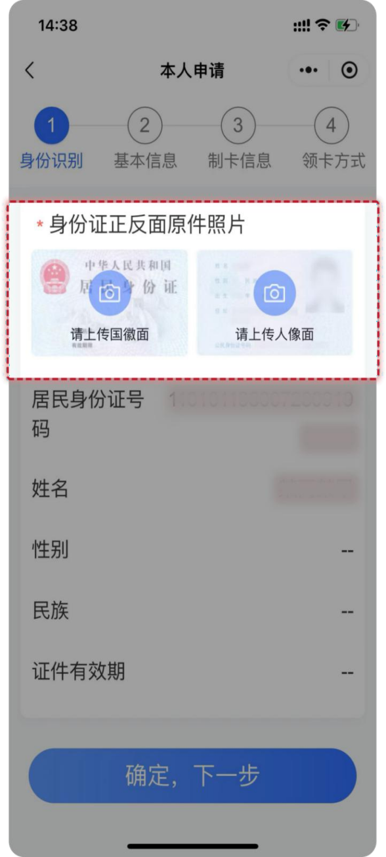
(1) Personal Identity Recognition Page: The photos of the front and back of the ID card are required to be uploaded. The system will automatically recognize and fill in information such as name, ethnicity, and ID validity period from the uploaded photos for display on the page. After verifying the information, click "Confirm, Next" (确定，下一步) to proceed to the next step.
（2）本人的基本信息页面，需要输入本人的常住地所在区、常住所在地地址，职业系统默认为“离退休人员”，可进行修改。填写完成后，点击【确定，下一步】进入下一步。
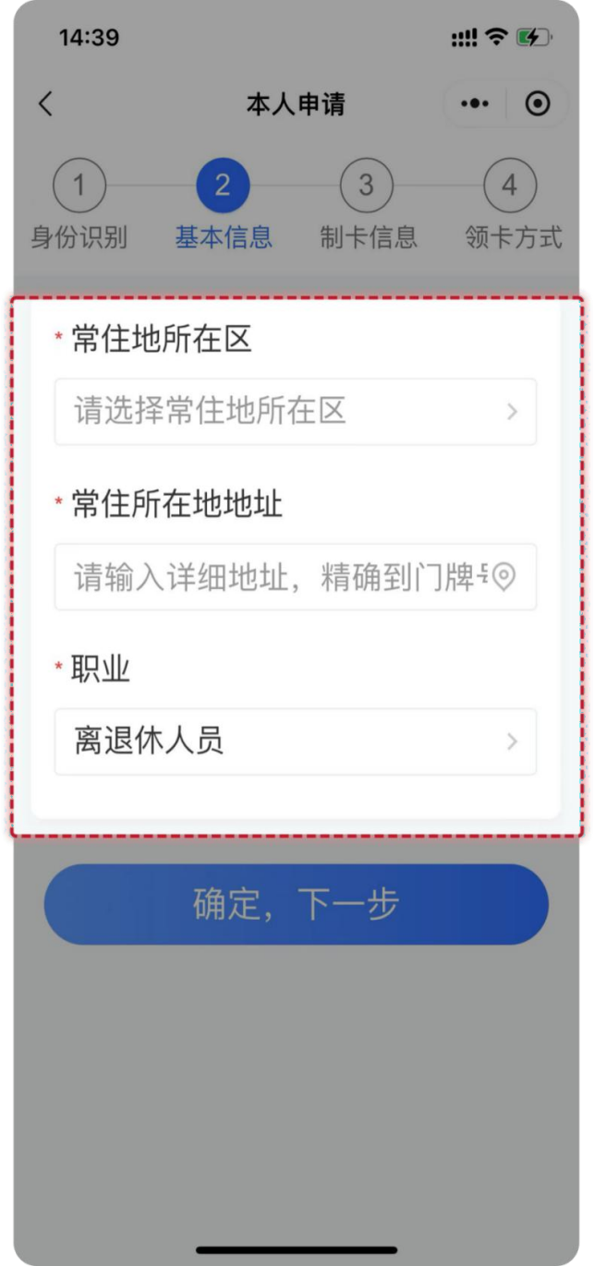
(2) Personal Basic Information Page: It is required to input the district of permanent residence and the permanent residence address. The Occupation defaults to "Retired Personnel" and can be modified. After completion, click "Confirm, Next" (确定，下一步) to proceed to the next step.
（3）本人的制卡信息页面，需要上传本人制卡照片（照片要求：上传本人近期彩色免冠照片，保证真实有效，照片保持清晰完整，五官无任何遮挡，避免反光）、卡预留手机号。离退休人员首次申领第三代社保卡的办卡银行和开户行网点与当前养老金代放行一致，无法修改。填写完成后，点击【确定，下一步】进入下一步。
(3) Card-making Information Page: Upload the photo for card-making (Photo requirements: A recent bareheaded color photo of the applicant. The photo should be authentic and effective, kept clear and complete, with the facial features unobstructed and glare avoided) and card-reserved mobile number, then select the card-application bank and the account opening branch, etc. After completion, click "Confirm, Next" (确定，下一步) to proceed to the next step.
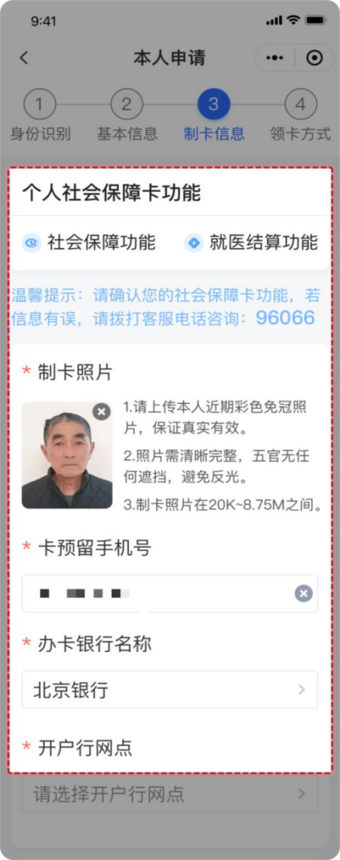
（4）选择领卡方式，退休人员领卡方式目前只支持银行邮寄，需完善邮寄接收人、接收人联系电话、邮寄接收地址等。
(4) Card-Collection Method: Currently, "Delivery by the bank" is the only supported way for retirees to collect the card. It is necessary to complete the information of the recipient, the recipient's contact number, and the receiving address, etc.
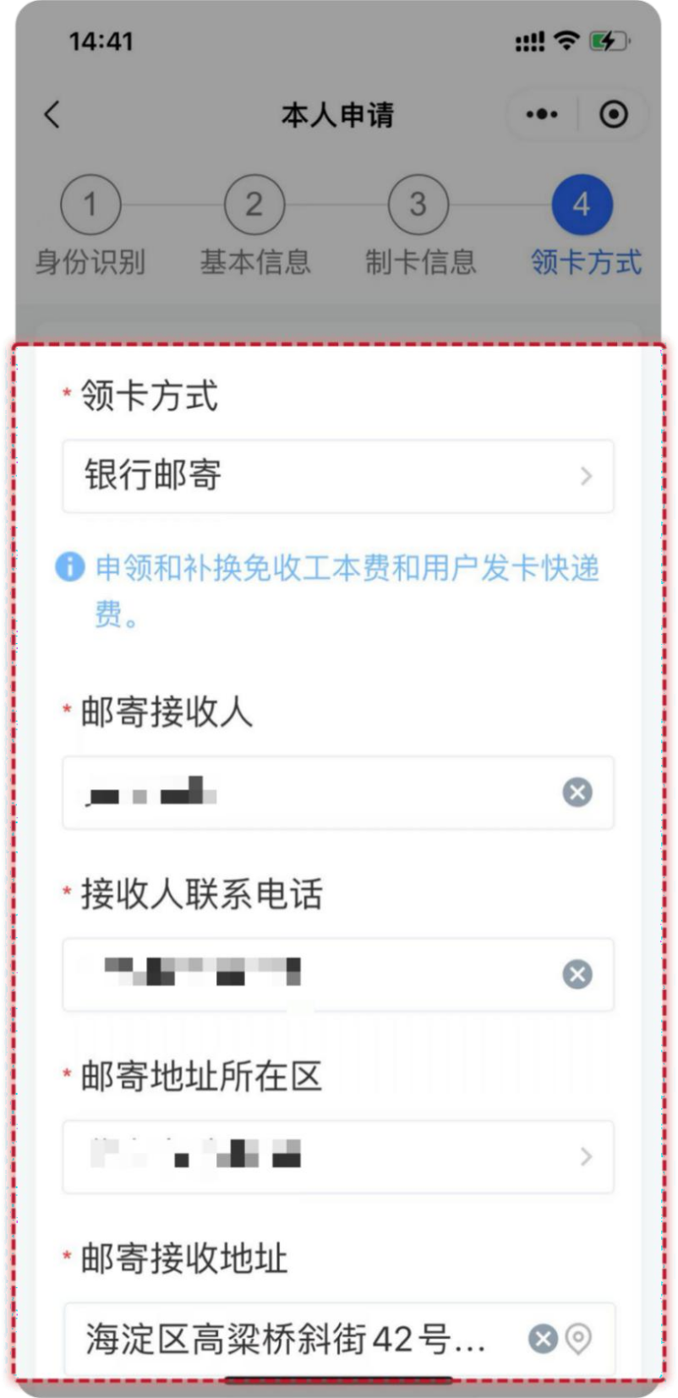

第五步：确认信息无误后勾选【我已阅读并同意】，并点击【确认提交】按钮，完成本人第三代社会保障卡申领操作。
Step 5: After confirming the information is correct, check "I have read and agree" (我已阅读并同意), and click the "Confirm Submission" (确认提交) button to complete the personal application operation for the third-generation social security card.
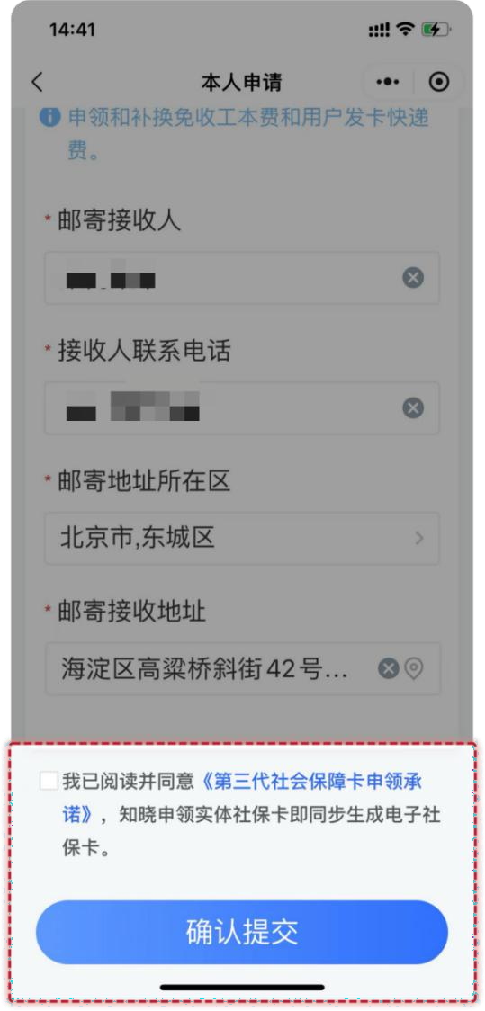

京通小程序 Jingtong Mini-Program

北京民生一卡通微信小程序
Beijing Minsheng Yikatong WeChat Mini-Program

