附件3
Attachment 3

北京市第三代社保卡个人参保人员线上申领操作说明
Online Operating Instructions for Independent Insurees Applying for Third-Generation Social Security Cards in Beijing

一、通过北京市人力资源和社会保障局官网进行个人参保人员申领第三代社会保障卡
I. Individual Application for Third-Generation Social Security Card via the Official Website of the Beijing Municipal Bureau of Human Resources and Social Security

登录北京市人力资源和社会保障局官网，依次点击【热点服务】-【我要办社保卡】，进行申领操作。
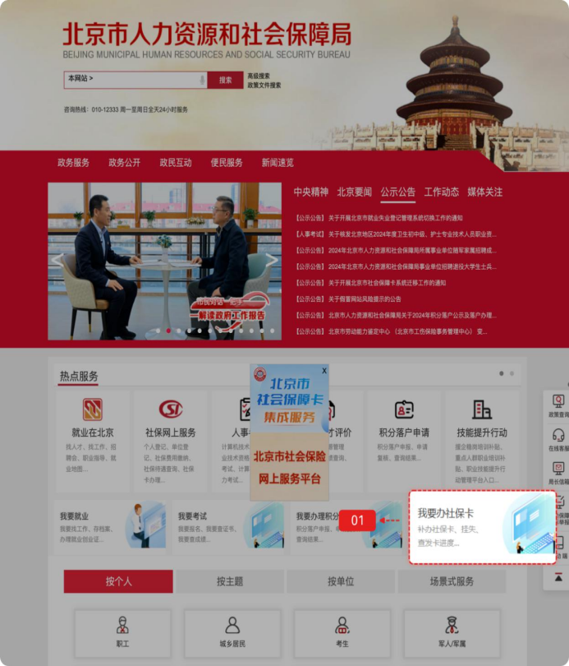
Log in to the official website of the Beijing Municipal Human Resources and Social Security Bureau. Click "Most-requested Services" (热点服务) - "I want to apply for a social security card" (我要办社保卡) to start application.

登录方式包括如下几种：
The login methods include:
- 扫码登录
用户可选择扫码登录，使用微信、支付宝或百度端“京通”小程序扫码登录，如下图：
- QR Code Login: Users may choose QR code login. Use the "Jingtong" Mini-Program on WeChat, Alipay, or Baidu App to scan the QR code for login as follows.
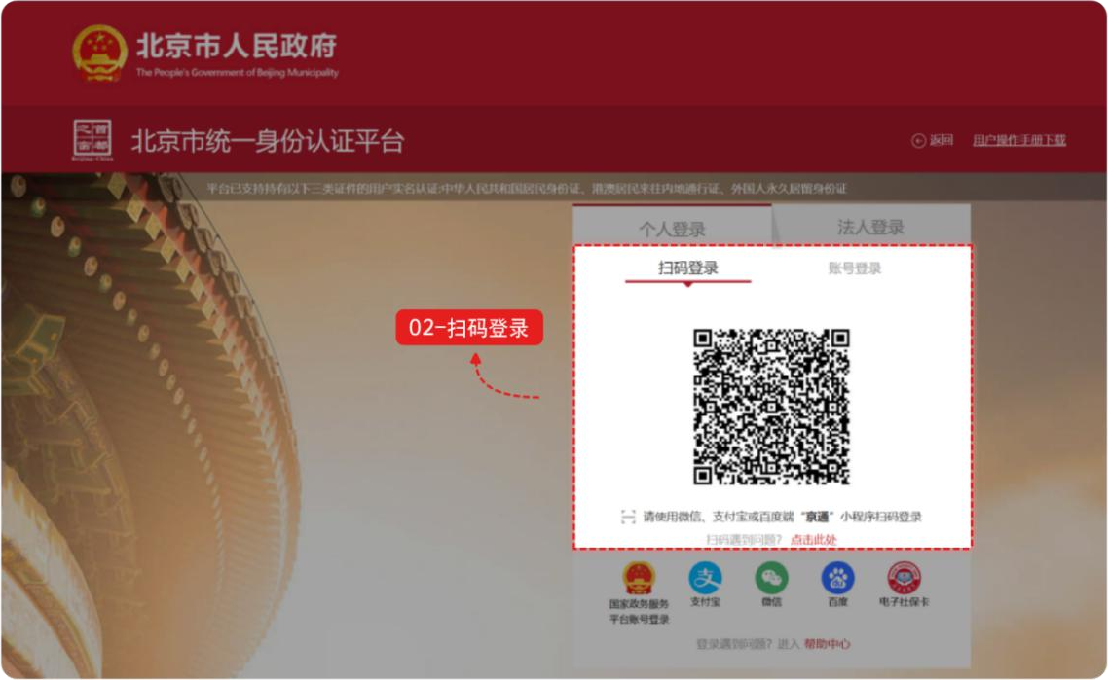
- 账号登录
用户可选择账号登录，输入用户名/手机号/身份证号、密码和图形验证码，点击【登录】，如下图：
(2) Account Login: Users may login through an account. Enter the username/mobile number/ID number, password, and graphical verification code, then click "Login" (登录) as follows.
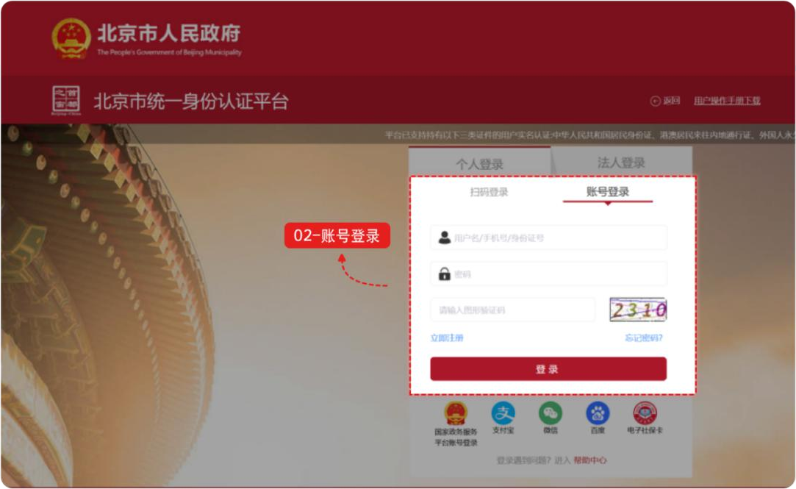

- 其他渠道登录
用户可选择国家政务服务平台账号登录，或者支付宝、微信、百度、电子社保卡进行登录。
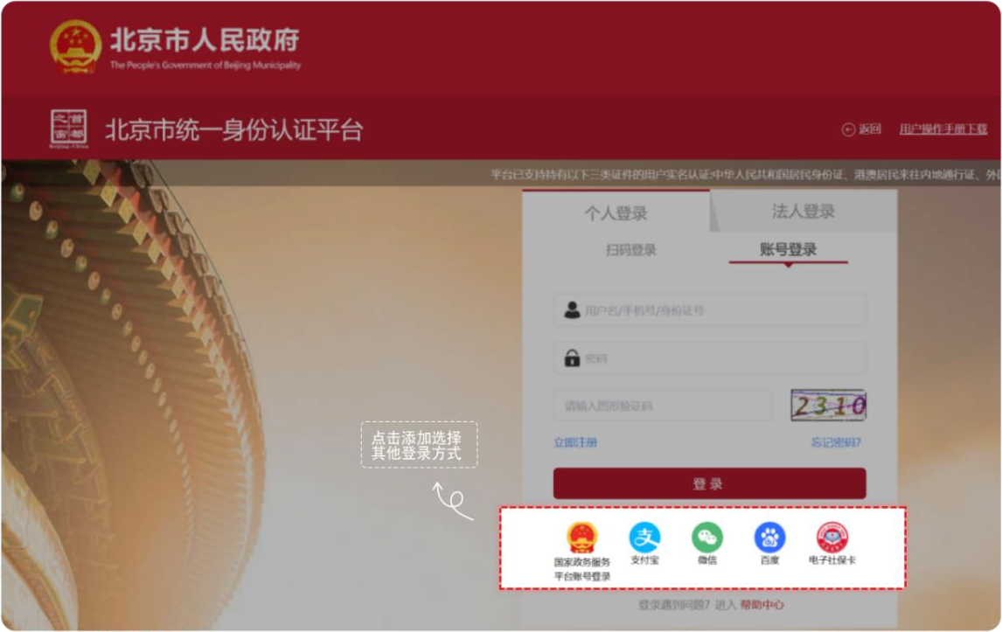
(3) Login through Other Channels:
Users may log in with a National Government Service Platform account, or via Alipay, WeChat, Baidu, or Electronic Social Security Card.

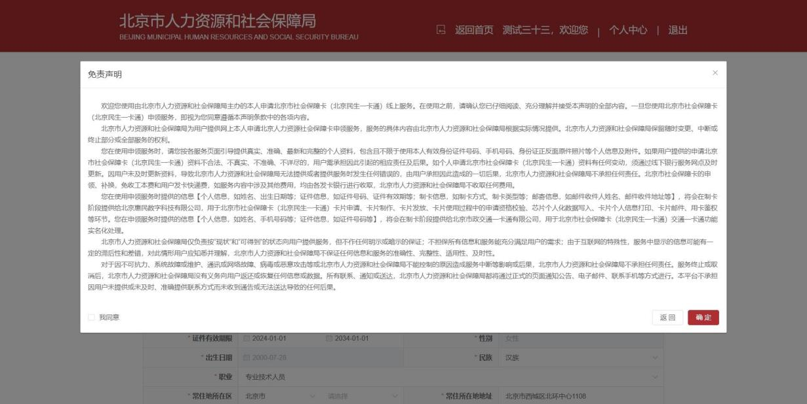
登录网厅后，点击【本人申请社会保障卡】，出现免责声明弹框。免责声明阅读后勾选【我同意】，点击【确定】按钮。

点击【确定】按钮后，进入本人社会保障卡申请信息填写页面。
After logging in to the web portal, click "Application of Social Security Card for Oneself" (本人申请社会保障卡) in the section of "third-generation social security card services". A disclaimer pop-up will appear. After reading it, check "I Agree" (我同意) and click "Confirm" (确定) to enter the information filling page.
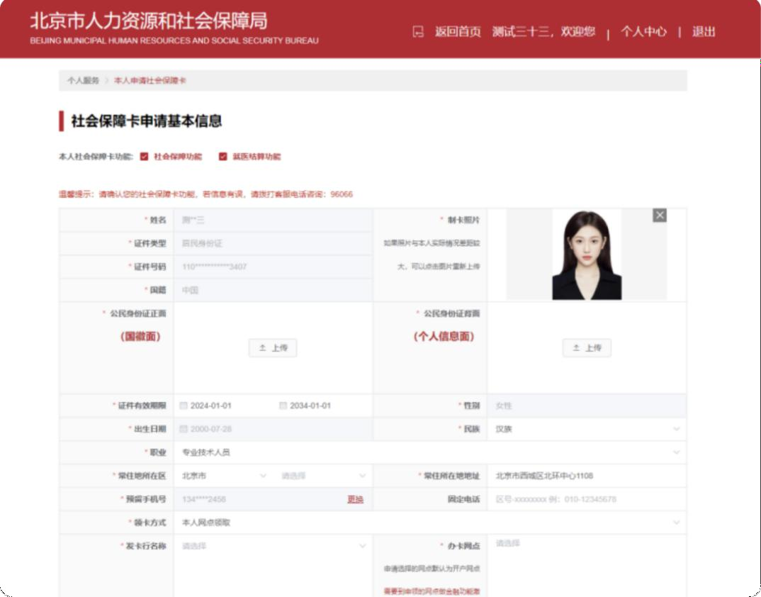
根据提示录入相关信息，涉及制卡照片、本人身份证正面原件照片、身份证背面原件照片。
Input relevant information following the guide, including the photo for card-making and the photos of the front and back sides of the insuree's original ID card.
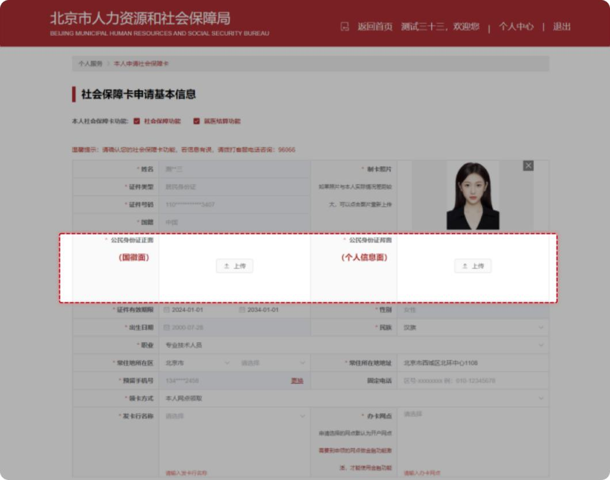

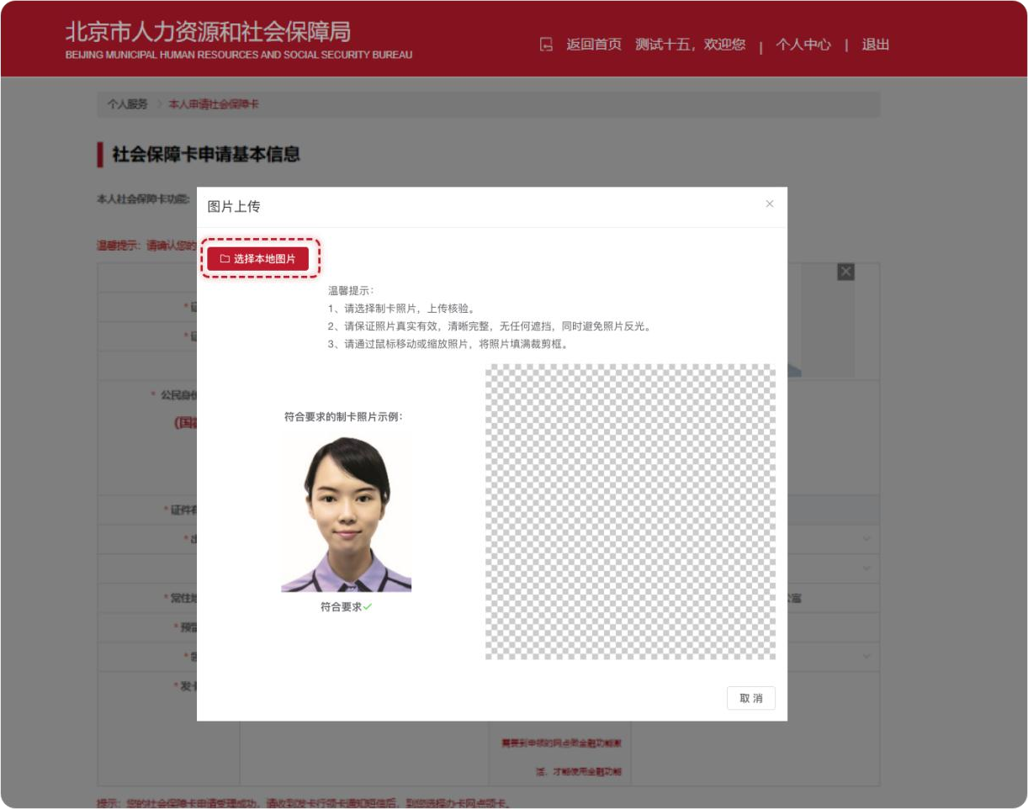
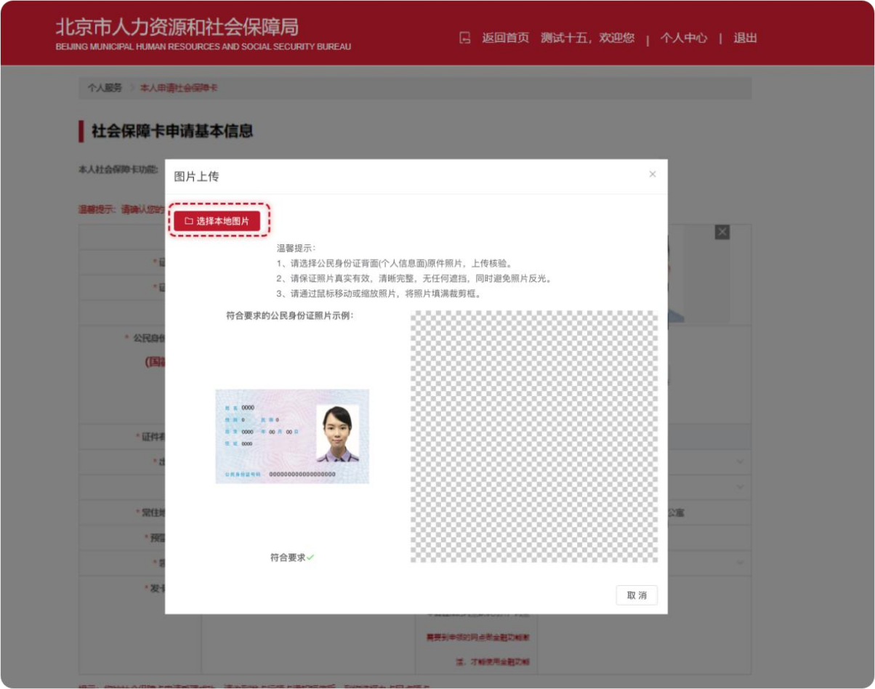

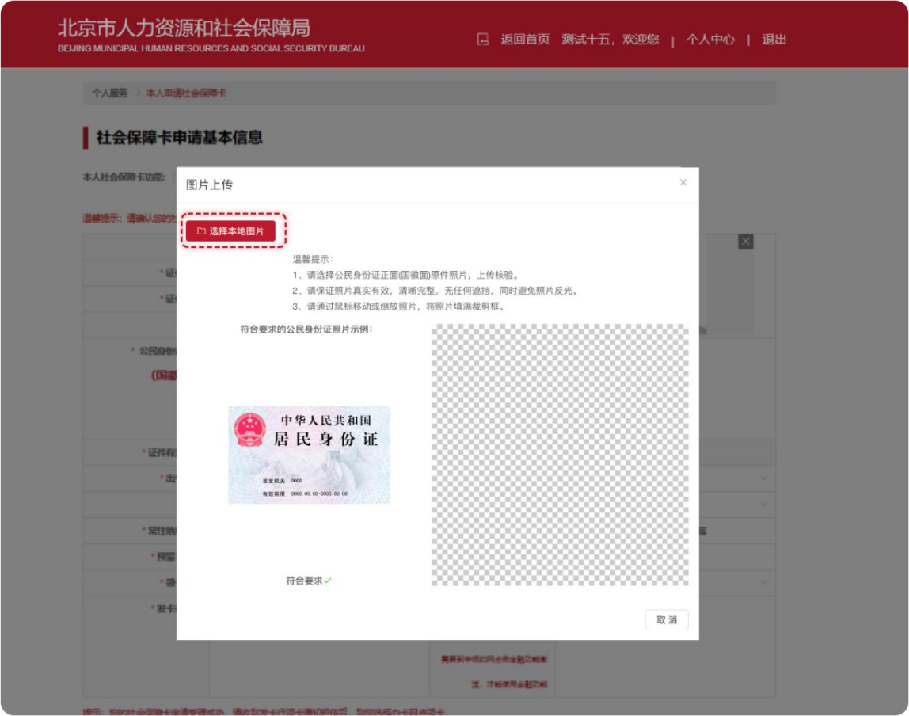
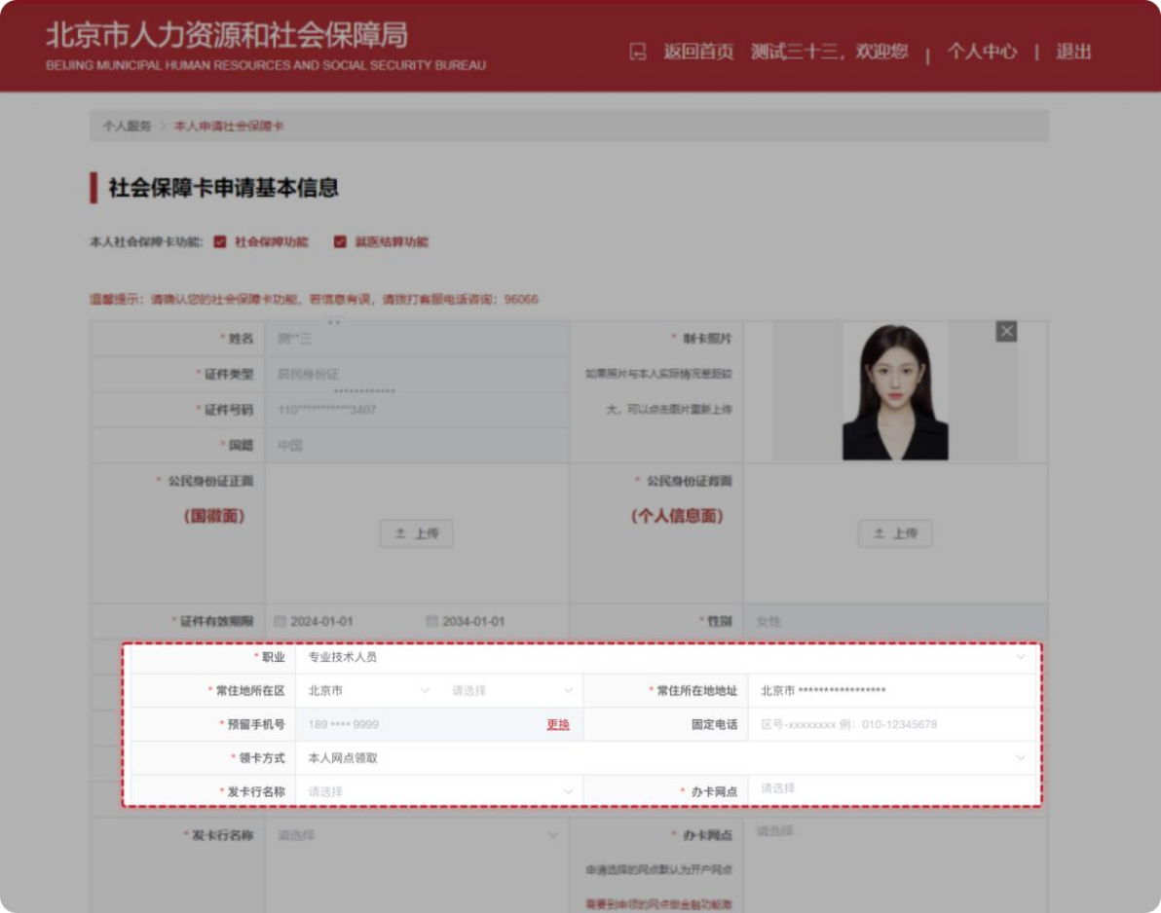
输入补录信息：职业、常住地所在区、常住地所在地址、发卡行名称及办卡网点等信息。
Enter the supplementary information:
Occupation, the district and address of the permanent residence, name of the card issuing bank, and the card application branch, etc.
选择领卡方式，可选择本人网点自取或银行网点邮寄。若选择银行网点邮寄需完善邮寄接收人、邮寄接收人手机号码、邮寄接收地址、邮寄编码等信息。
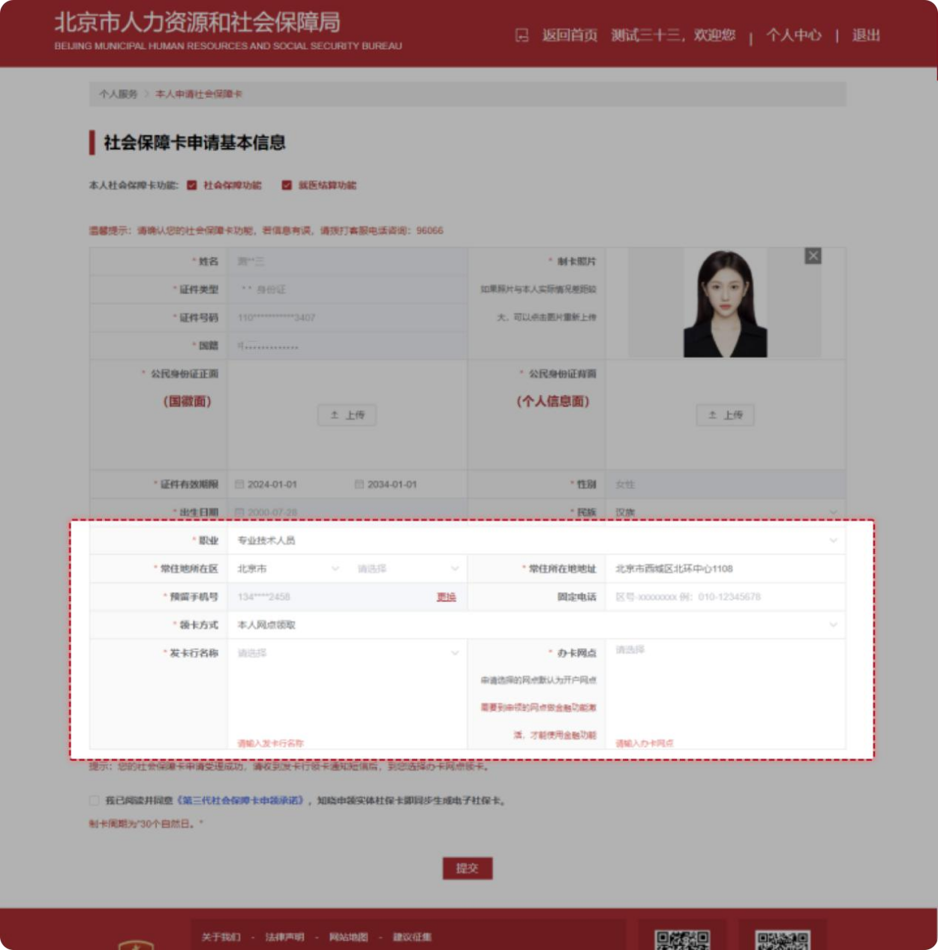
Select the card collection method, which can be collection at the branch in person or delivery by the bank. If the insuree selects delivery by the bank, it is required to complete the information such as the recipient, the recipient's mobile number, the receiving address, the postal code, etc.
信息全部完善后勾选【申请人承诺】，点击【提交】本人申领社保卡信息。
After all information is completed, check the box "Applicant Commitment" (申请人承诺), and click "Submit" (提交) the personal information for social security card application.
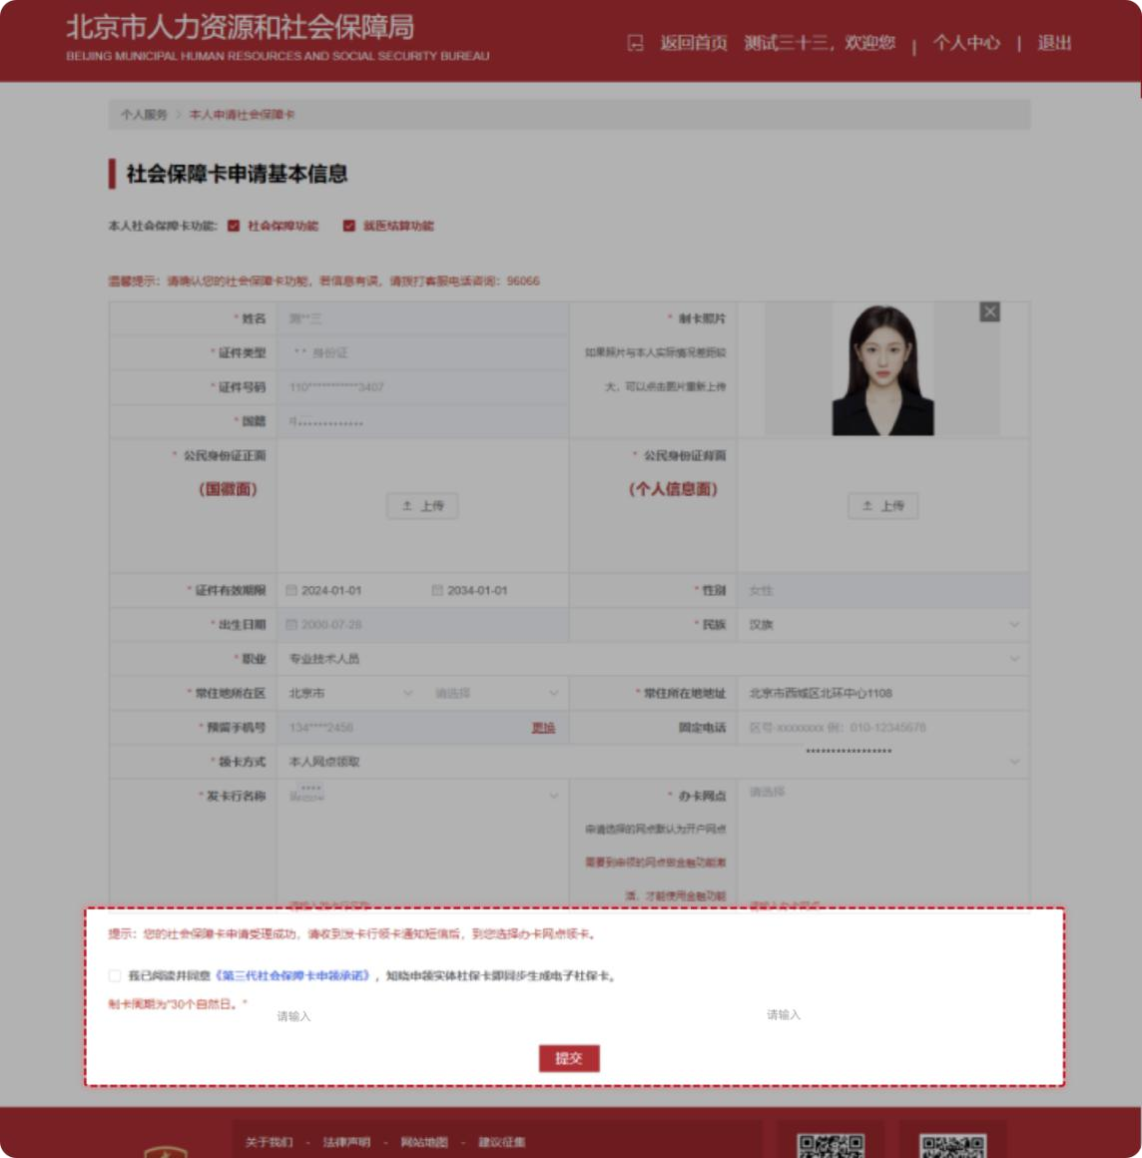
点击【提交】后，出现二次弹框确认提示“是否确认提交个人申领”，选择【确定】后，页面提示“您已完成个人申领业务办理，请在个人中心我的办事中查看办事进度”。
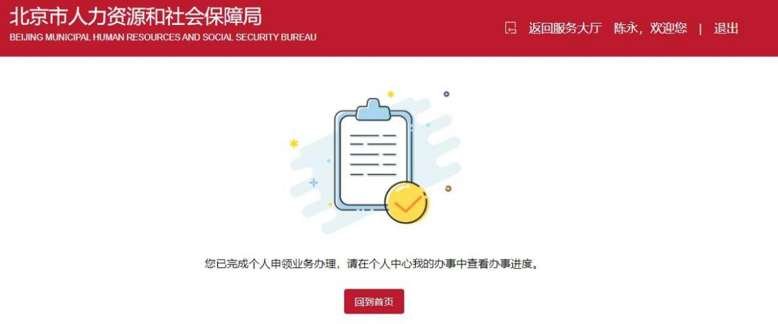
After clicking "Submit" (提交), a secondary pop-up will appear, asking "whether to confirm submission of personal application". After selecting "Confirm" (确定), the page will inform that "You have completed the personal application processes. Please check the updates in 'My Affairs' under the 'Personal Center' section".

二、通过“京通”小程序进行个人参保人员申领第三代社会保障卡。
II. Individual Application for Third-Generation Social Security Card via "Jingtong" Mini-Program.
第一步：通过微信、支付宝、百度搜索京通，进入京通小程序或者扫描下方二维码进入京通-第三代社会保障卡专区。
Step 1: Search for "Jingtong" (京通) on WeChat, Alipay, or Baidu to enter the "Jingtong" Mini-Program, or scan the QR code below to enter the Jingtong - Third-Generation Social Security Card section (京通-第三代社会保障卡专区).

京通-第三代社会保障卡专区
Jingtong - Third-Generation Social Security Card Section

微信：WeChat

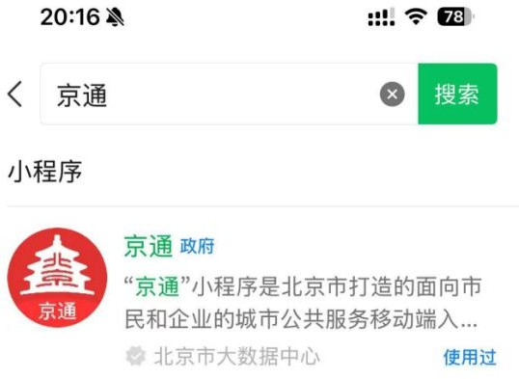

支付宝：Alipay
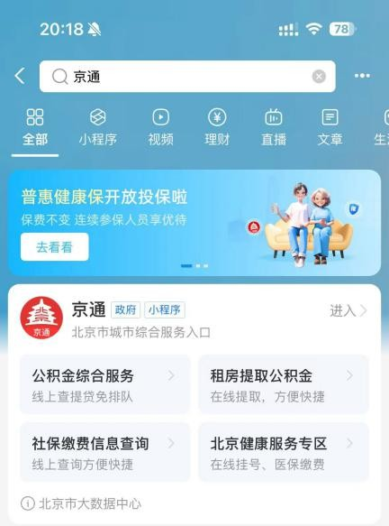

百度：Baidu

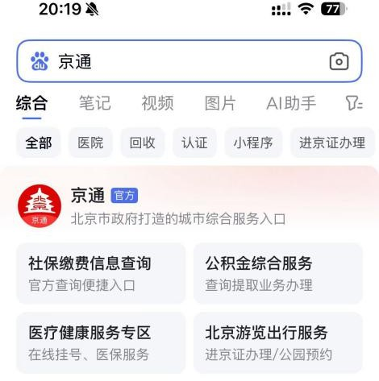
第二步：进入京通小程序后，首页特色服务找到第三代社会保障卡图片，点击【第三代社会保障卡】图片。
Step 2: After entering the "Jingtong" Mini-Program, find the image of the Third-Generation Social Security Card in the Featured Services section on the homepage and click it.
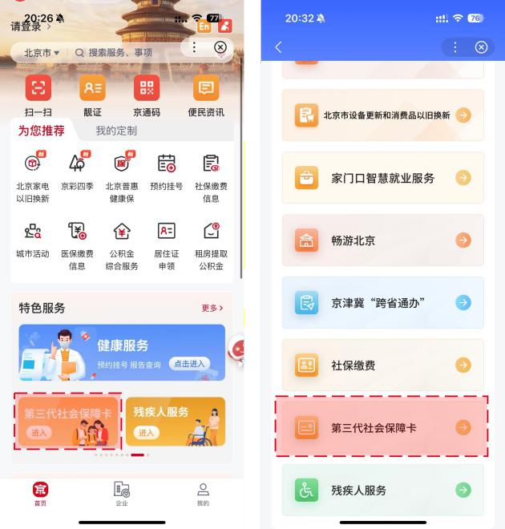
- 登录：第三代社会保障卡页面需要登录认证后进入，在此页面勾选【同意】，点击开始人脸识别，识别成功进入第三代社会保障卡页面。

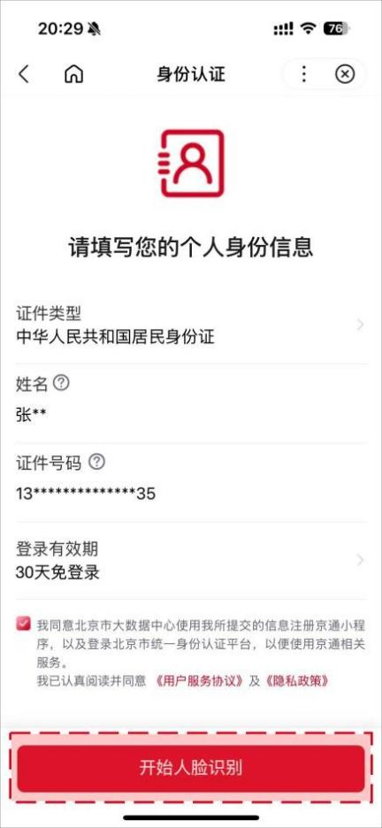
(1) Login: It requires login authentication to enter the page of the third-generation social security card. On this page, check "Agree" (同意) and click the button below to start facial recognition. Upon successful recognition, enter the page of the third-generation social security card.
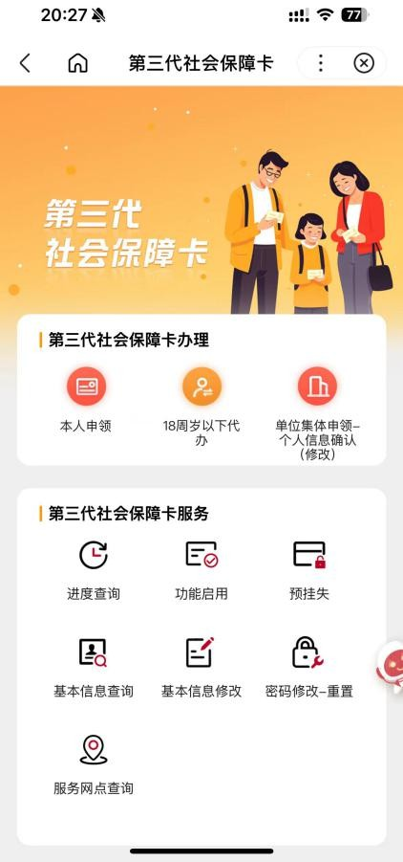
第三步：完成登录进入页面的用户，点击【本人申领】按钮，进入免责声明页，阅读后勾选【我同意】并点击【确定申领】，进入第四步本人申请信息填写页。
Step 3: Users who have completed login and entered the page may click the "Application in Person" (本人申领) button to enter the disclaimer page. After reading it, check "I Agree" (我同意) and click "Confirm Application" (确定申领), then enter Step 4 for filling in the personal information for application.
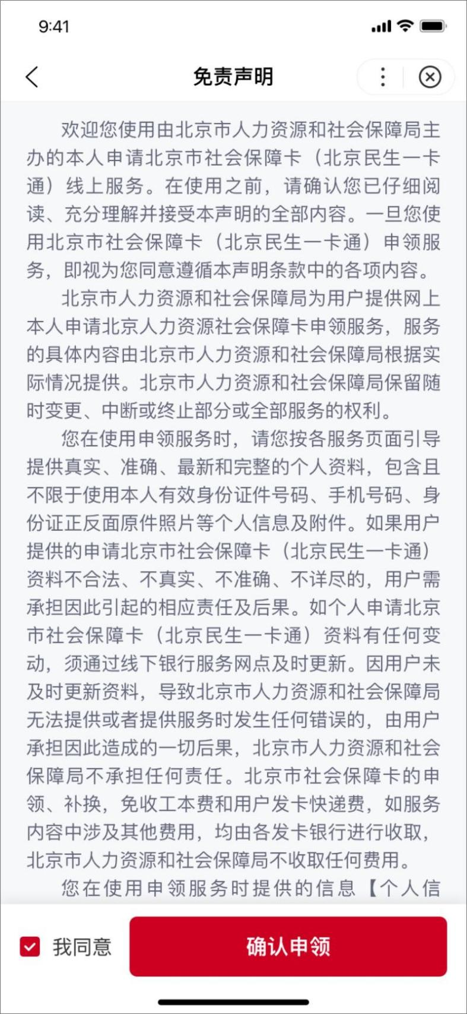

第四步：申领人姓名、证件类型、证件号码显示，勾选
【访问授权】，点击【开始资格校验】按钮，校验人员是否可以进行申领。
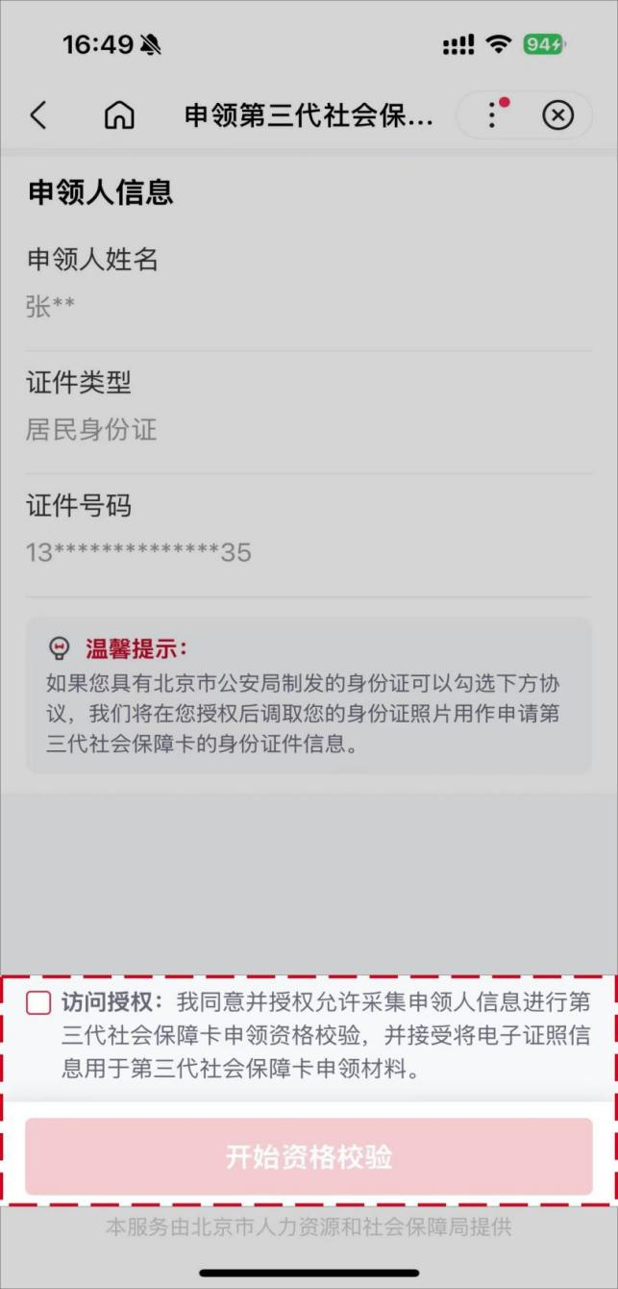
Step 4: The applicant's name, ID type, and ID number are displayed on this page. Check "Access Authorization" (访问授权) and click the "Start Eligibility Verification" (开始资格校验) button to verify whether the person is eligible to apply.

第五步：用户个人基本信息（姓名、证件类型、证件号码、证件有效期限开始日期、性别、出生日期、国籍、常住所在地地址、卡预留手机号），检查反显信息是否正确。
Step 5: User's basic personal information (name, ID type, ID number, start date of the ID validity period, gender, date of birth, nationality, permanent residence address, and card-reserved mobile number). Check whether the displayed information is correct.
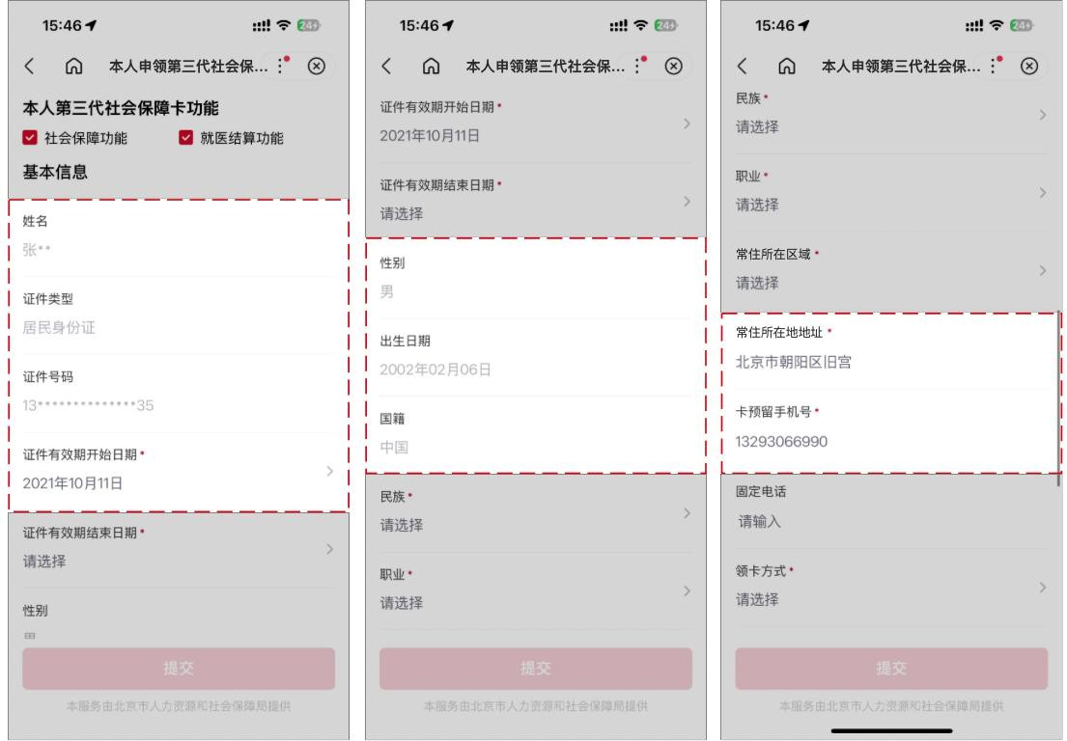

第六步：输入民族、职业、常住地所在区域三个必填项的内容。
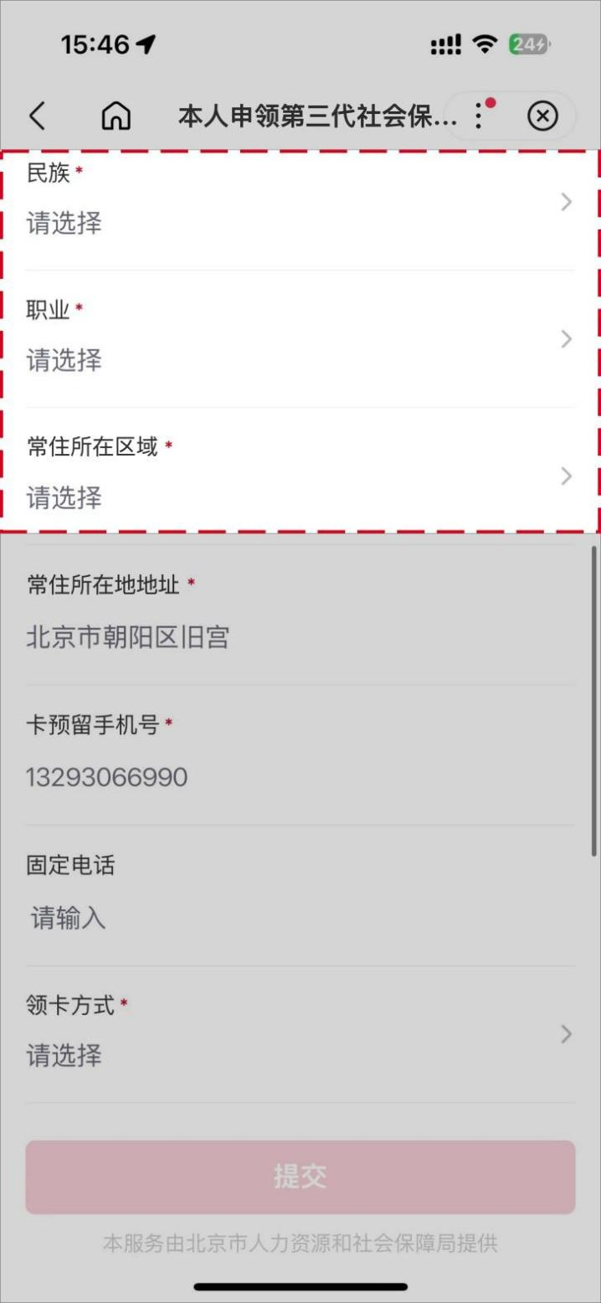
Step 6: Input the content of three mandatory fields: ethnicity, occupation, and the district of Permanent Residence.
第七步：填写领卡方式、发卡行名称、办卡网点，领卡方式可选择本人“个人网点领卡”和“银行邮寄”，若选择银行邮寄需完善收件人人姓名、收件人联系电话、收件地所在区、邮政编码、收件地所在区、收件详细地址等。
Step 7: Fill in the card-collection method, the name of the card-issuing bank, and the card-application branch. The card collection method can be "Collection at the Branch in Person" (个人网点领卡) or "Delivery by the Bank" (银行邮寄). If "Delivery by the Bank" is selected, it is necessary to complete the name and contact number of the recipient, the district of the mailing address, the postal code, and the detailed mailing address, etc.
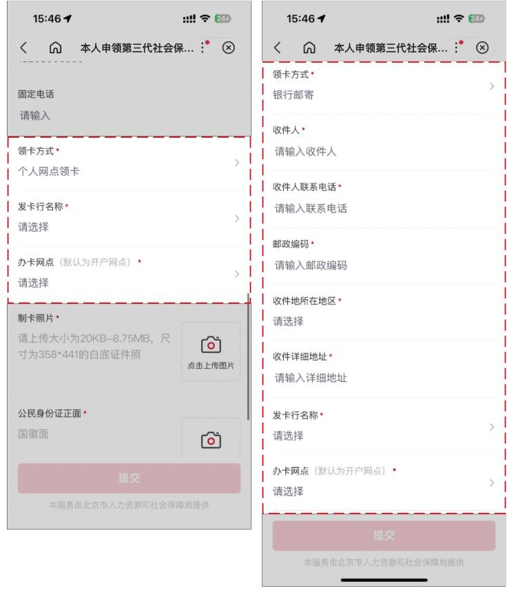

第八步：上传身份证正、反面原件照片，补充实体卡的制卡照片（照片要求：大小为 20KB-8.75M 以内，尺寸为 358*441）。
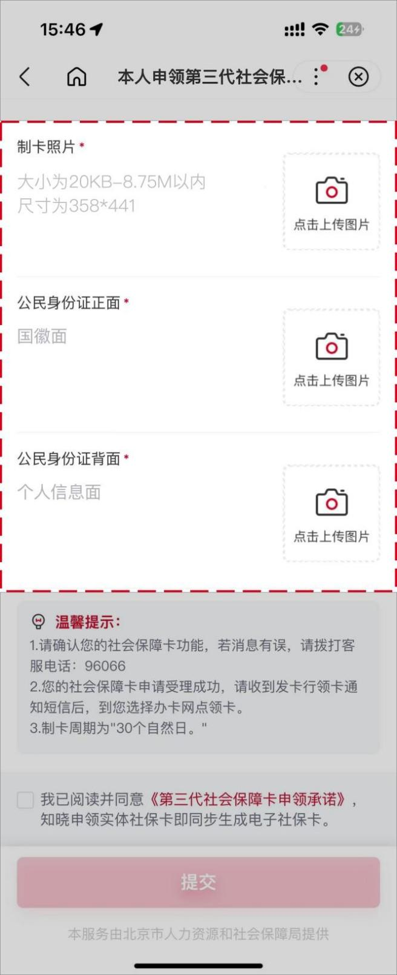
Step 8: Upload the photos of the front and back of the ID card, and supplement the photo for the physical card production (Photo requirements: size within 20KB – 8.75M, dimension of 358*441).
第九步：确认填写信息无误后勾选【我已阅读并同意】，并点击【提交】按钮，本人第三代社会保障卡申领操作。
Step 9: After confirming the filled information is correct, check "I have read and agree" (我已阅读并同意), and click the "Submit" (提交) button to complete the personal application for the third-generation social security card.
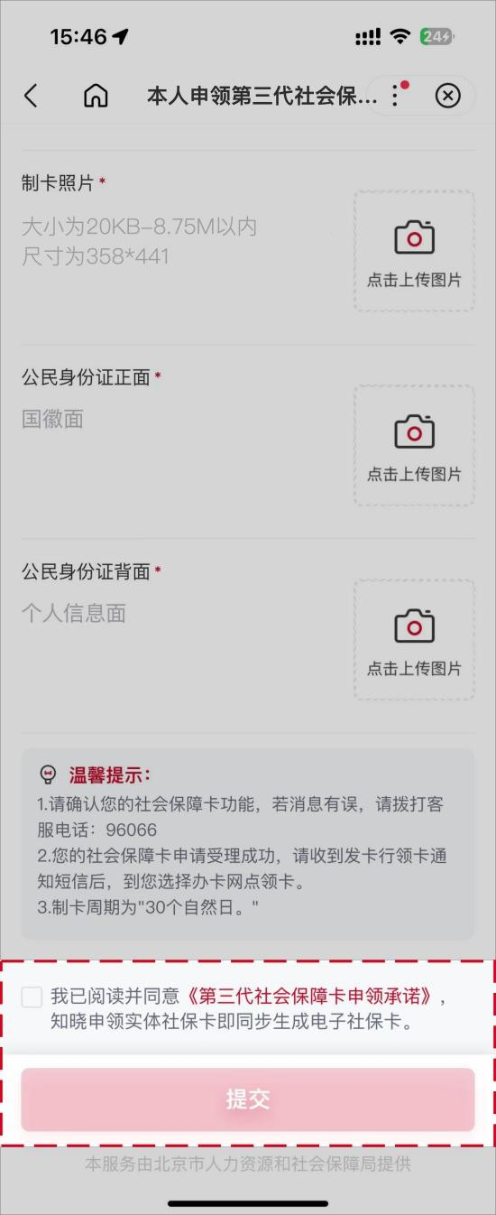
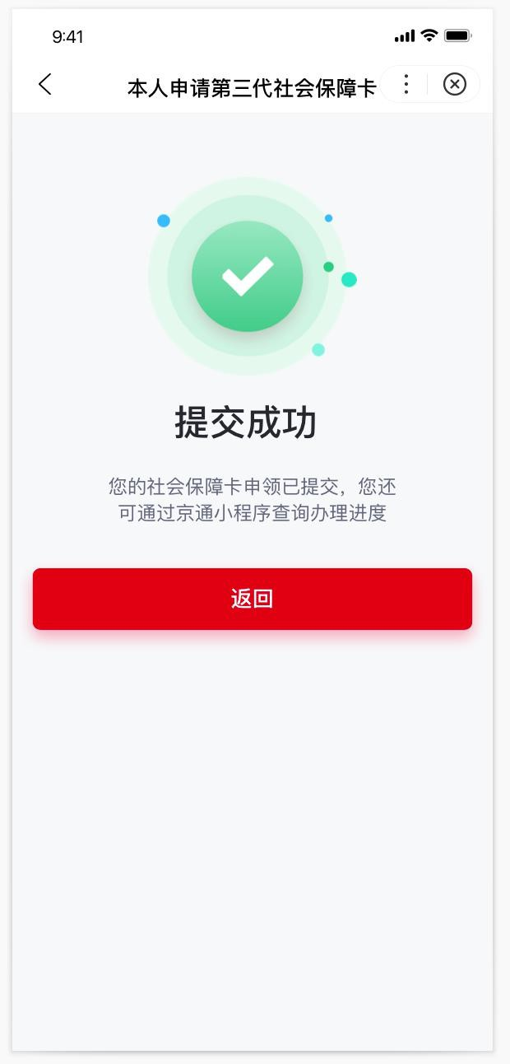

三、通过北京民生一卡通小程序进行个人参保人员申领第三代社会保障卡
III. Application for Third-Generation Social Security Card by Individual Insured Persons via Beijing Minsheng Yikatong (北京民生一卡通) Mini-program
第一步：通过微信扫描下方二维码或者微信搜索框选择小程序，输入“北京民生一卡通”，找到如下产品图标 icon，点击图标直接进入小程序。
Step 1: Scan the QR code below via WeChat or or search "北京民生一卡通" in WeChat to enter the mini-program.

北京民生一卡通微信小程序
Beijing Minsheng Yikatong WeChat Mini-Program

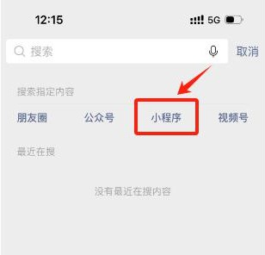


第二步：进入北京民生一卡通小程序后，进入首页社保卡页，顶部找到申请本人社会保障卡按钮，点击【申请本人社会保障卡】按钮进行申请。
Step 2: After entering the mini-program, enter the social security card page from the homepage, find the "Apply for My Social Security Card" (申请本人社会保障卡) button at the top, and click it to apply.
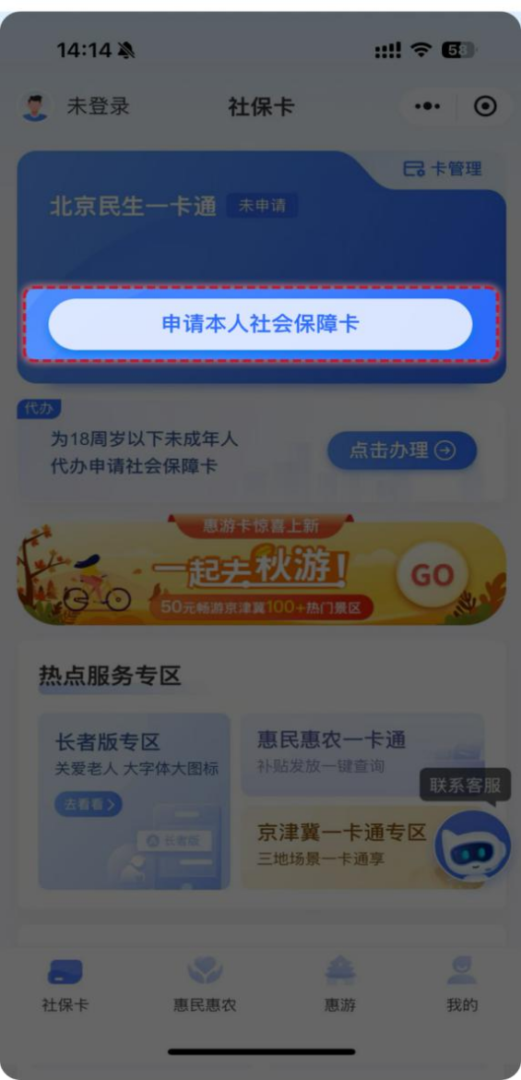

申请第三代社会保障卡前，用户需要完成登录和实名认证，才可以进行第三代社会保障卡的线上申领；若用户已完成上述操作，无需再次进行登录和实名认证，直接进入第三步申领卡流程页。
Before applying for the third-generation social security card online, users need to complete login and real-name authentication. Users that already completed the above operations do not need to log in and authenticate again; they can access directly to the application process page in Step 3.
登录：目前支持微信授权用户手机号快捷登录和手机号验证码登录两种方式。
Login: Two login methods are supported currently, respectively the swift login through WeChat-authorized user mobile number and the mobile number verification code login.
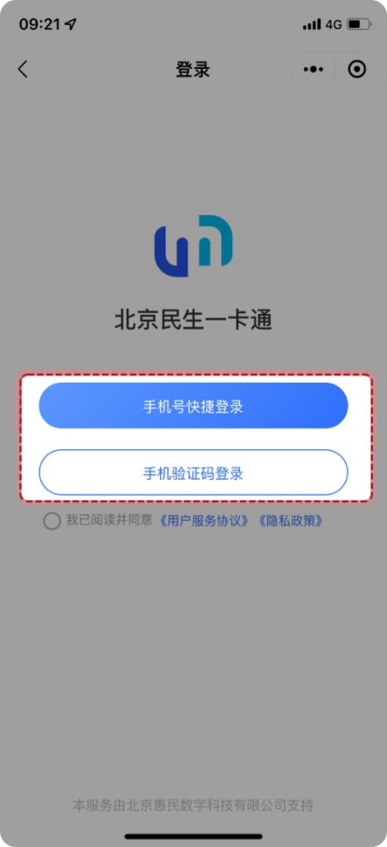

实名认证：需要输入姓名、身份证号并使用手机摄像头进行人脸核验，三要素保持一致才可通过实名认证。
Real-Name Authentication: Facial verification requires inputting the name, ID number, and using the mobile phone camera. The three elements must be consistent to pass the real-name authentication.
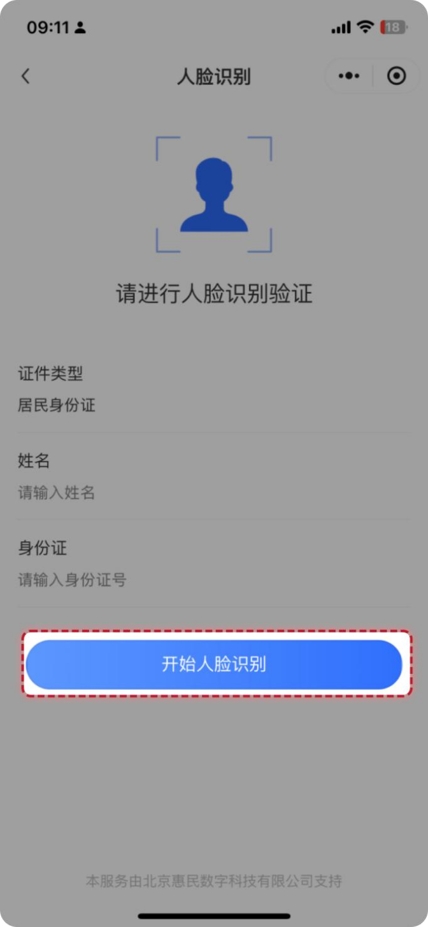

第三步：完成登录和身份认证的用户，点击【申请本人社会保障卡】按钮后，出现免责声明条款，阅读后勾选【我已阅读并同意免责声明】并点击【确定】，进入第四步本人申请信息填写页。
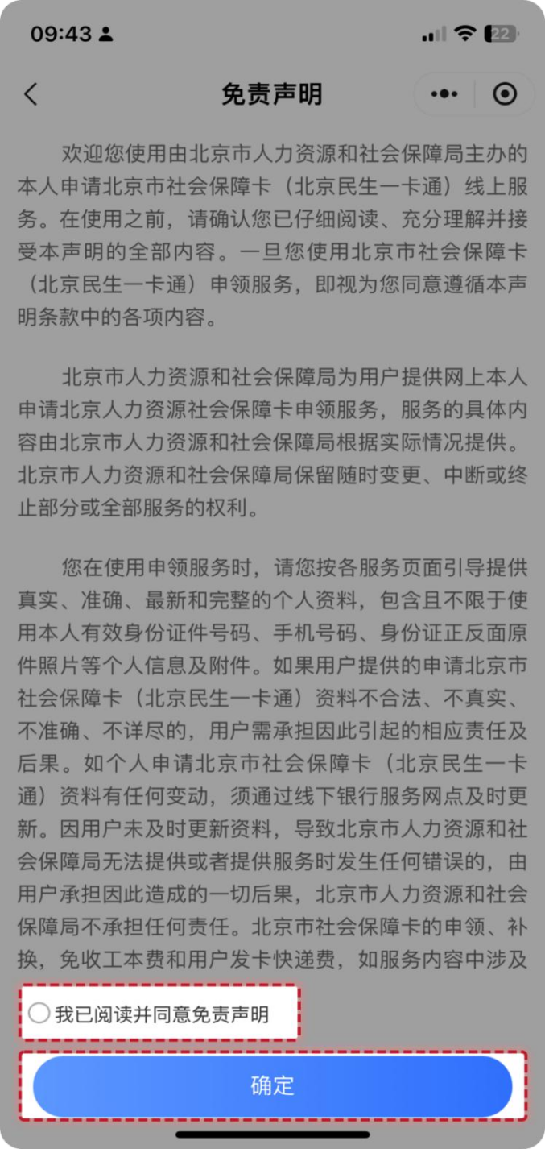
Step 3: After completing login and identity authentication and clicking the "Apply for My Social Security Card" (申请本人社会保障卡) button, the user will see a disclaimer appear. After reading it, check "I have read and agree to the disclaimer" (我已阅读并同意免责声明) and click "Confirm" (确定) to enter Step 4 for personal application information filling.
第四步：填写的本人申请信息依次是身份识别、基本信息、制卡信息和领卡方式。
Step 4: The personal application information to be filled comprises sequentially the identity recognition, basic information, card-making information, and card-collection method.
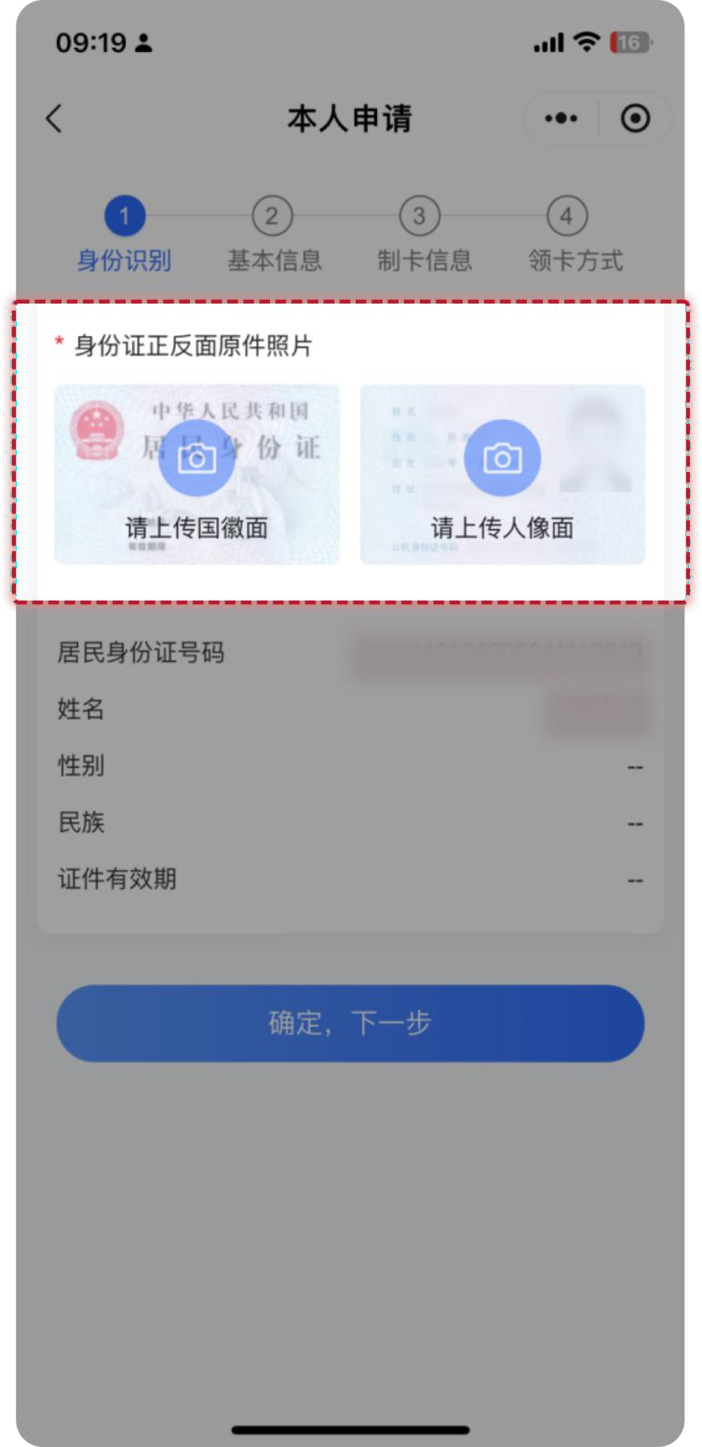
- 本人的身份识别页面，需要上传身份证正、反面原件照片，系统会自动识别上传的身份证照片中的姓名、民族、证件有效期等信息，并自动填写到页面中。核对无误后，点击【确定，下一步】进入下一步。
(1) Personal Identity Recognition Page: The photos of the front and back of the ID card are required to be uploaded. The system will automatically recognize the name, ethnicity, ID validity period and other information from the uploaded photos and fill them into the page. After verifying the information, click "Confirm, Next Step" (确定，下一步) to proceed to the next step.

- 本人的基本信息页面，需要输入本人的常住地所在区、常住所在地地址和职业三个必填项的内容。填写完成后，点击【确定，下一步】进入下一步。
(2) Personal Basic Information Page: The content of three mandatory fields are required to be filled in: the district of permanent residence, permanent residence address, and occupation. After completion, click "Confirm, Next Step" (确定，下一步) to proceed to the next step.
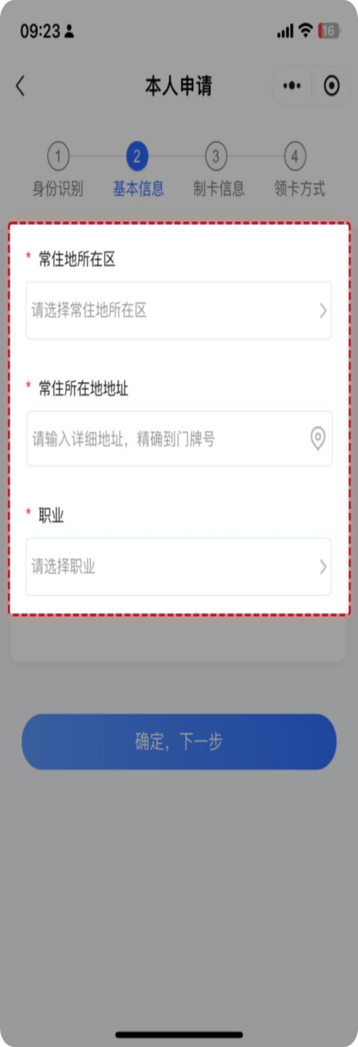
- 本人的制卡信息页面，需要上传本人制卡照片（照片要求：上传本人近期彩色免冠照片，保证真实有效，照片保持清晰完整，五官无任何遮挡，避免反光）、卡预留手机号、选择办卡银行、选择开户行网点等。填写完成后，点击
【确定，下一步】进入下一步。
(3) Card-making Information Page: Upload the photo for card-making (Photo requirements: A recent bareheaded color photo of the applicant. The photo should be authentic and effective, kept clear and complete, with the facial features unobstructed and glare avoided) and card-reserved mobile number, then select the card-application bank and the account opening branch, etc. After completion, click "Confirm, Next Step" (确定，下一步) to proceed to the next step.
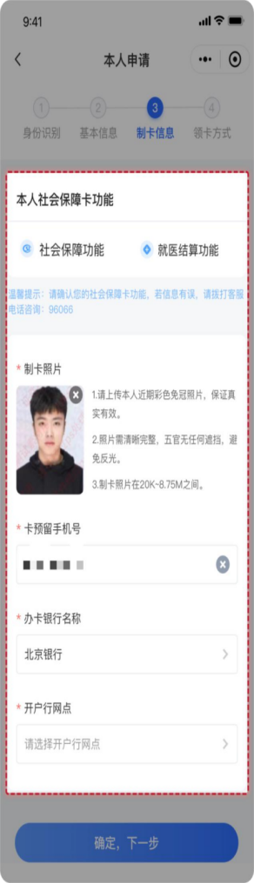
- 选择领卡方式，可选择本人“网点自取”和“银行邮寄”，若选择银行邮寄需完善邮寄接收人、接收人联系电话、邮寄接收地址等。
(4) Card-Collection Method: Choose "Collection at the Branch in Person" (网点自取) or "Delivery by the Bank" (银行邮寄). If "Delivery by the Bank" is selected, it is necessary to complete the information of the recipient, the recipient's contact number, and the receiving address, etc.

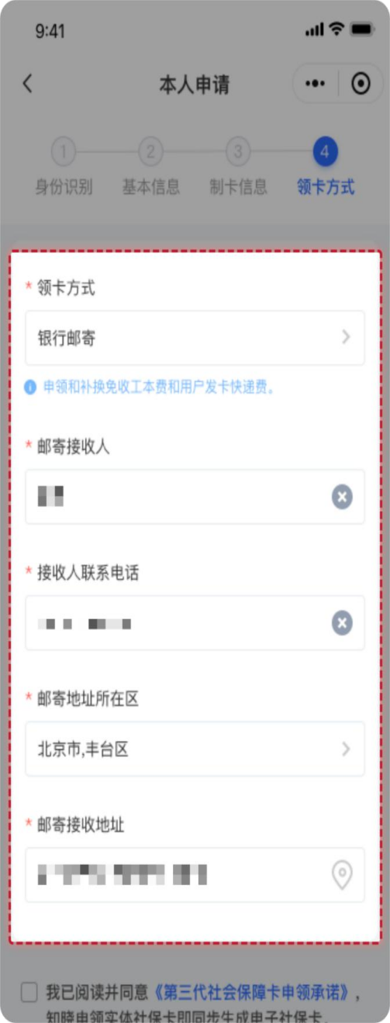

第五步：确认信息无误后勾选【我已阅读并同意】，并点击【确认提交】按钮，完成本人第三代社会保障卡申领操作。
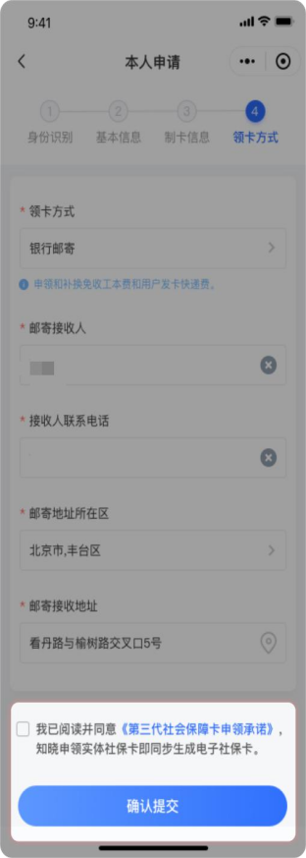
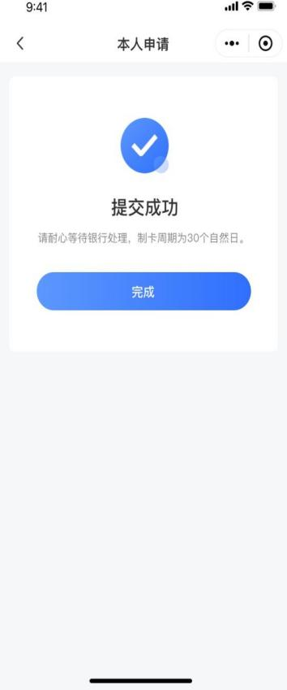
Step 5: After confirming the information is correct, check "I have read and agree" (我已阅读并同意), and click the "Confirm Submission" (确认提交) button to complete the personal application for the third-generation social security card.

京通小程序Jingtong Mini-Program
北京民生一卡通微信小程序 Beijing Minsheng Yikatong WeChat Mini-Program

