附件2
Attachment 2

北京市第三代社保卡18岁以下未成年人线上代办操作说明
Online Operating Instructions for Agents of Minors (Individuals Aged Under 18) Applying for Third-Generation Social Security Cards in Beijing

一、通过北京市人力资源和社会保障局官网进行18岁以下未成年人代办第三代社会保障卡
I. Application for Third-Generation Social Security Card for Minors (Individuals Aged Under 18) via the Official Website of the Beijing Municipal Bureau of Human Resources and Social Security.
登录北京市人力资源和社会保障局官网，依次点击【热点服务】-【我要办社保卡】，进行申领操作。
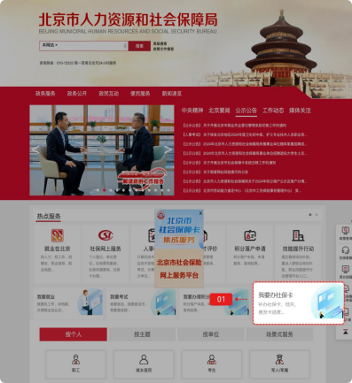
Log in to the official website of the Beijing Municipal Bureau of Human Resources and Social Security. Click "Most-requested Services" (热点服务) - "I want to apply for a social security card" (我要办社保卡) to start application.
登录方式包括如下几种：
The login methods include:
- 扫码登录
用户可选择扫码登录，使用微信、支付宝或百度端“京通”小程序扫码登录，如下图：
(1) QR Code Login: Users may choose QR code login. Use the "Jingtong" (京通) Mini-Program on WeChat, Alipay, or Baidu app to scan the QR code for login as follows.
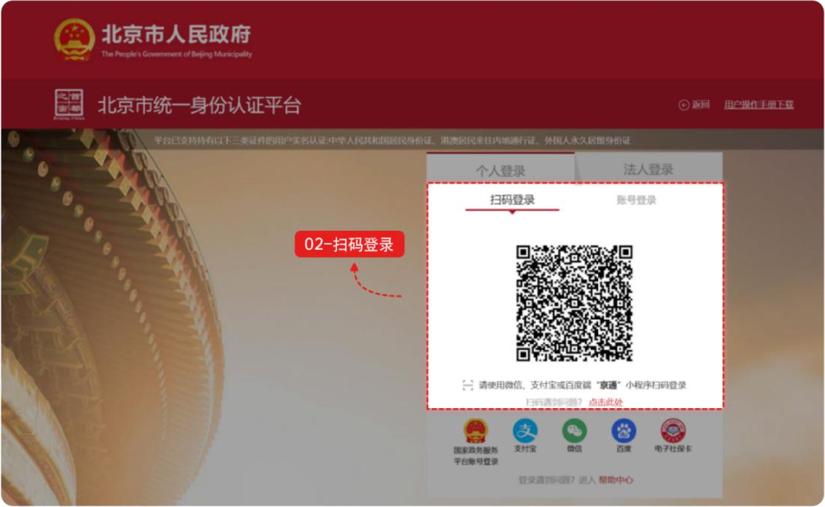
- 账号登录
用户可选择账号登录，输入用户名/手机号/身份证号、密码和图形验证码，点击【登录】，如下图：
(2) Account Login: Users may log in through an account. Enter the username/mobile number/ID number, password, and graphical verification code, then click "Login" (登录), as followed.
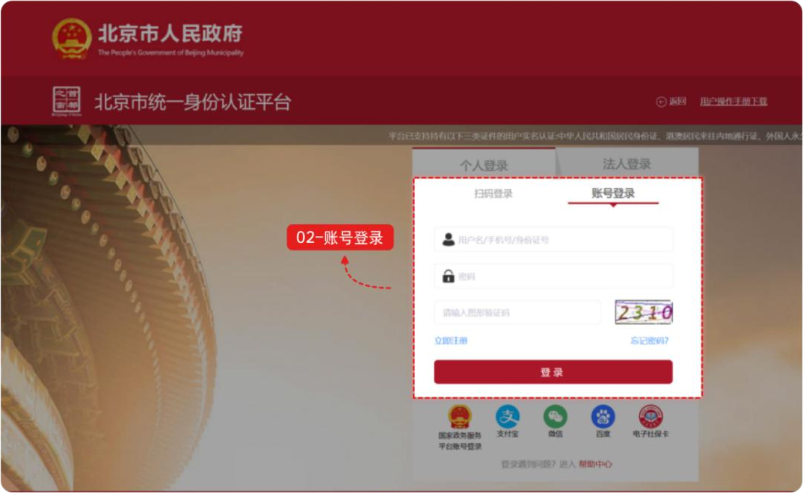

- 其他渠道登录
用户可选择国家政务服务平台账号登录，或者支付宝、微信、百度、电子社保卡进行登录。
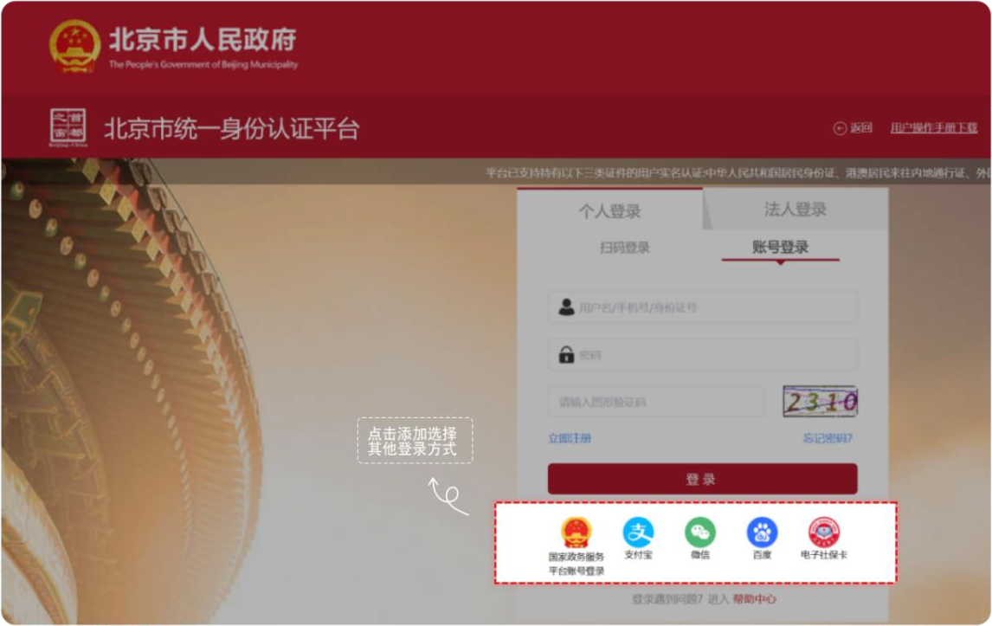
(3) Login Through Other Channels: Users may log in with a National Government Service Platform account, or via Alipay, WeChat, Baidu, or Electronic Social Security Card.

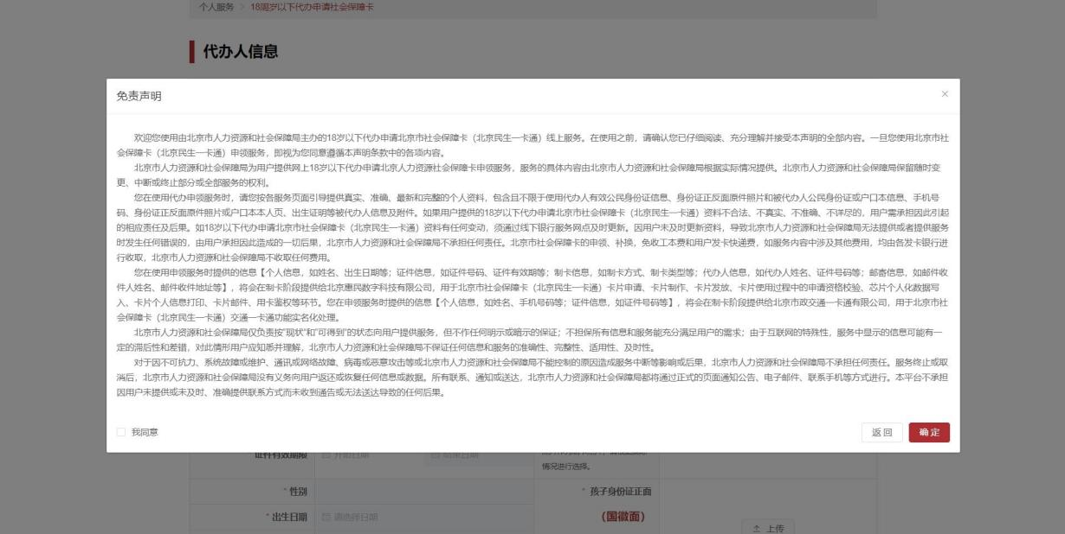
登录网厅后，在第三代社会保障卡服务中，点击【18周岁以下代办申领社保卡】，出现免责声明弹框。免责声明阅读后勾选【我同意】，点击【确定】。

点击【确定】后，进入18周岁以下代办申领社保卡信息填写页面。
After logging in to the web portal, click "Application of social security card for minors aged under 18" (18周岁以下代办申领社保卡) in the section of "third-generation social security card services" (第三代社会保障卡服务). A disclaimer pop-up will appear. After reading it, check "I Agree" (我同意) and click "Confirm" (确定) to enter the information filling page.
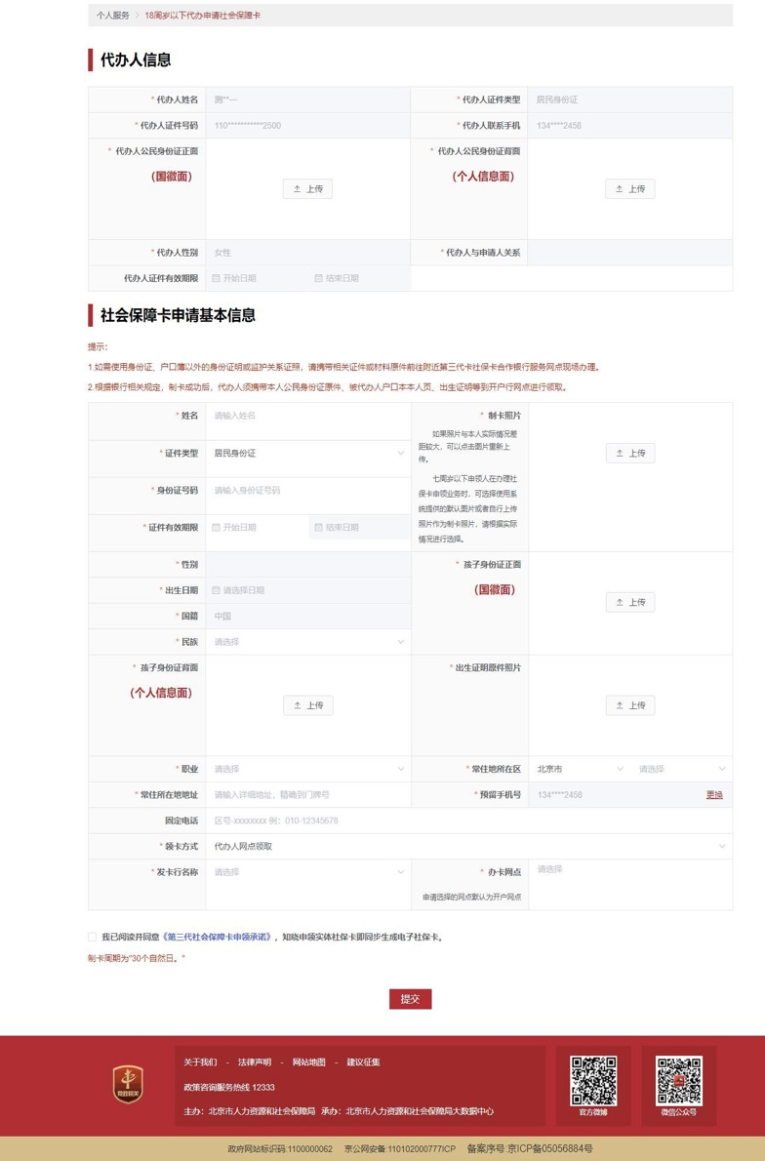

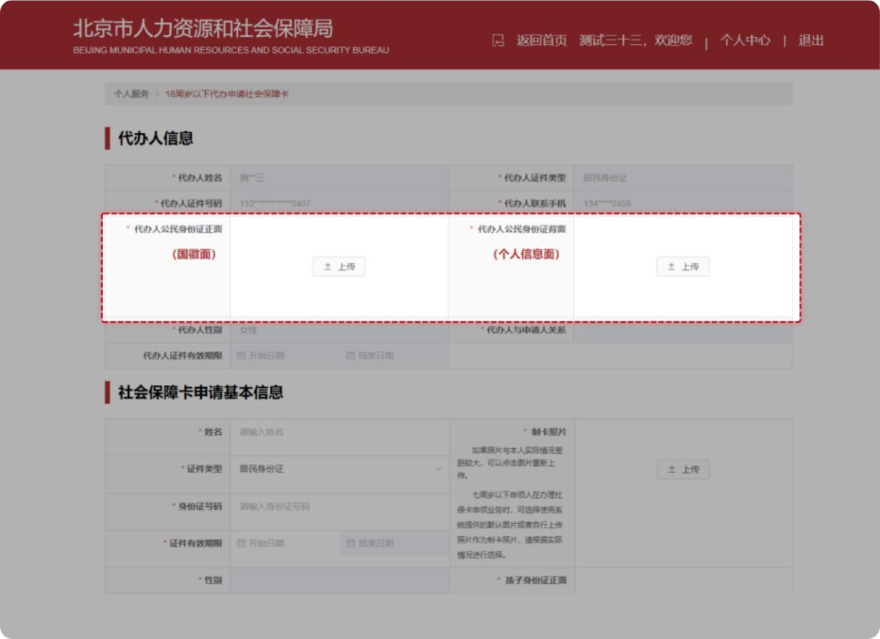
上传“代办人公民身份证正面（国徽面）”、“代办人公民身份证背面（个人信息面）”。
Upload the photocopy of the front (the national emblem side) and back (the personal information side) of the agent's ID Card.
输入孩子“姓名”、选择“证件类型”、输入“身份证号码”后，弹出提示：您与被代办人的关系是XX，请确认。
Enter the child's name, select the ID Type, and enter the ID number. A prompt will appear, requiring you to confirm the relationship between you and the applicant.
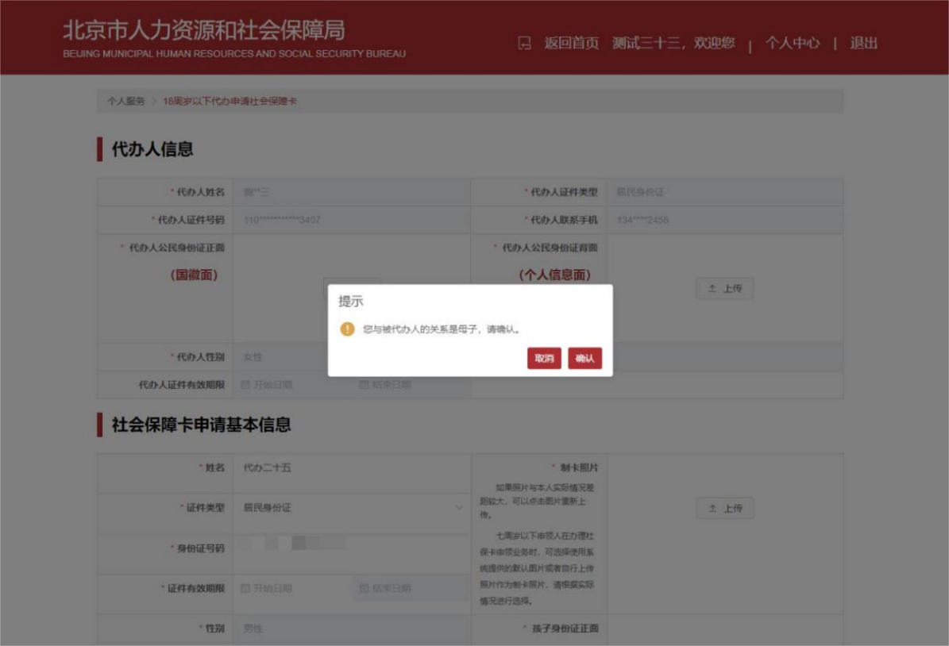

点击【确认】后，您与孩子的关系展示在：代办人与申请人关系选项中，不允许修改。
After clicking "Confirm" (确认), the relationship is displayed in "relationship between the agent and applicant" (代办人与申请人关系) and cannot be modified.
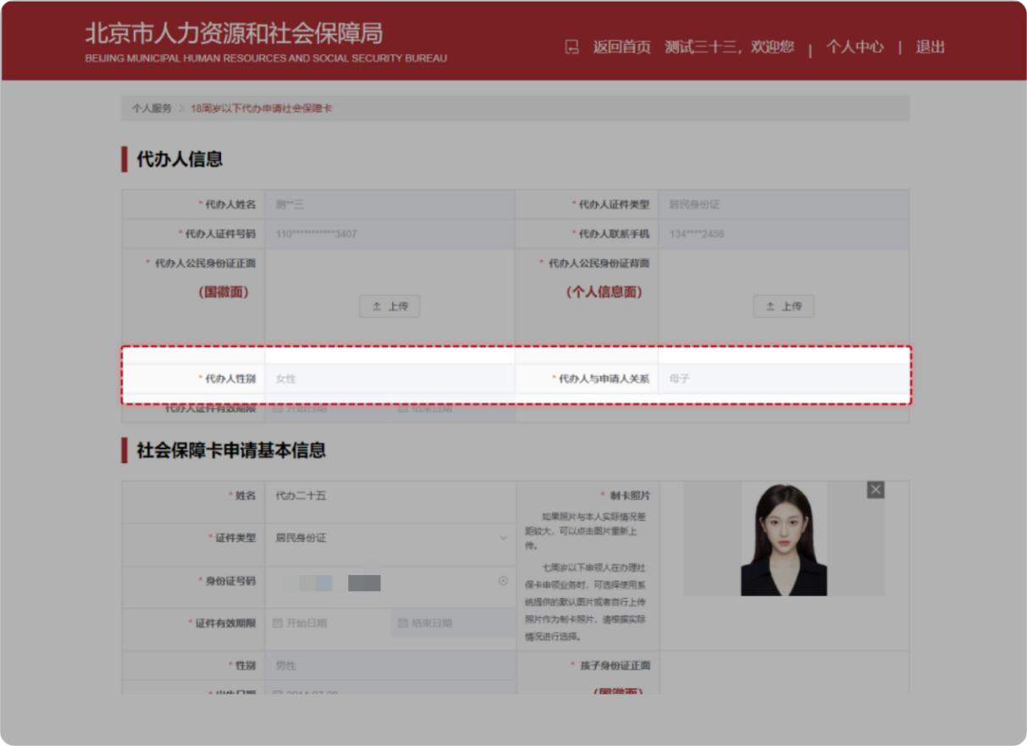

若选择申请人的“证件类型“为“居民身份证”，需要上传申请人的身份证正、反面照片原件、出生证明原件照片。
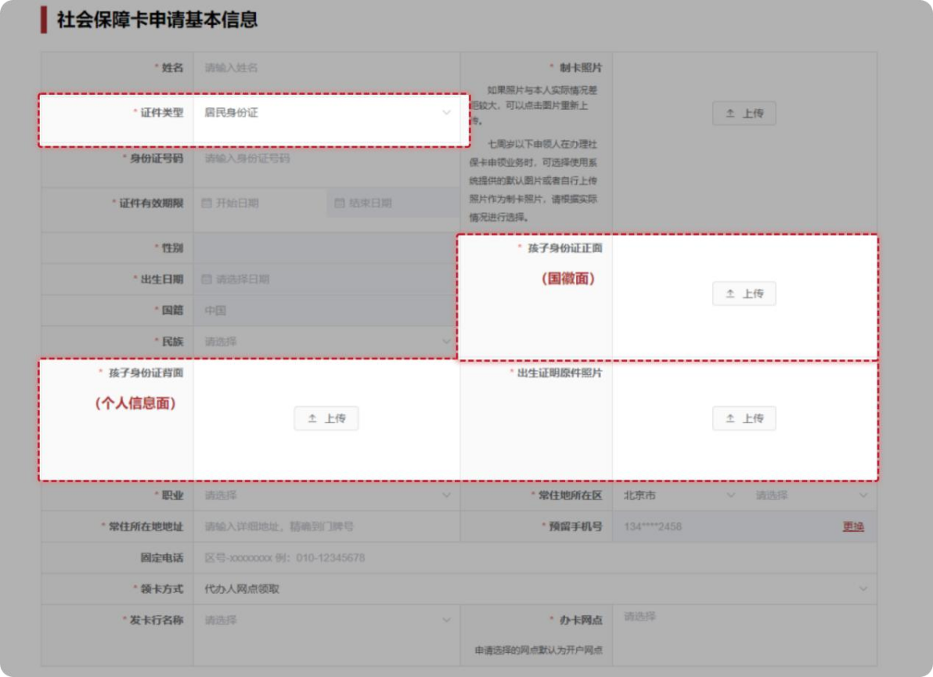
If the ID type chosen for the applicant is the Resident ID Card, the photos of the front and back of the applicant's ID card and of the original birth certificate should be uploaded.

若选择申请人的“证件类型“为“户口本”，根据“代办人和户主关系”上传相应的材料：
- 代办人是户主：上传户主页，选择“代办人和孩子是否在一个户口本上”，上传孩子页户口页、户主本人页。

- 代办人不是户主：上传户主页，选择“代办人和孩子是否在一个户口本上”，上传孩子页户口页、出生证明原件照片。
If the ID type chosen for the applicant is the Household Registration Booklet, materials should be uploaded according to the relationship between the agent and applicant:
If the agent is the householder, upload the photo of the householder's registration page, select whether the agent and the child are registered in the same booklet, and upload the photos of the child's household register page and the householder's page.
If the agent is not the householder, upload the photo of the householder's registration page, select whether the agent and the child are registered in the same booklet, and upload the photos of the child's household registration page and the origin Birth Certificate.
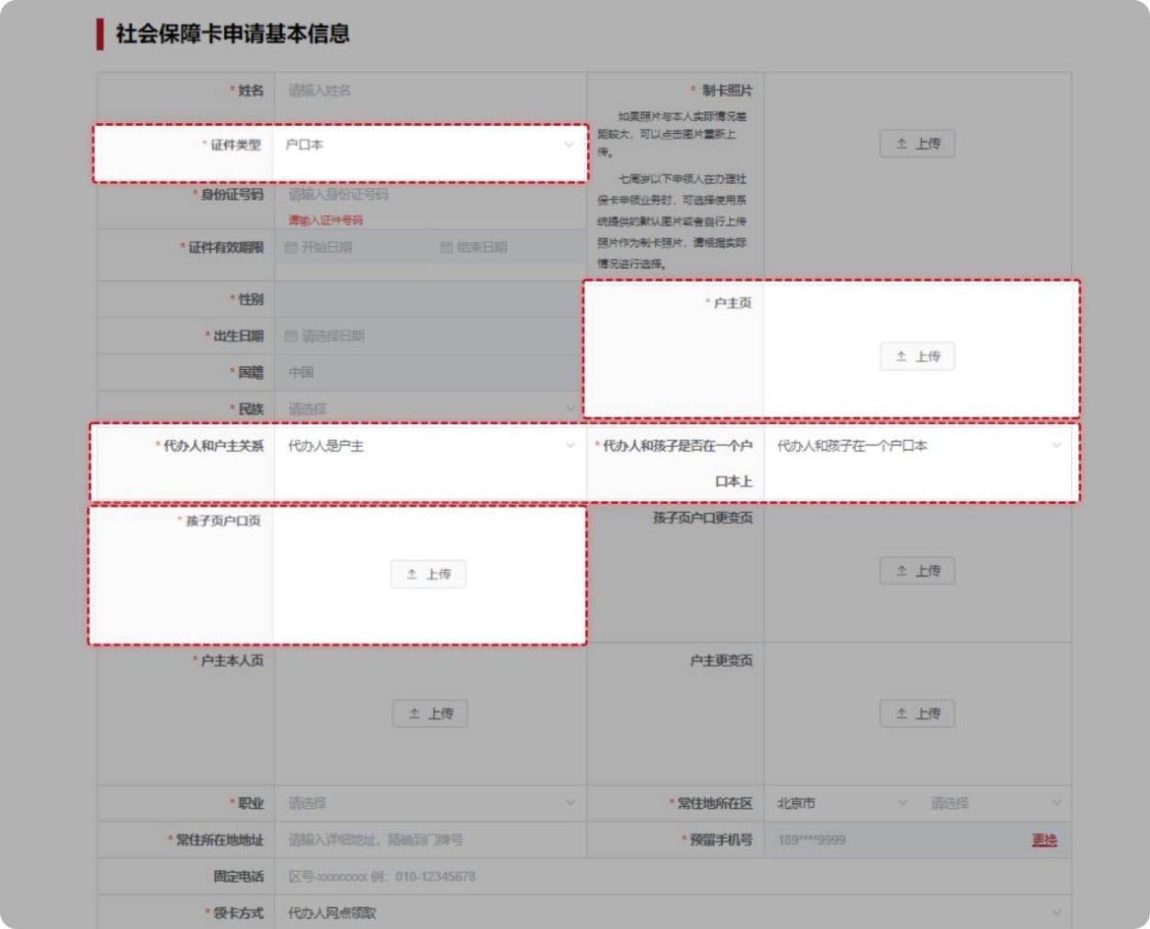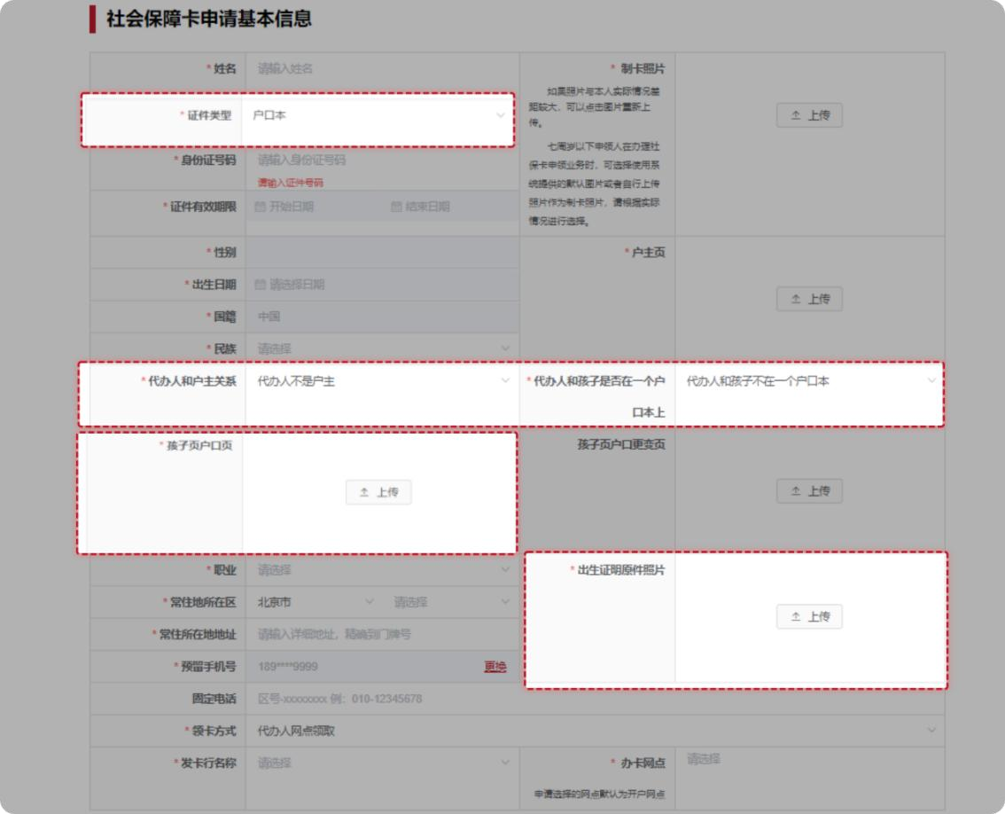

录入补录信息：申请人制卡照片、民族、常住地所在区、常住所在地地址、领卡方式（仅支持代办人网点领取）、发卡行名称及办卡网点等信息。
Enter the Supplementary Information:
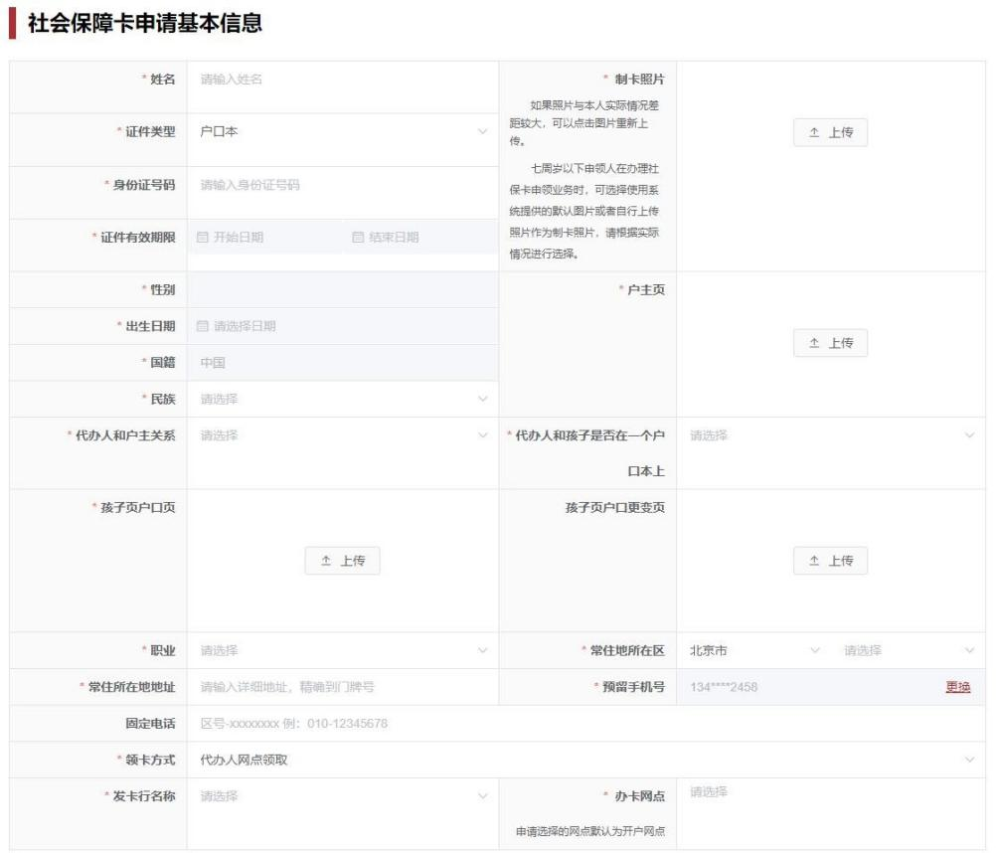
The photo of the applicant for card-making, the applicant's ethnicity, the district and address of the applicant's permanent residence, the card collection method (only "collection by the agent at a branch" is supported), name of the card issuing bank, and the card application branch.
信息全部完善后勾选【申请人郑重承诺】，点击【提交】。
After completing all information, check "Applicant Solemnly Promises" (申请人郑重承诺) and click "Submit" (提交).
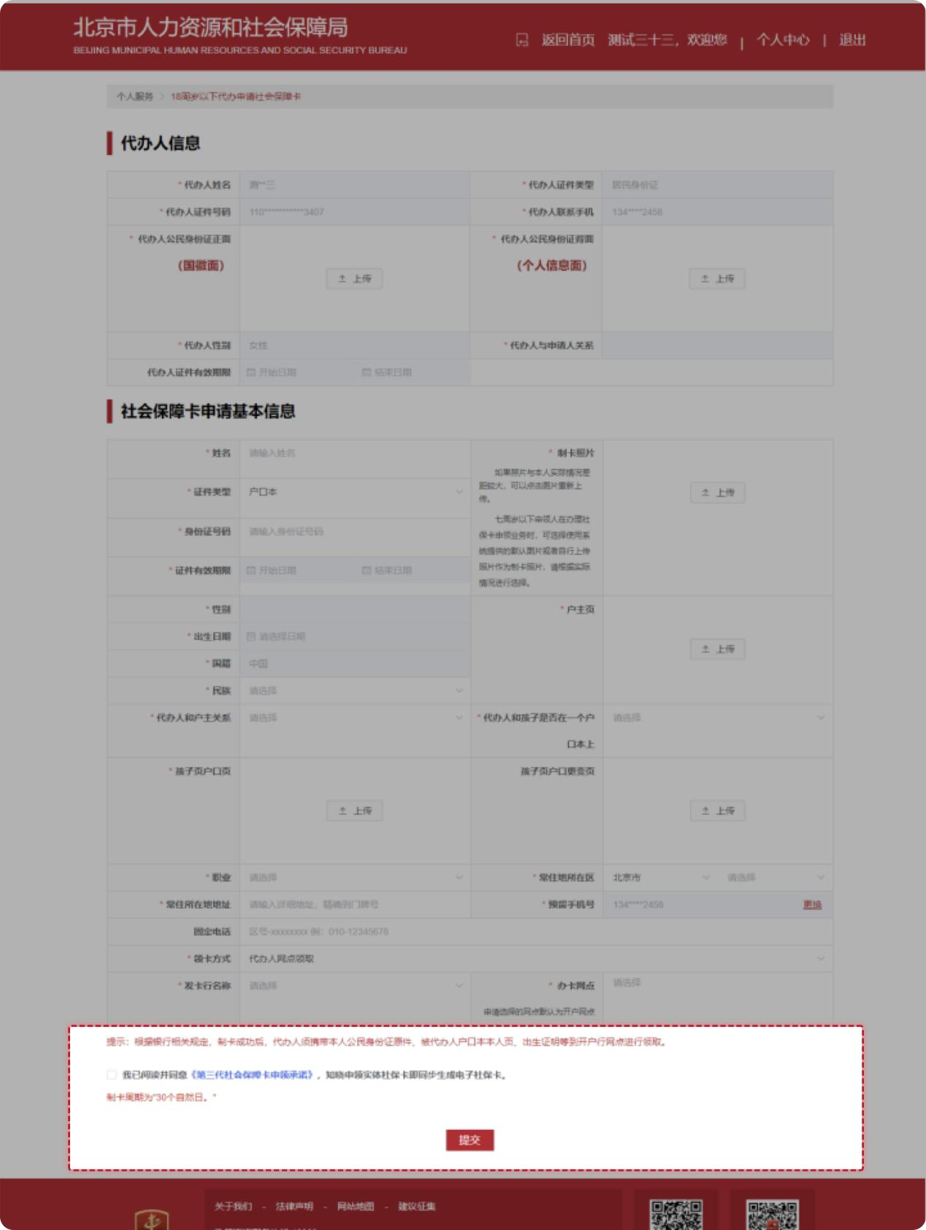

二、通过“京通”小程序进行18岁以下未成年人代办第三代社会保障卡。
II. Application for Third-Generation Social Security Card for a Minor Aged under 18 via "Jingtong" (京通) Mini-Program
第一步：通过微信、支付宝、百度搜索京通，进入京通小程序或者直接扫描下方二维码进入京通-第三代社会保障卡专区。
Step 1: Search for "Jingtong" (京通) on WeChat, Alipay, or Baidu to enter the mini-program, or directly scan the QR code below to access the "Jingtong - Third-Generation Social Security Card" section (京通-第三代社会保障卡专区).

京通-第三代社会保障卡专区
Jingtong – Third-Generation Social Security Card Section

微信：WeChat

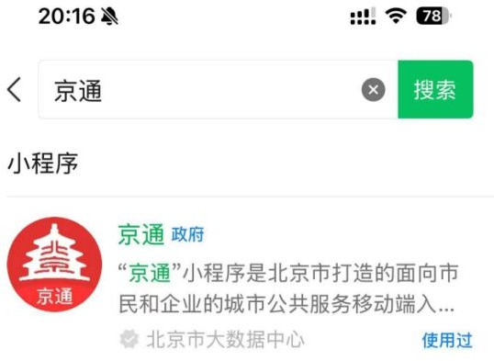
支付宝：Alipay
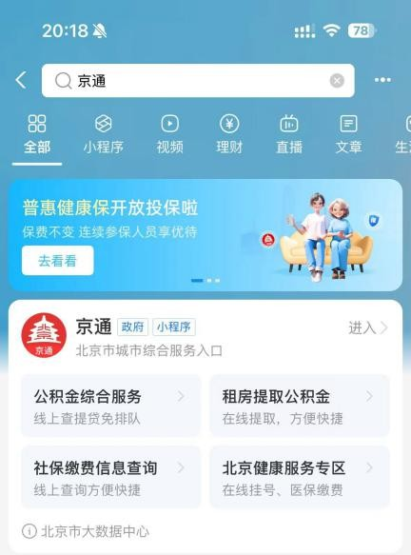

百度：Baidu

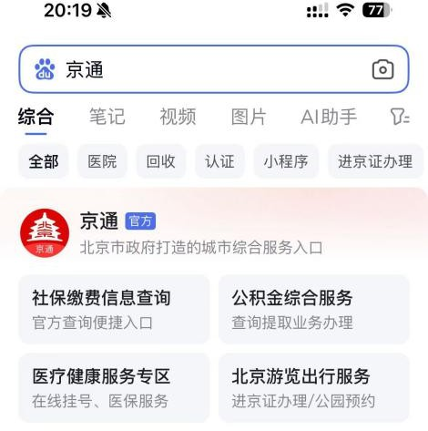

第二步：进入京通小程序后，首页特色服务找到第三代社会保障卡图片，点击【第三代社会保障卡】图片。
Step 2: On the Jingtong homepage, find the "Third-Generation Social Security Card" (第三代社会保障卡) image in the Featured Services section and click it.
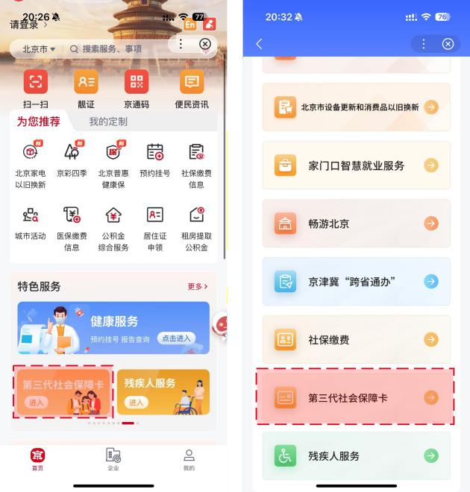
登录：第三代社会保障卡页面需要登录认证后进入，在此页面【勾选】同意，点击开始人脸识别，识别成功进入第三代社会保障卡页面。
Login: To enter the Third-Generation Social Security Card section, login and authentication are required. Check the agreement box on this page and click to start facial recognition. Upon successful recognition, enter the Third-Generation Social Security Card section.
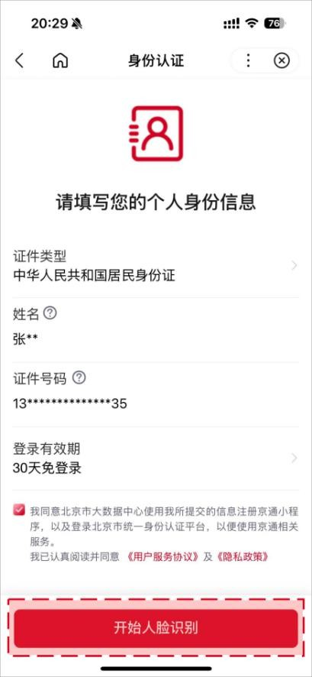
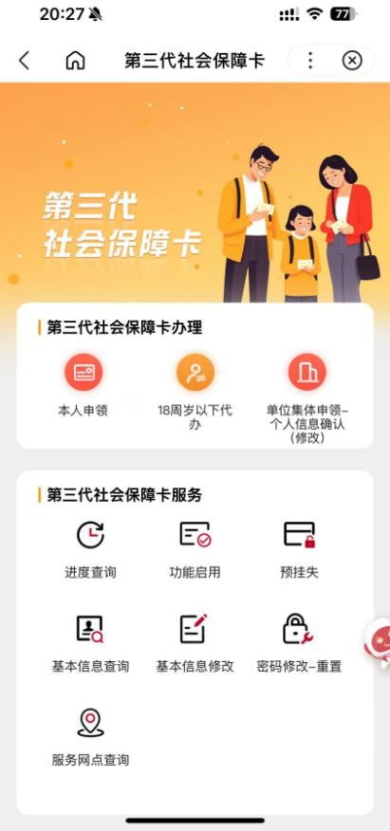
第三步：完成登录进入页面的用户，点击【18 岁以下代办】按钮，进入免责声明页，阅读后勾选【我同意】并点击
【确定申领】，进入代办申请信息填写页。
Step 3: Users who have logged in and entered the section may click the "Application for Minors Aged Under 18" (18 岁以下代办) button to enter a disclaimer page. After reading it, check "I Agree" (我同意), click "Confirm Application" (确定申领), and proceed to the information submission page.

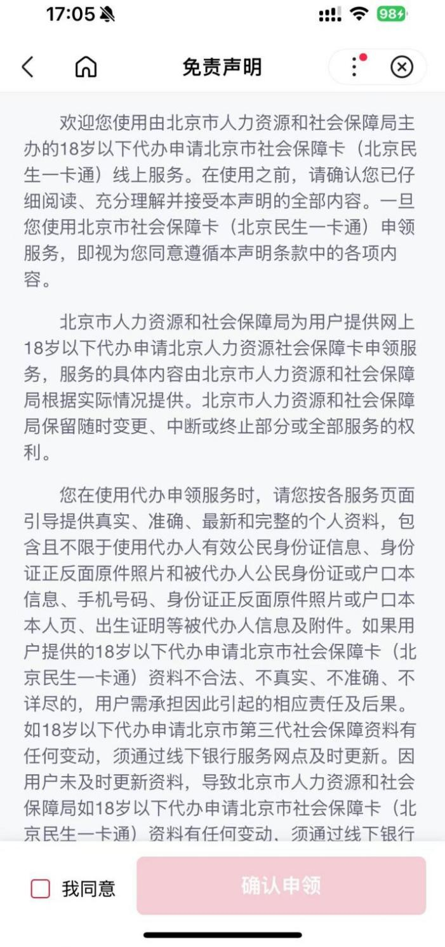

第四步：填写被代办人姓名、证件类型、证件号码，勾选【访问授权】，点击【开始资格校验】按钮，校验人员是否可以进行申领。
Step 4: Enter the applicant's name, ID type, and ID number. Check "Access Authorization" (访问授权) and click "Start Eligibility Verification" (开始资格校验) to verify if the agent is eligible to apply.
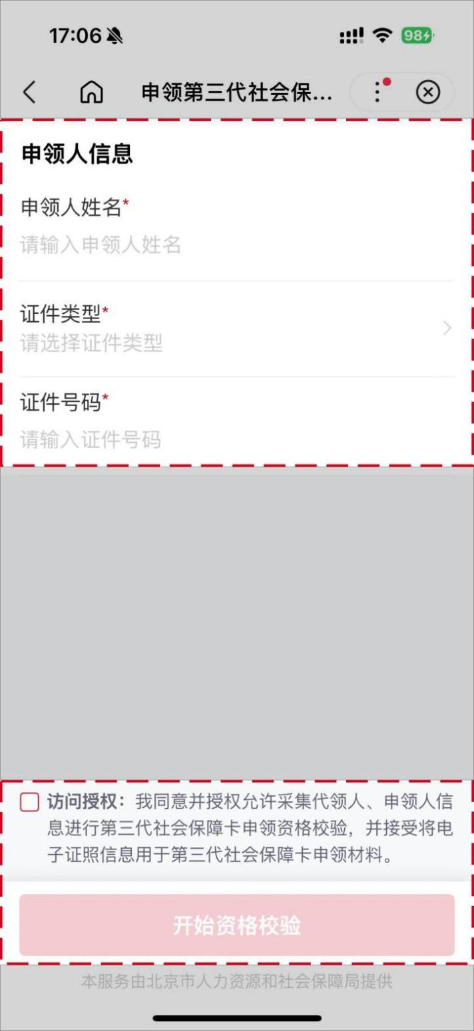

第五步：代办人姓名、代办人证件类型、代办人证件号码、代办人性别、代办人联系手机信息显示，检查显示信息是否正确。并上传被代办人身份证正、背面照片，点击【下一步】按钮。
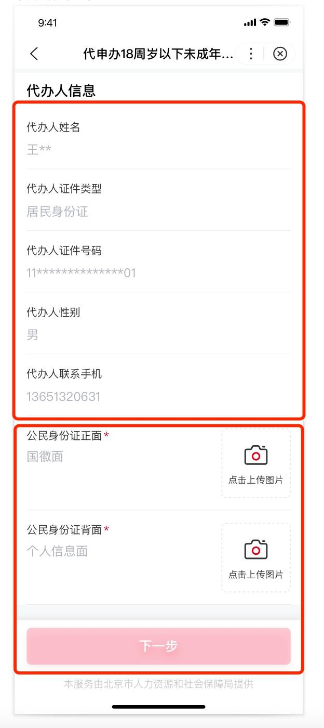
Step 5: Verify the displayed information of the agent (name, ID type, ID number, gender, contact number). Upload the photos of the front and back of the applicant's ID card. Click "Next" (下一步).
第六步：用户个人基本信息（姓名、证件类型、证件号码、性别、出生日期、国籍、卡预留手机号），检查显示信息是否正确。
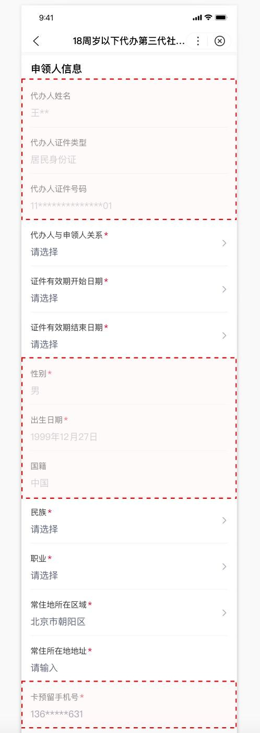
Step 6: Verify the applicant's basic information displayed (name, ID type, ID number, gender, date of birth, nationality, card-reserved mobile number).
第七步：申领人信息选择的证件类型选择为“居民身份证”，需选择“代办人与申领人关系”“证件有效期开始日期”“证件有效期结束日期”信息。若申领人证件类型选择为“户口本”，需选择“代办人与申领人关系”“代办人是否为户主”“证件有效期开始日期”“证件有效期结束日期”信息。
Step 7:
If applicant's ID type is the "Resident ID Card" (居民身份证), enter "relationship between the agent and applicant," (代办人与申领人关系) "start date of the ID Validity," (证件有效期开始日期) and "end date of the ID Validity" (证件有效期结束日期).
If applicant's ID type is the "Household Registration Booklet" (户口本), besides the information above, the agent also needs to answer if the agent is the householder.
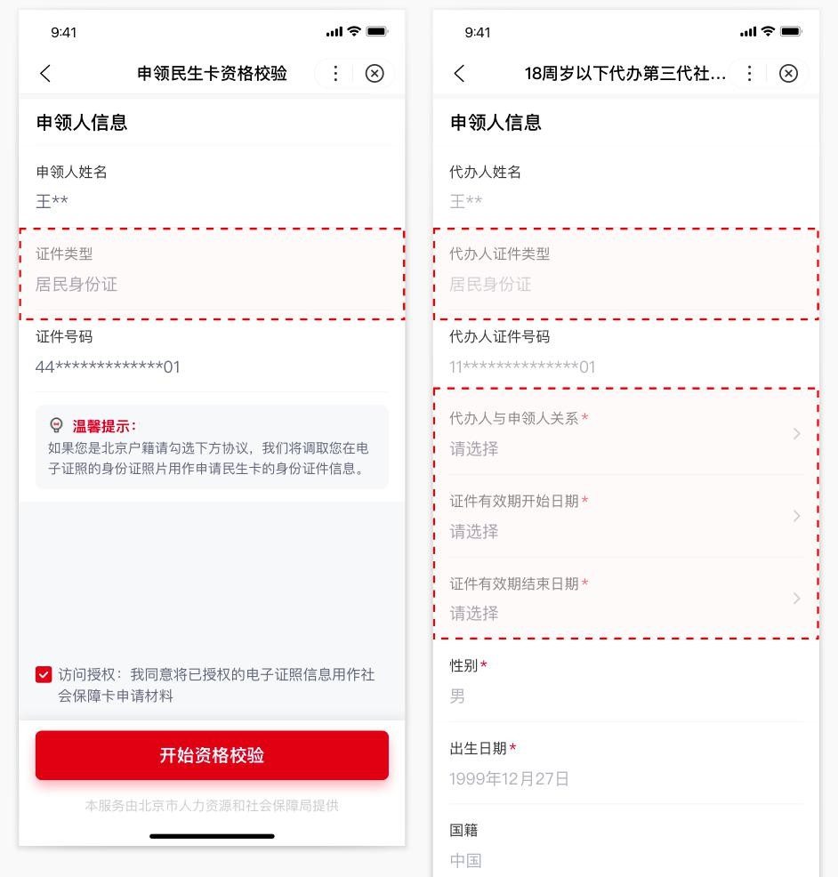

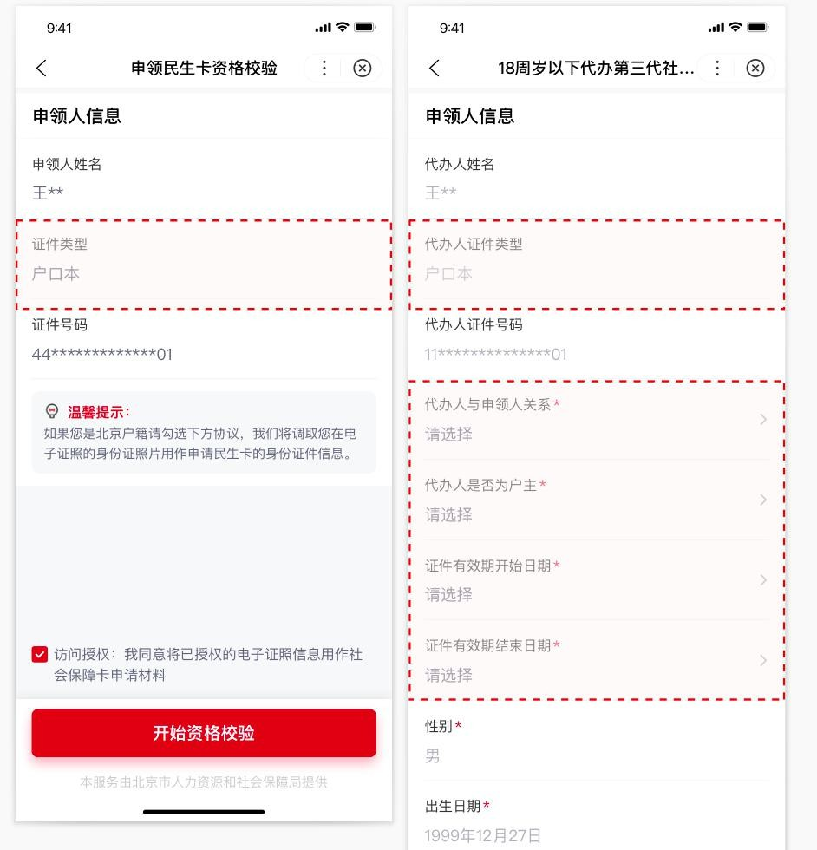

第八步：输入民族、职业、常住地所在区域和常住所在地地址四个必填项的内容。
Step 8: Enter mandatory contents including ethnicity, occupation, district of permanent residence, and permanent residence address.
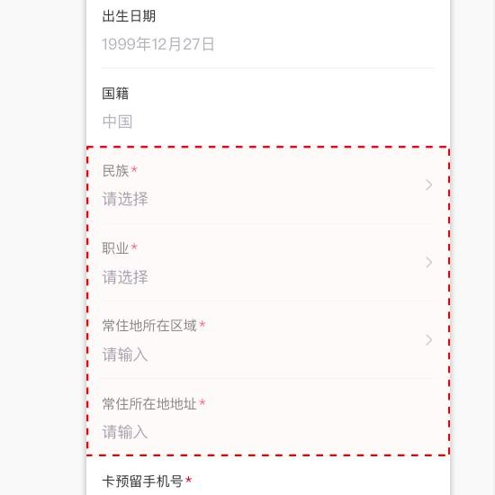

第九步：填写领卡方式、发卡行名称、办卡网点，领卡方式，18 岁以下子女代办业务领卡方式只支持：个人网点领卡。
Step 9: Fill in the card collection method, the name of the issuing bank, and the branch of application. "Collection at the branch in person" is the only supported collection method for applications for minor children aged under 18.

第十步：被代办人的制卡信息，需要上传被代办人本人制卡照片（子女小于 7 岁可以使用系统提供的默认卡通照片作为制卡照片）。
Step 10: Upload the applicant's information for card-making. A card-making photo of the applicant is required (The default cartoon photo provided by the system can be used as the card-making photo if the child is younger than 7 years old).
- 被代办人证件类型若选择“居民身份证”，需上传身份证正、背面，申请人出生证明材料。
(1) If the ID type of the applicant has been selected as the "Resident Identity Card" (居民身份证), upload the front and back of the ID card and the applicant's birth certificate.

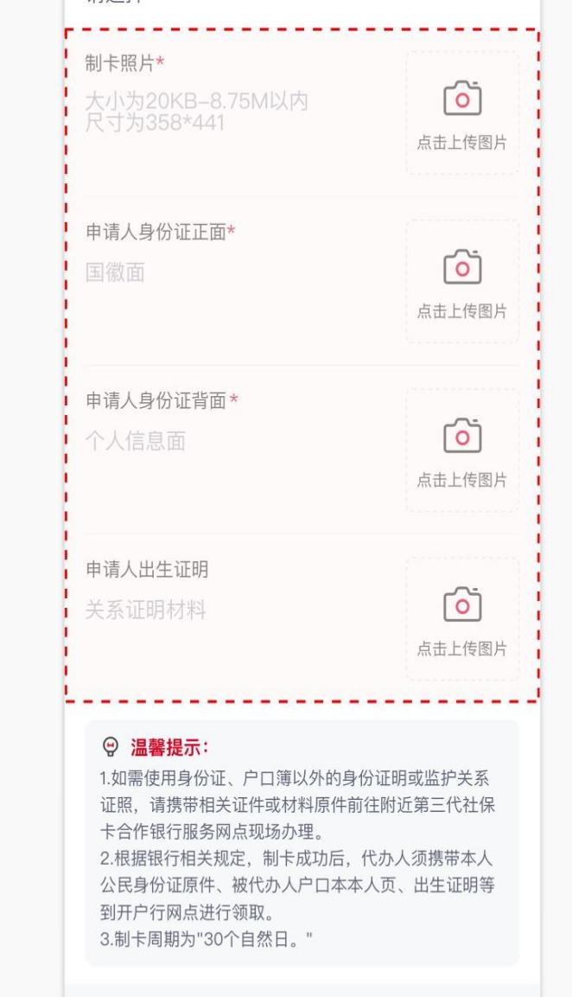
- 被代办人证件类型若选择“户口本”，代办人是否为户主选择“否”，需上传户口本首页、申请人户口本本人页、申请人户口本本人页背面、申请人出生证明材料。
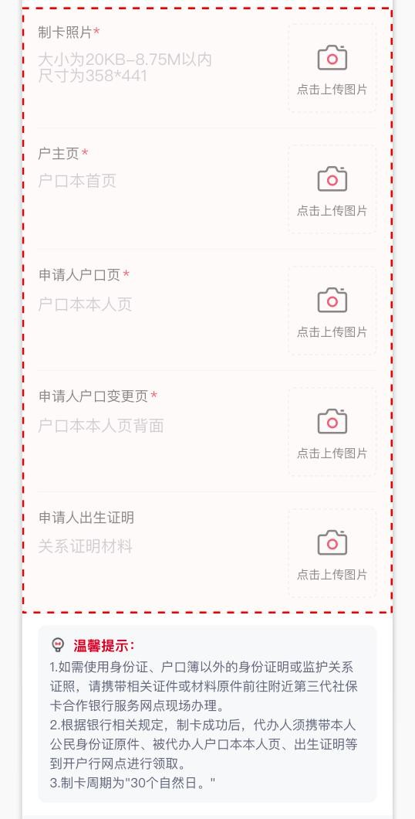
(2) If the ID type of the applicant has been selected as the "Household Registration Booklet" (户口本), and the agent is not the householder, upload the first page, the applicant's page, and the back side of the applicant's page of the Household Registration Booklet, and the applicant's Birth Certificate.
- 被代办人证件类型若选择“户口本”，代办人是否为户主选择“是”，需上传户口本首页、申请人户口本本人页、申请人户口本本人页背面、户主本人页、户主本人页背面。
(3) If the ID type of the applicant has been selected as the "Household Registration Booklet", and the agent is the householder, upload the first page, the applicant's page and its back, and the householder's page and its back of the Household Registration Booklet.
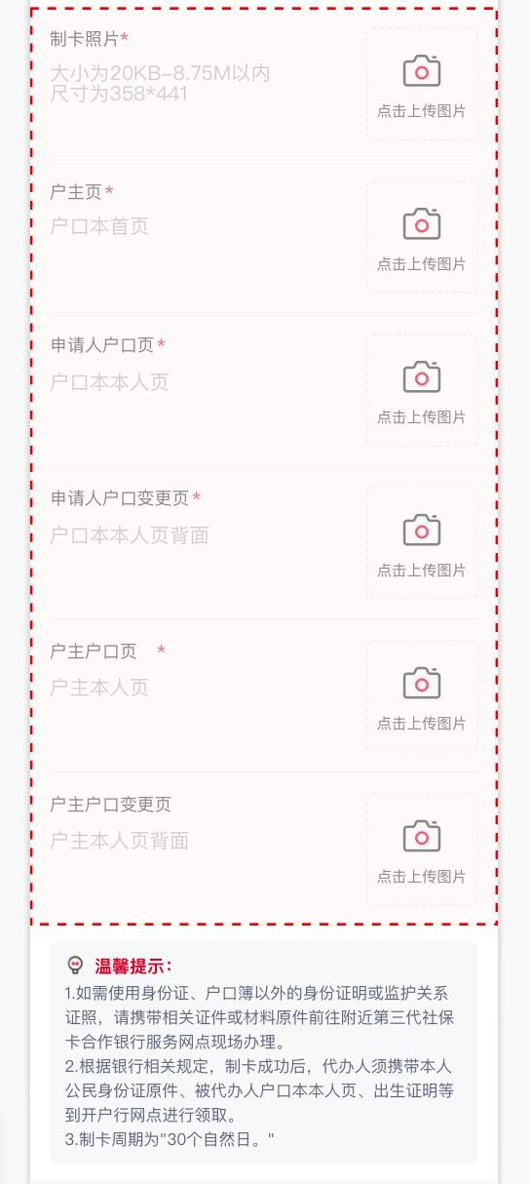

第十二步：确认填写信息无误后勾选【我已阅读并同意】，并点击【提交】按钮，完成 18 岁以下子女代办第三代社会 保障卡的申领操作。
Step 11: After confirming the information, check the box "I have read the Promise and agree with it" (我已阅读并同意) and click "Submit" (提交) to complete the application for the Third-Generation Social Security Card for children under 18 years old.
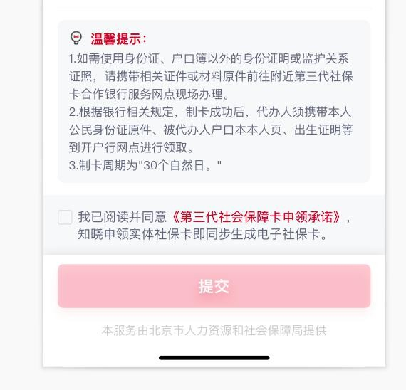
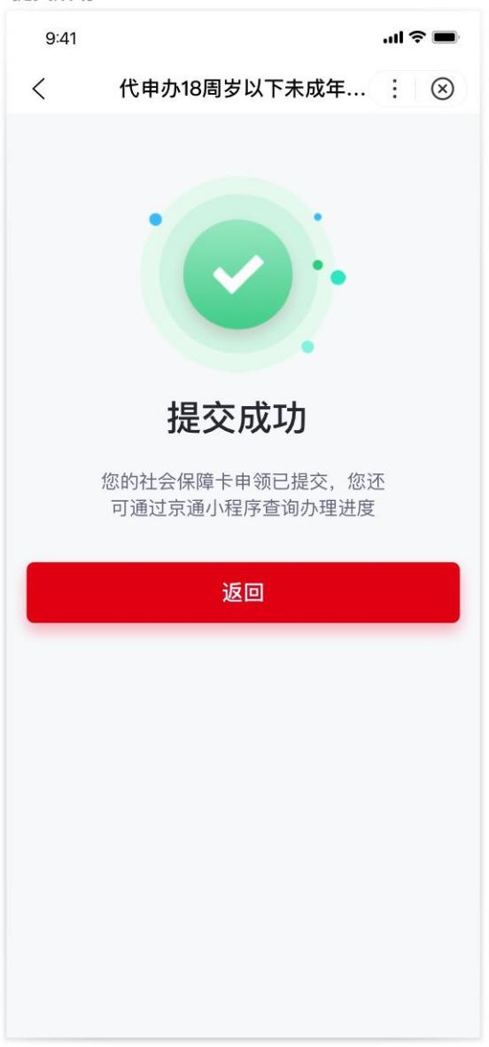

三、通过北京民生一卡通小程序进行18岁以下未成年人代办第三代社会保障卡
3. Application for Third-Generation Social Security card for Minors Aged Under 18 through the Beijing Minsheng Yikatong (北京民生一卡通) Mini-Program
第一步：通过微信扫描下方二维码或者微信搜索框选择小程序，输入“北京民生一卡通”，找到如下产品图标 icon，点击图标直接进入小程序。
Step 1: Scan the QR code below or search "北京民生一卡通" in WeChat to enter the mini-program.


北京民生一卡通微信小程序
Beijing Minsheng Yikatong

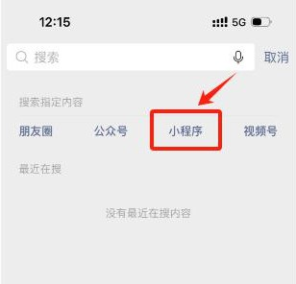



第二步：进入北京民生一卡通小程序后，展示首页社保卡页，点击代办卡片区域，进入代办申请流程页面。
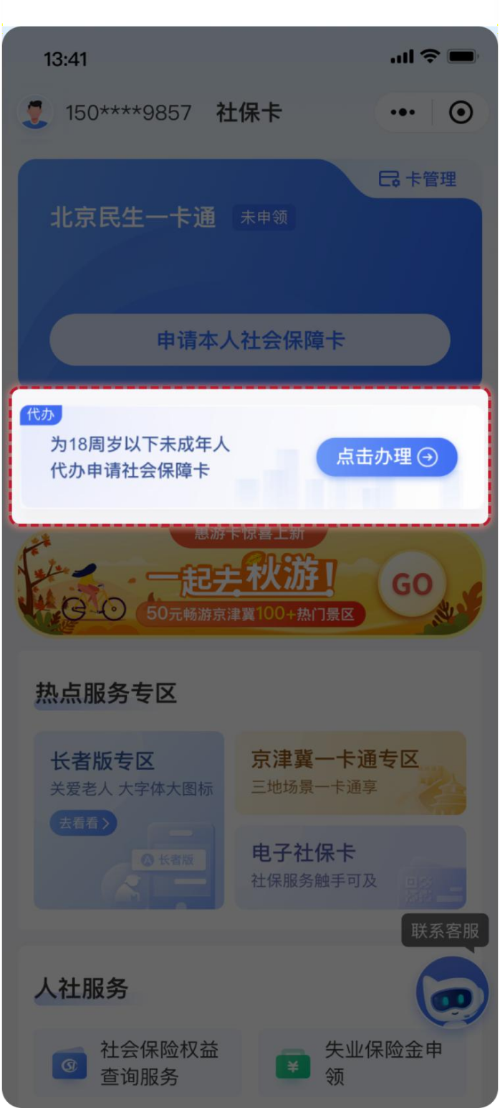
Step 2: After entering the mini-program, the homepage will display the social security card page. Click on the area of the card application and enter the page for application processes.

进入代办申请流程页面，用户需要完成登录和实名认证后，才可以进入；若用户已完成上述操作，无需再进行登录和实名认证，直接进入第三步代办申请流程页面
To enter the application page, the user needs to complete the login and real-name authentication. If the user has already completed these steps, proceed directly to Step 3.
登录：目前支持微信授权用户手机号快捷登录和手机号验证码登录两种方式。
Login: Two login methods are supported currently: quick login via WeChat-authorized mobile number and mobile number login with verification code.

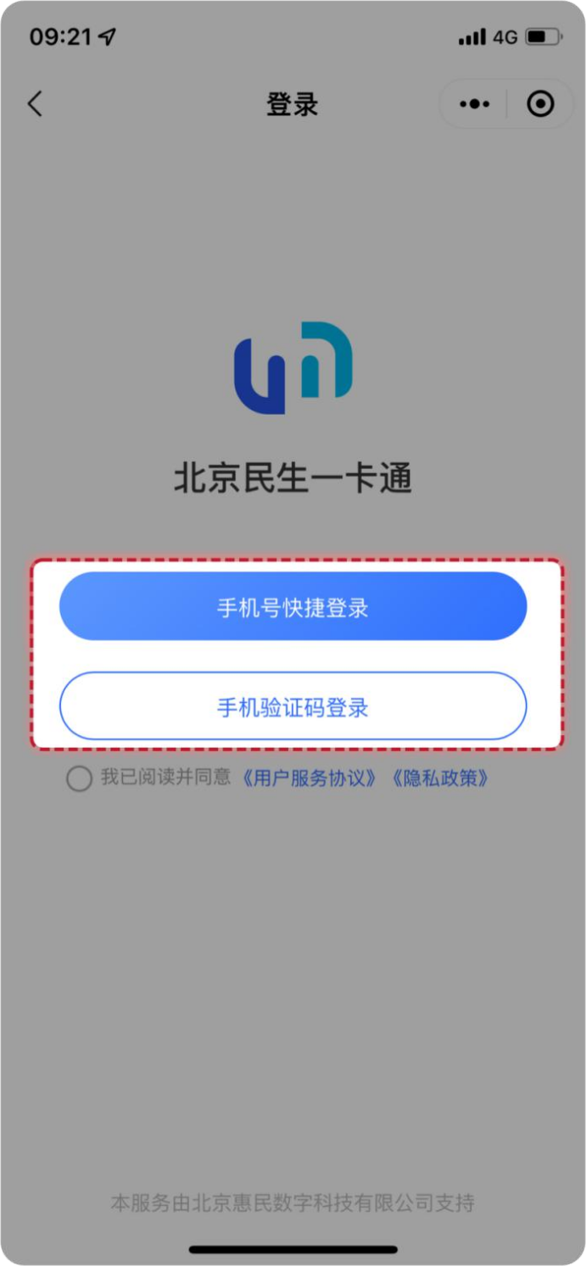

实名认证：需要输入姓名、身份证号并使用手机摄像头进行人脸核验，以上信息保持一致才可通过实名认证。
Real-Name Authentication: Enter the name and ID number, then complete facial verification. The information above must be consistent to pass the authentication.
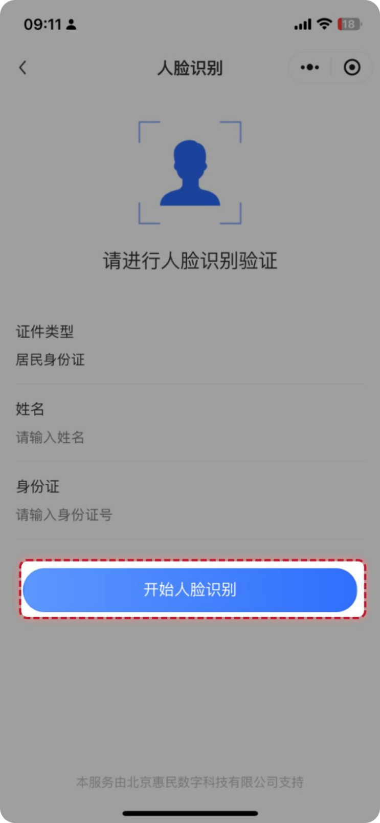

第三步：完成登录和身份认证的用户，进入代办申请流程页面，点击代办卡片区域，需要再次点击【去代办】的二次弹框确认。

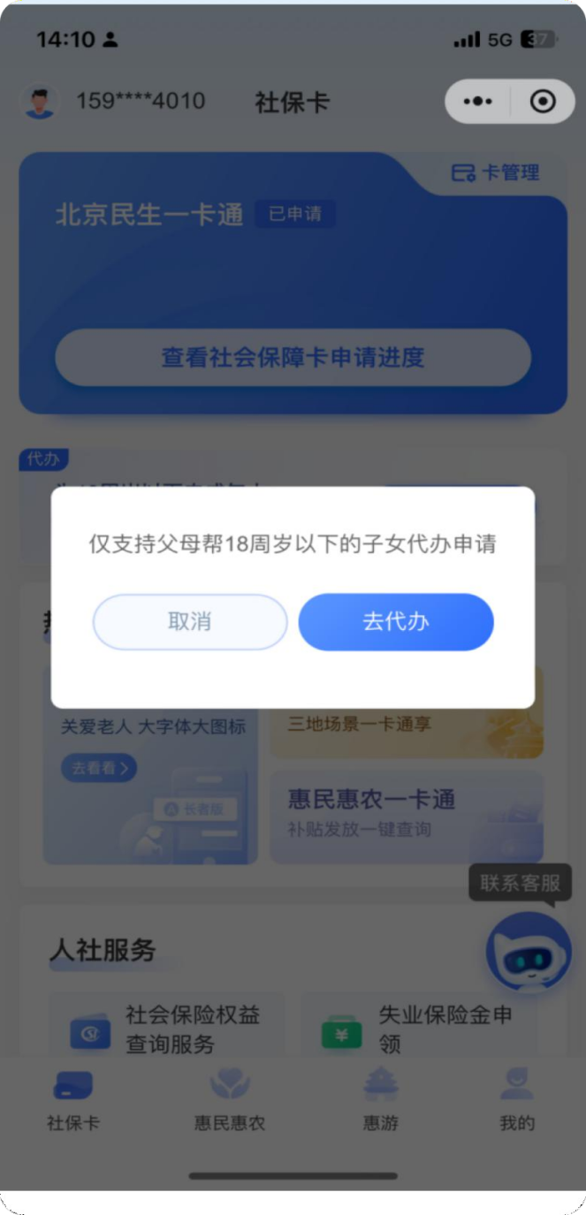
Step 3: After login and authentication, the user may proceed with the application. Click on the area of the card application and confirm on the pop-up again.
第四步：进入信息确认流程，出现免责声明条款，阅读后勾选【我已阅读并同意免责声明】，点击【确认】后进入代办申请信息填写页。
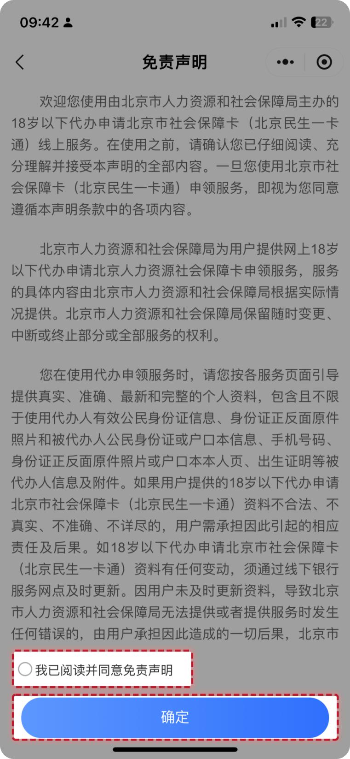
Step 4: Enter the information confirmation process, the disclaimer terms will appear. After reading, check "I have read the disclaimer and agree to it" (我已阅读并同意免责声明) and click "Confirm" (确定) to enter the detailed page for personal information confirmation.
第五步：填写代办申请信息，依次是代办人（父母）的身份识别、被代办人（子女）的基本信息、被代办人（子女）的制卡信息和确认领卡方式。
Step 5: Fill in the information for the application in order of the identification of the agent (parent), the basic information of the applicant (child), the applicant's information for card-making, and the confirmed card-collection method.
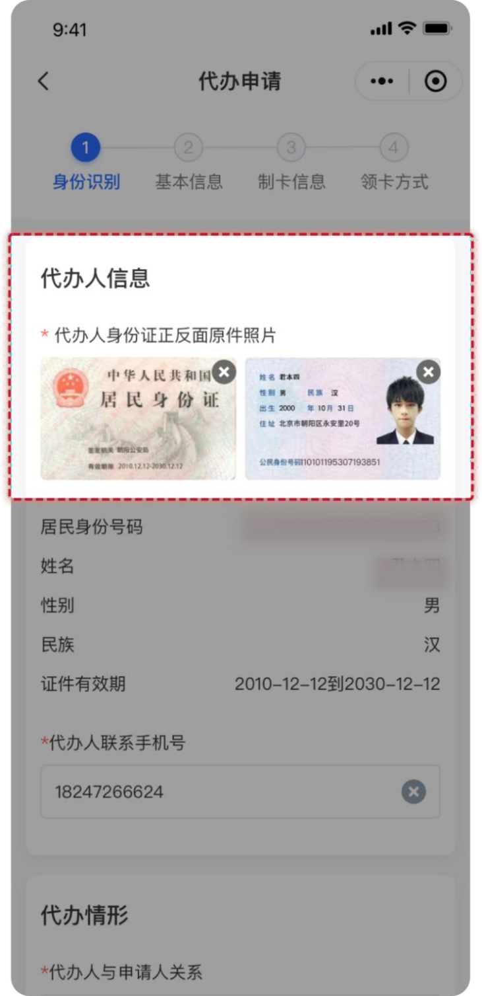
- 代办人的身份识别页面，在“代办人信息”下，需要上传代办人的身份证正、反面原件照片等相关信息进行身份确认，并输入代办人联系手机号。
(1) Identity Verification Page of the Agent:
Upload the photos of the front and back of the agent's ID card to verify the identity, and enter the contact number in the agent information.

在“代办申请”下，选择“代办人与申请人关系”与“被代办人证件类型”。若被代办人证件类型选择为“户口本”，需要选择“代办人与户主关系”、“代办人和孩子是否在一个户口本上”。
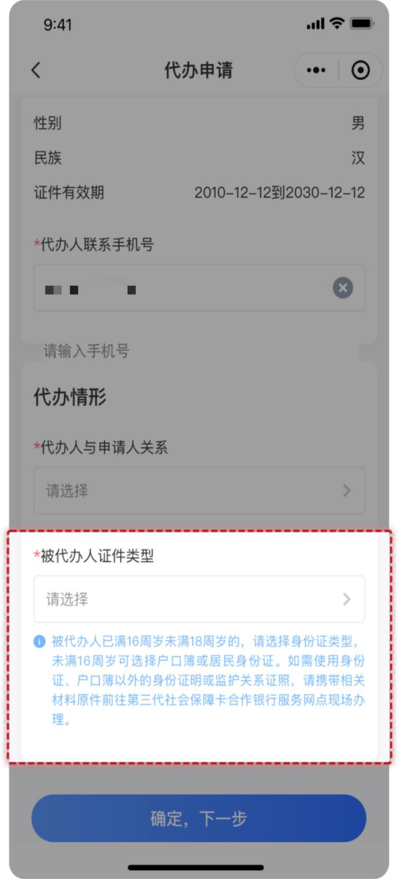
Under the "agent application" (代办申请), select the "relationship between the agent and the applicant" (代办人与申请人关系) and the "ID type of the agent" (被代办人证件类型). If the ID type selected is the "Household Registration Booklet" (户口本), it is required to select the "relationship between the agent and the householder" (代办人与户主关系) and "whether the agent and the applicant (child) are registered on the same booklet" (代办人和孩子是否在一个户口本上).
- 被代办人的基本信息，若在（1）选择被代办人的 “证件类型”为“居民身份证”，则需要上传被代办人的身份证正、反面原件照片和出生证明原件照片。
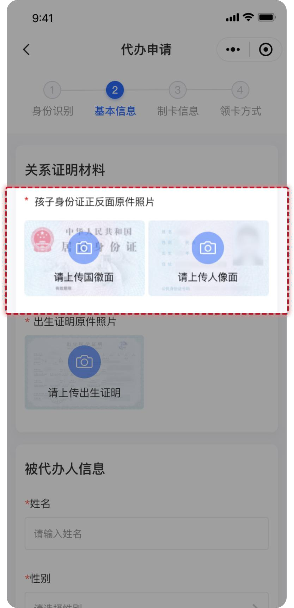
(2) Basic information of the applicant.
If the applicant's ID type selected is the "Resident Identity Card" (居民身份证) in (1), the photos of the front and back of the applicant's original ID card and the photo of the original birth certificate are required to be uploaded.
若在（1）选择被代办人的“证件类型”为“户口本”，则根据“代办人和户主关系”、“代办人和孩子是否在一个户口本上”的选择关系上传相应的材料。
If the applicant's ID type selected is the "Household Registration Booklet" (户口本) in (1),, the documents should be uploaded according to the "relationship between the agent and the householder" (代办人和户主关系), and "whether the agent and the applicant (child) are registered on the same booklet" (代办人和孩子是否在一个户口本上).
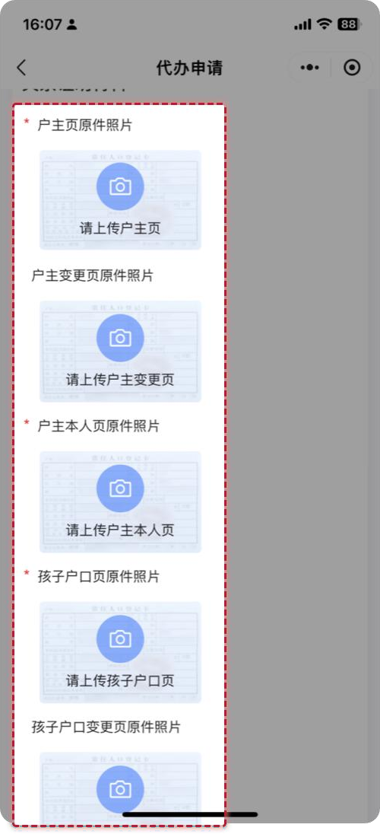

- 被代办人的制卡信息，需要上传被代办人本人制卡照片（子女小于 7 岁可以使用系统提供的默认卡通照片作为制卡照片）、卡预留手机号、选择办卡银行、选择开户行网点等。
(3)Applicant's information for card-making.
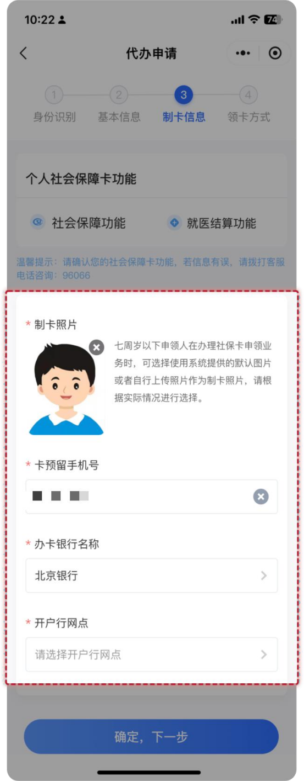
A card-making photo of the applicant (The default cartoon photo provided by the system can be used as the card-making photo if the child is younger than 7 years of age), the reserved mobile phone number of the card, the card-issuing bank, and the account-opening branch are required.
- 领卡方式，18 岁以下子女代办业务领卡方式只支持：代办人网点领取。
(4) Card-Collection Method:
"Collection at the branch in person" (代办人网点领取) is the only supported collection method for applications for minor children aged under 18.
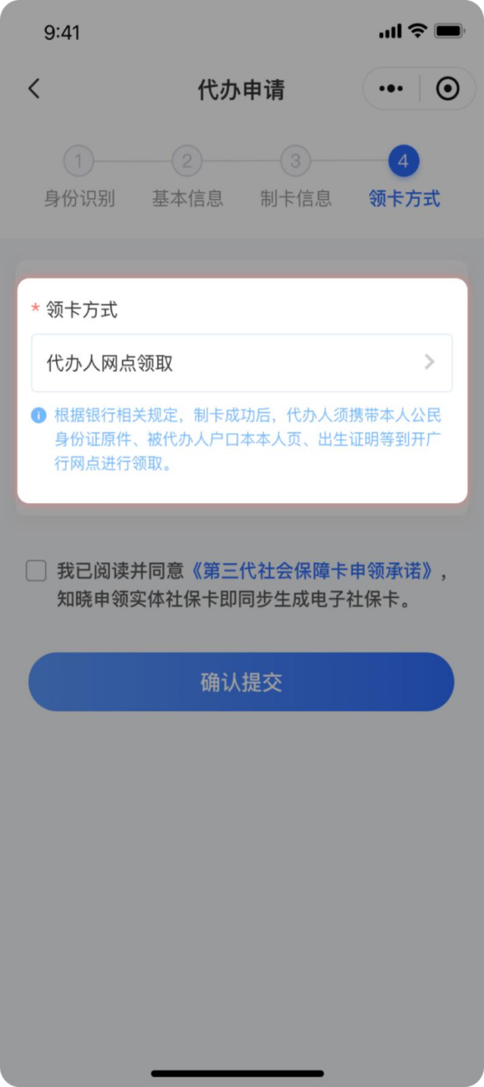

第六步：确认信息无误后勾选【我已阅读并同意】，并点击【确认提交】按钮，完成 18 岁以下子女代办第三代社会保障卡的申领操作。
Step 6: After verification, check "I have read and agree the Promise" (我已阅读并同意) and click "Confirm Submission" (确认提交) to complete the processes of applying for the Third-Generation Social Security Card for children aged under 18.
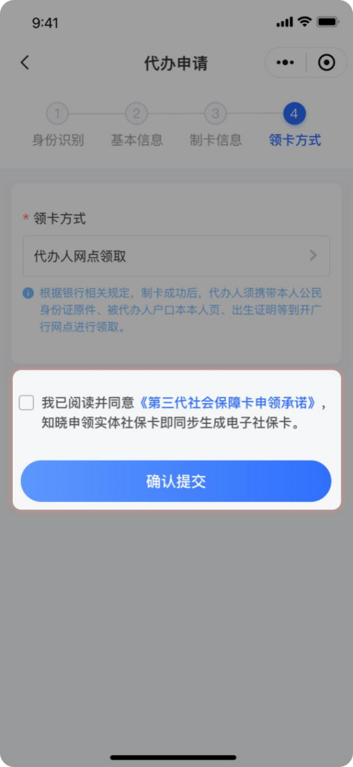

京通小程序"Jingtong" Mini-Program 北京民生一卡通微信小程序Beijing Minsheng YiKaTong Wechat Mini-Program

