附件 1
Attachment 1

北京市第三代社保卡单位线上集体申领
操作说明
Operating Instructions for Online Collective Applications for Third-Generation Social Security Cards by Employers in Beijing

一、单位经办人开通线上集体申领
I. Entity's Designated Person Opens Channel for Online Collective Application
第一步：登录北京市人力资源和社会保障局官网，依次点击“热点服务”-“我要办社保卡”。
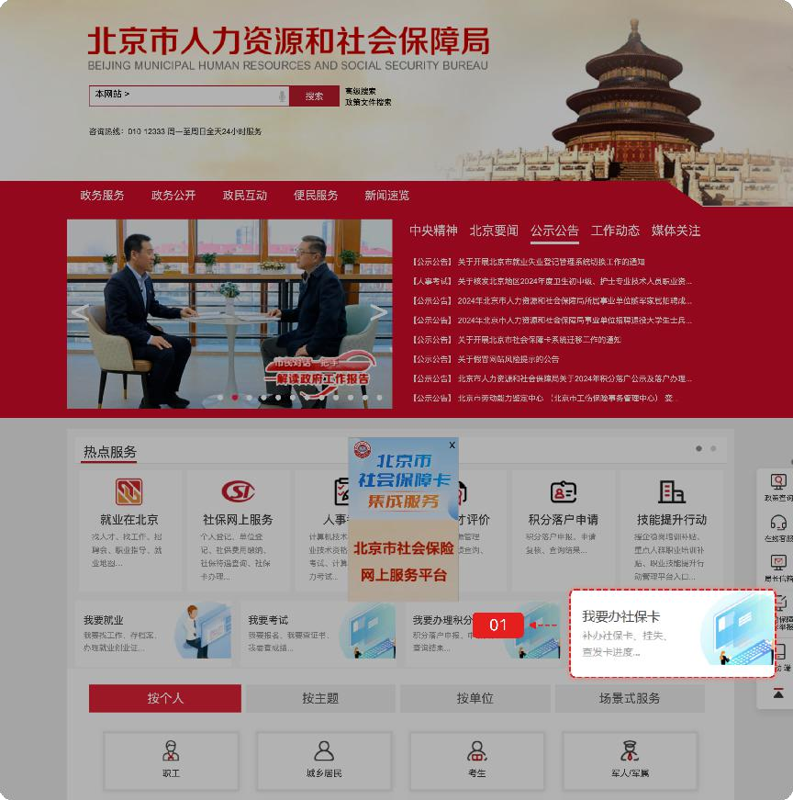
Step 1: Log into the official website of the Beijing Municipal Human Resources and Social Security Bureau. Click successively "Most-requested Services" (热点服务) - "I Want to Apply for a Social Security Card" (我要办社保卡).

第二步：选择“法人登录”。单位经办人通过北京市统一身份认证平台登录后办理社会保障卡相关业务，登录方式包括如下几种：
Step 2: Select "Legal Person Login" (法人登录). After logging in via the Beijing Unified Identity Authentication Platform, the entity's designated person can handle the social security card-related issues. Login methods include the following:
- 证书登录
单位用户可选择证书登录，插入证书，输入证书密码，点击【登录】，如下图：
(1) Certificate Login: Entity users may log in with the certificate. Insert the certificate, enter the certificate password, and click "Login" (登录), as shown below:
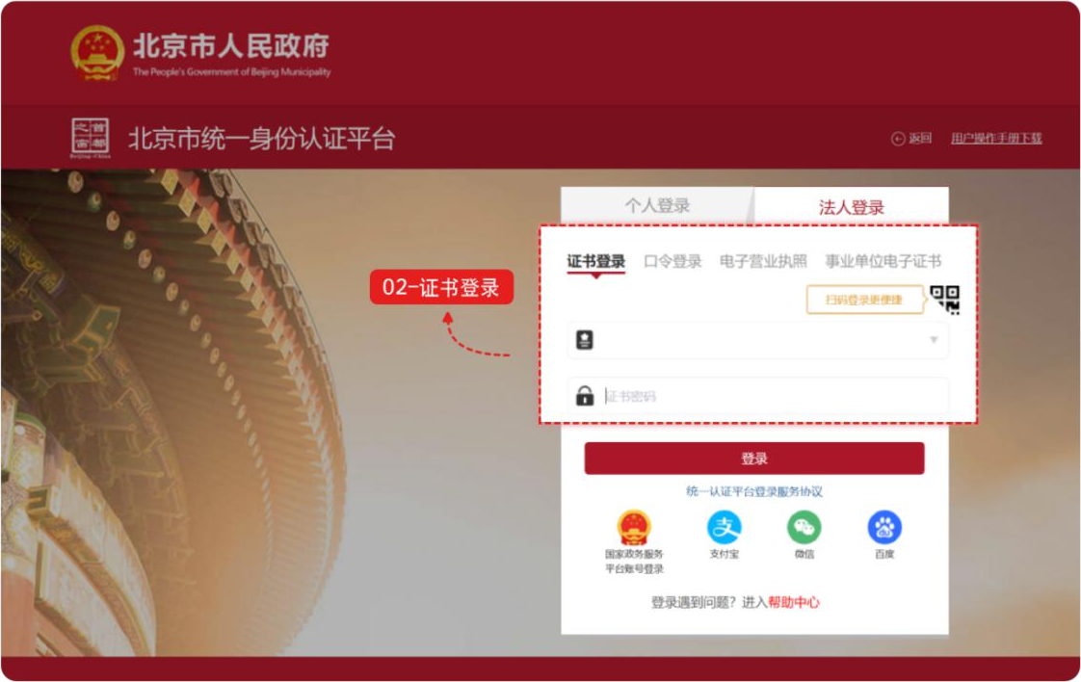
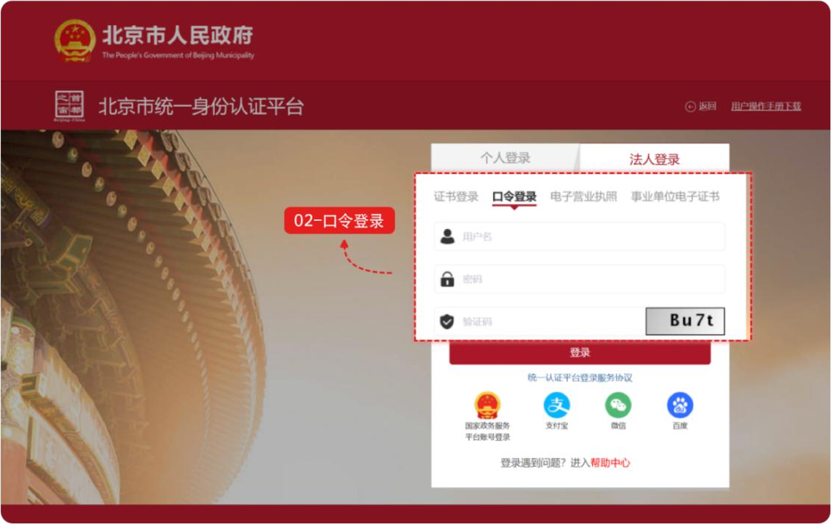
- 口令登录
单位用户可选择口令登录，输入用户名、密码及验证码登录，点击【登录】，如下图：
(2) Password Login: Entity users may log in by password. Enter the username, password, and verification code, then click "Login" (登录), as shown below:

- 电子营业执照登录
单位用户可选择电子营业执照登录，使用电子营业执照 APP、微信或支付宝小程序扫一扫登录，如下图：
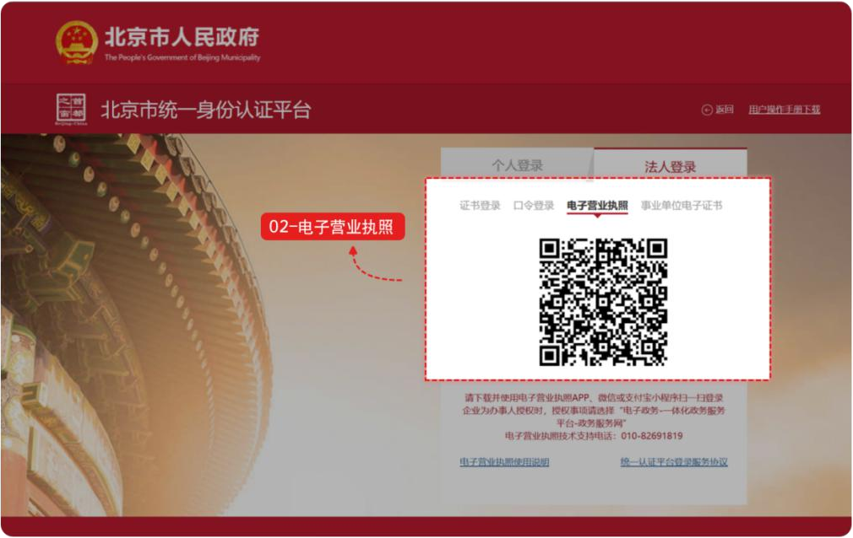
(3) Electronic Business License Login: Entity users may log in with the electronic business license. Use the Electronic Business License App, WeChat, or Alipay Mini-Program to scan the QR code to log in, as shown below:
- 事业单位电子证书登录
单位用户可选择事业单位电子证书登录，使用事业单位电子证书登录扫一扫登录，如下图：
(4) Public Institution Electronic Certificate Login: Entity users may log in with the Public Institution Electronic Certificate by scanning the QR code with the Certificate, as shown below:
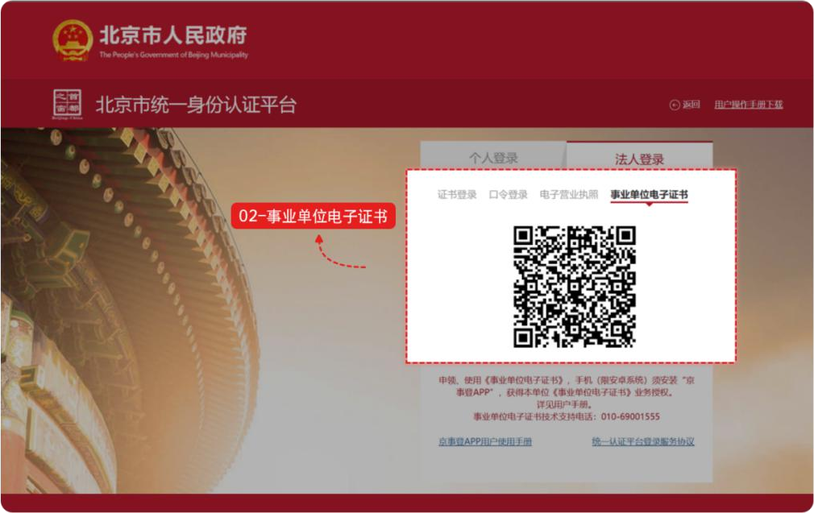

- 其他渠道登录
单位用户可选择国家政务服务平台账号登录，或者使用支付宝、微信、百度账号进行登录。

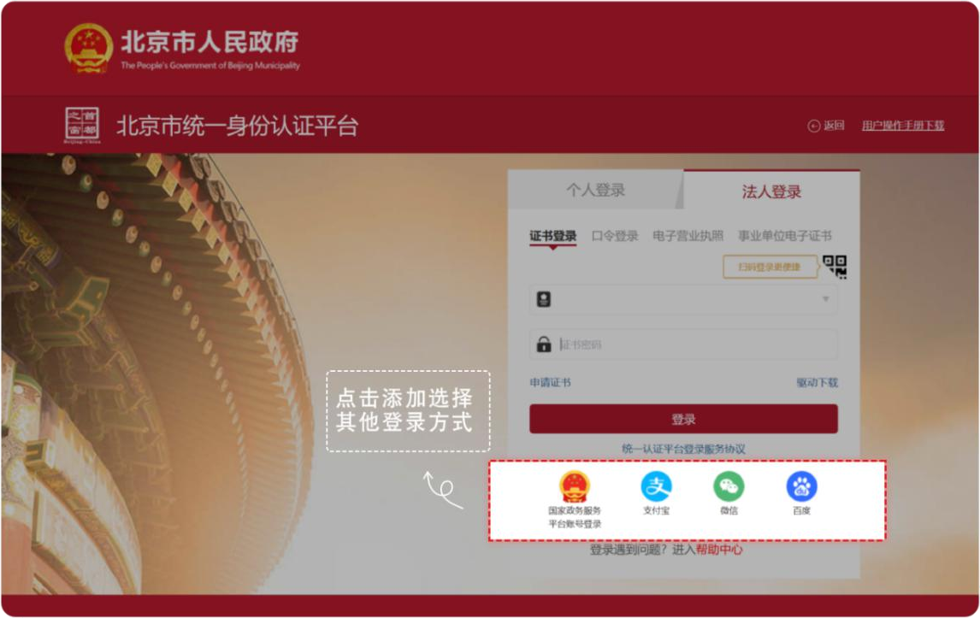
(5) Other Login Channels: Entity users may log in with a National Government Service Platform account, or through Alipay, WeChat, and Baidu accounts.

第三步：登录后，单位经办人选择“单位开通集体申请”。
Step 3: After logging in, the entity's designated person may select "Entity Opens Collective Application" (单位开通集体申请).
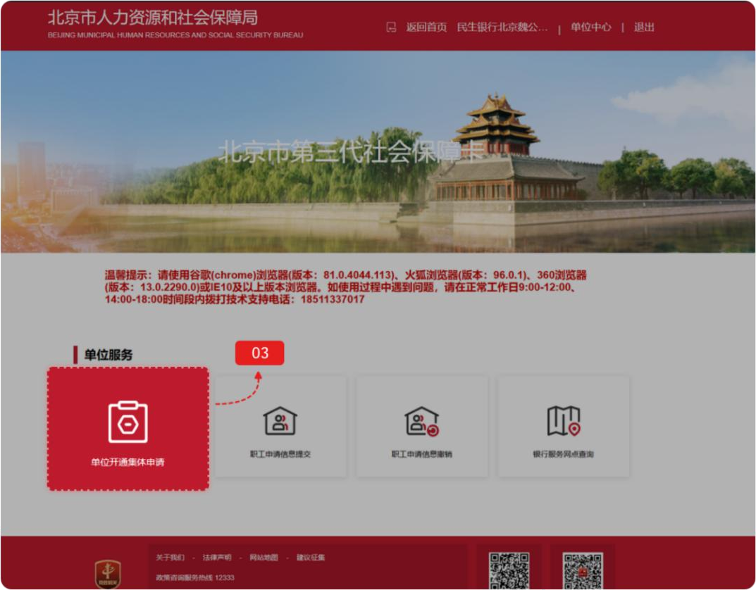

第四步：进行单位开通集体申请资料填写，填写相关单位基础信息。是否开通单位集中办卡选择“开通”、选择是否支持单位代领、填写职工办卡的开户银行及办卡网点，并提交单位资料。
Step 4: Fill in the materials required for the entity collective application. Complete the basic information of the entity, select "Yes" (开通) for "Whether to enable the entity collective card application", and confirm whether to support the entity to collect the cards on the employees' behalf. Then, fill in the banks and branches available for employees to open the social security card account, and submit the documents of the entity.
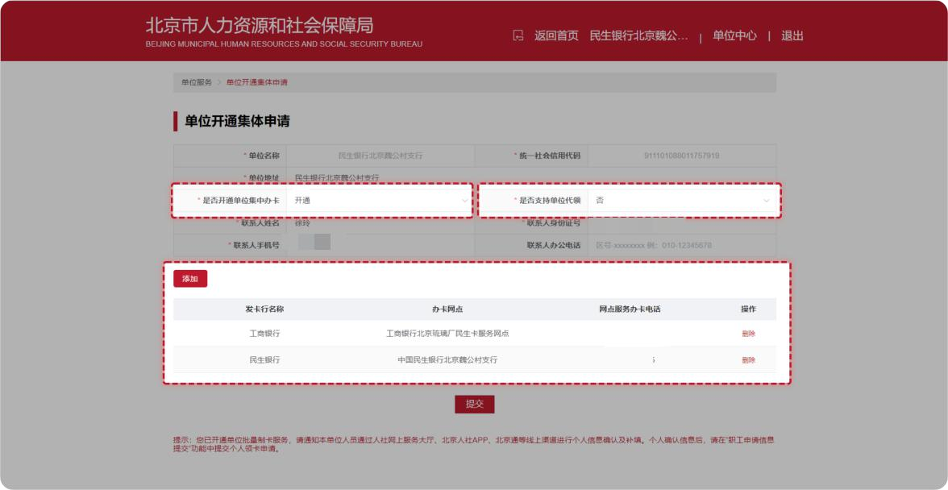
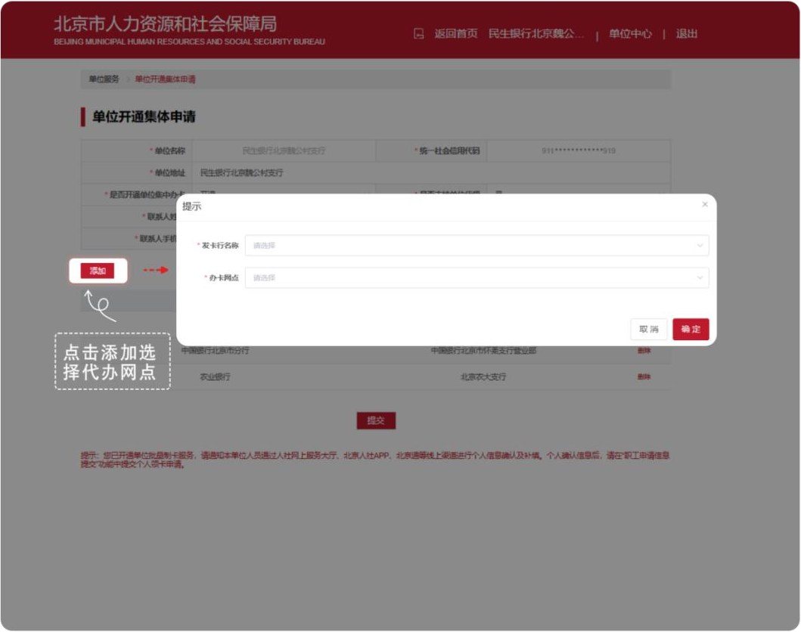

二、单位职工线上确认领卡信息
II. Employees of Entity Confirm Card Collection Information Online
（一）通过北京市人力资源和社会保障局官网进行单位职工信息确认
1. Via the official website of the Beijing Municipal Bureau of Human Resources and Social Security
第一步：登录北京市人力资源和社会保障局官网，依次点击【热点服务】-【我要办社保卡】，确认申领信息。

Step 1: Log into the official website of the Beijing Municipal Bureau of Human Resources and Social Security. Click successively "Most-Requested Services" (热点服务) - "I Want to Apply for a Social Security Card" (我要办社保卡) to confirm the application and collection information.

登录方式包括如下几种：
Login methods include:
- 扫码登录
用户可选择扫码登录，使用微信、支付宝或百度端“京通”小程序扫码登录，如下图：
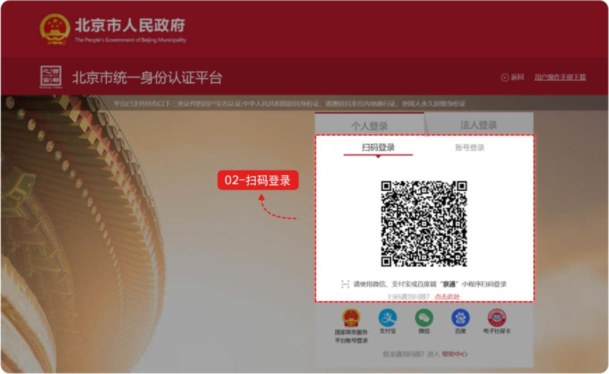
(1) QR Code Scanning: Users may log in by scanning the QR code. Use the "Jingtong" Mini-Program on WeChat, Alipay, or Baidu App to scan the QR code and log in, as shown below:

- 账号登录
用户可选择账号登录，输入用户名/手机号/身份证号、密码和图形验证码，点击【登录】，如下图：
(2) Account Login: Users may select account login. Enter the username/mobile number/ID number, password, and graphical verification code, then click "Login" (登录), as shown below:
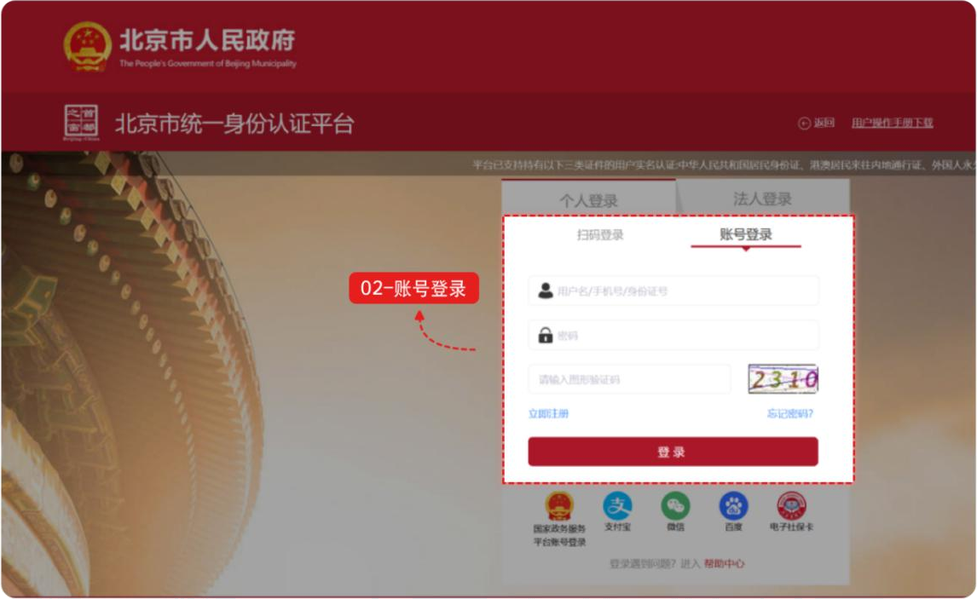
- 其他渠道登录
用户可选择国家政务服务平台账号登录，或者支付宝、微信、百度、电子社保卡进行登录。
(3) Other Login Channels: Users may log in with a National Government Service Platform account, or via Alipay, WeChat, Baidu, and Electronic Social Security Card.

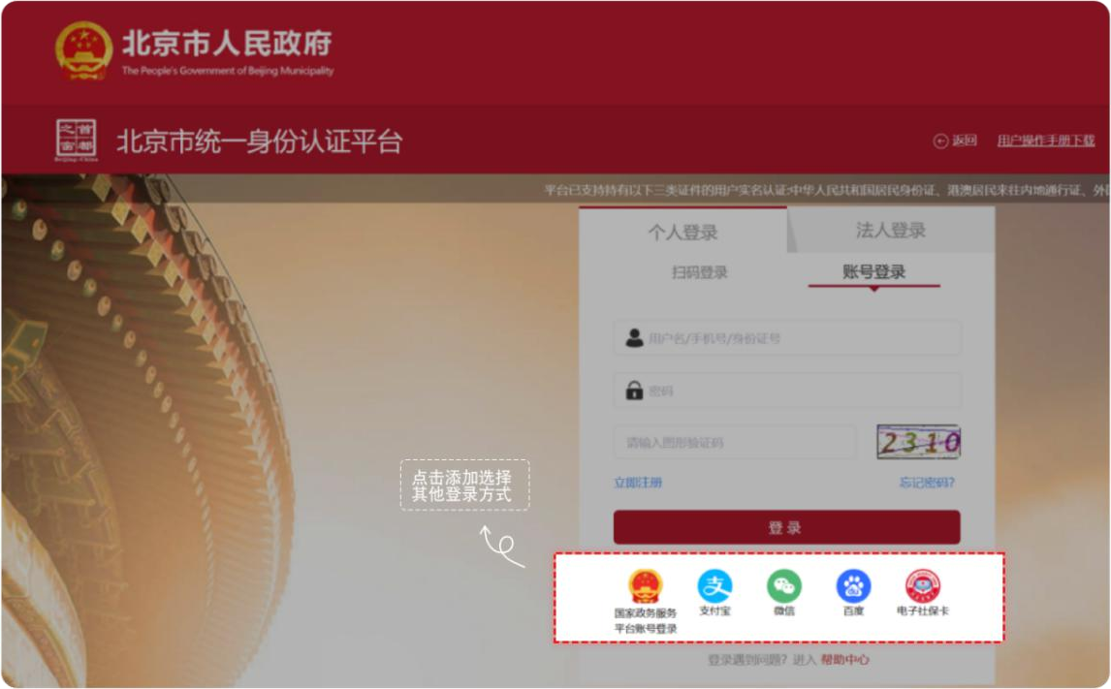

第二步：登录成功后，职工点击【单位集体申请社会保障卡-个人信息确认】按钮，出现免责声明，阅读后勾选【我同意】，进入确认个人信息详情页。
Step 2: After the login, the employee may click the "Collective Social Security Card Application of Entity - Personal Information Confirmation" (单位集体申请社会保障卡-个人信息确认) button. A disclaimer will appear. After reading it, check the "I Agree" (我同意) box and enter the details page for personal information confirmation.
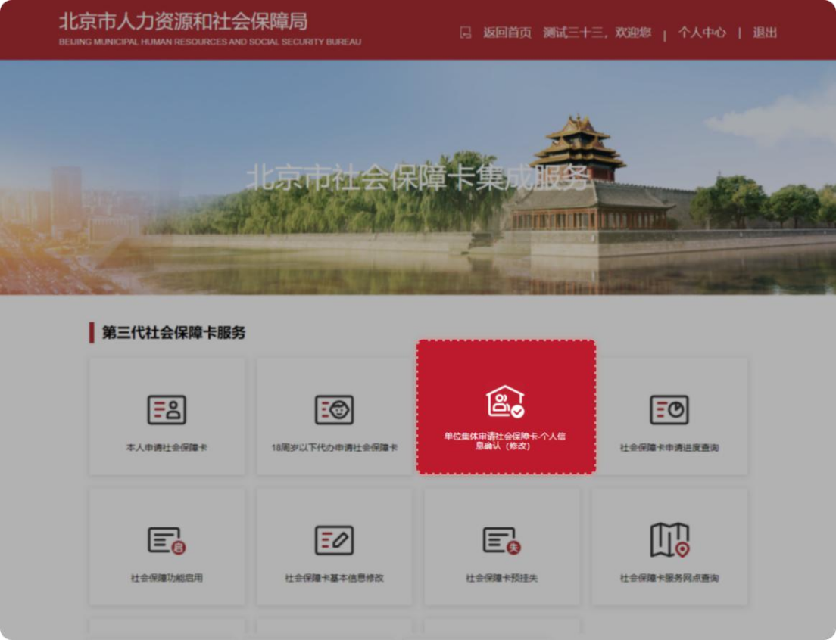

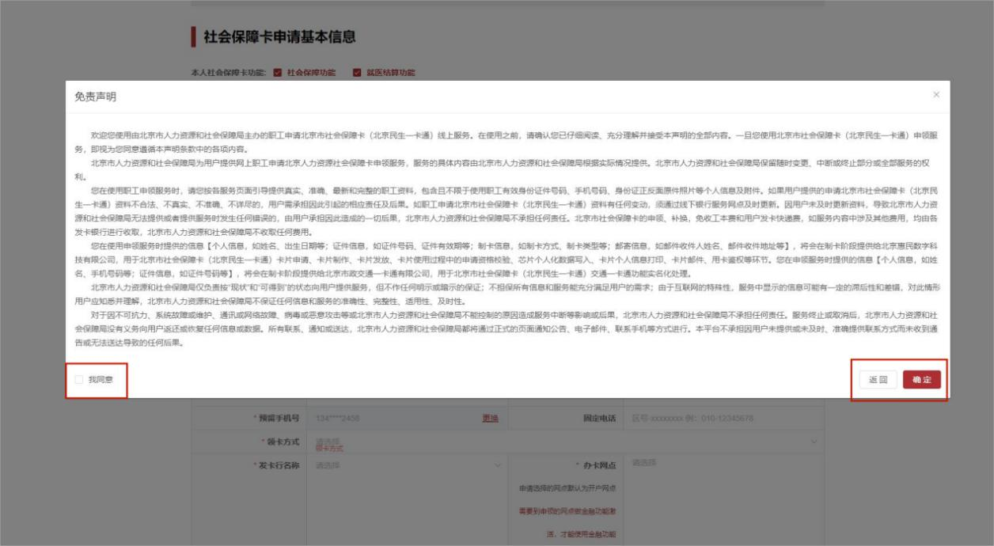
第三步：查看个人基本信息是否正确，非置灰字段可以进行编辑修改，上传公民身份证正面、反面等。
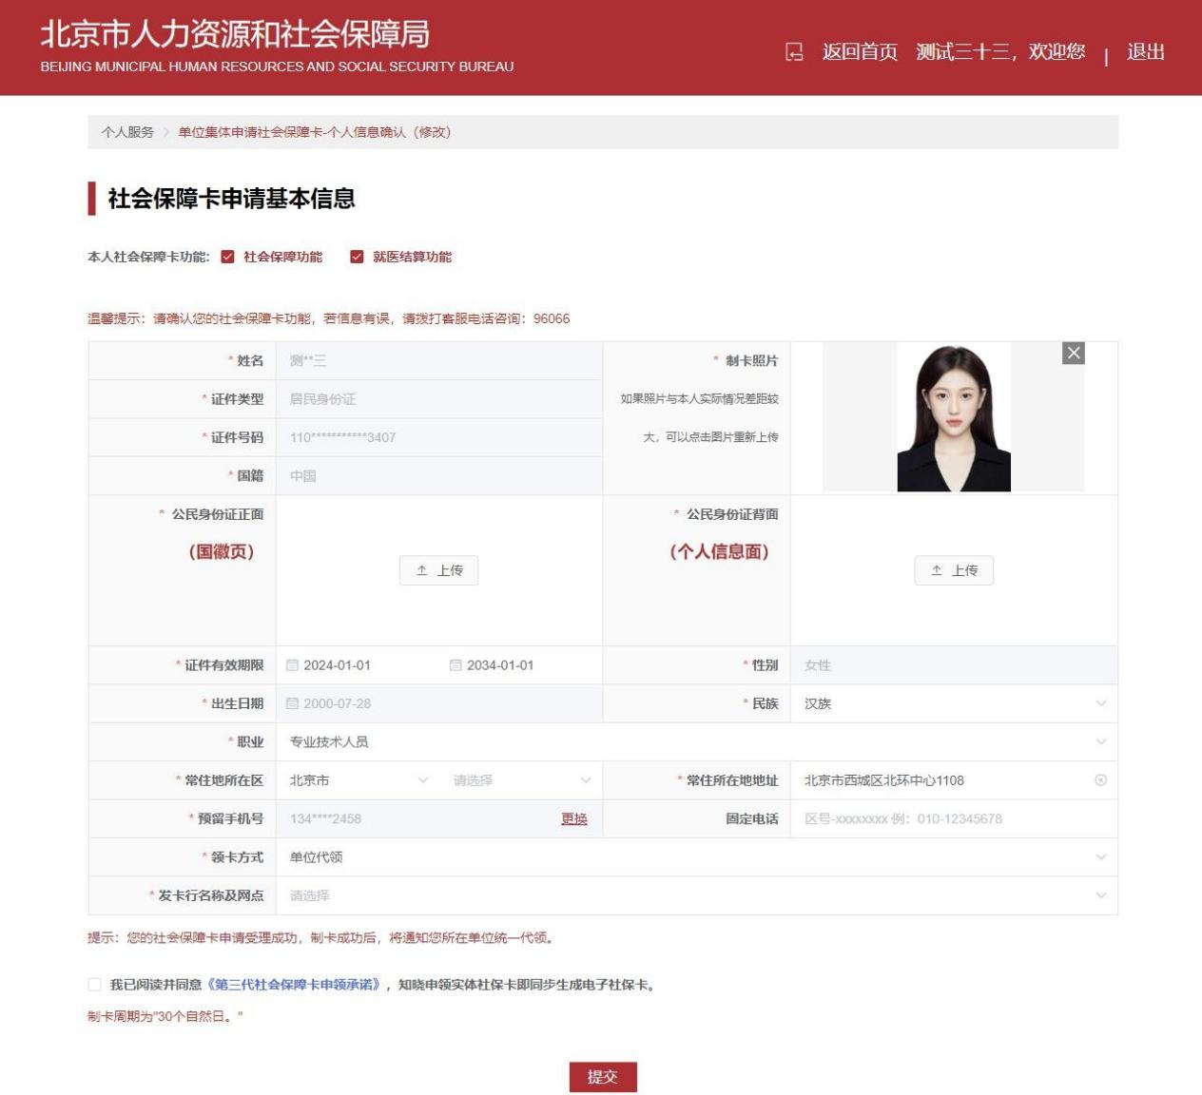
Step 3: Check whether the personal basic information is correct. Non-grayed-out fields can be edited and modified. Upload the front and back of the citizen's ID card and other materials required.

第四步：若上述【单位开通集体申请】页面中“是否支持单位代领”经办人选“是”，则单位职工对应的领卡方式为单位代领。
Step 4: If the designated person of the entity had selected "Yes" for "Whether to support the entity to collect the cards on the employees' behalf" on the aforementioned "Entity Opens Collective Application" (单位开通集体申请) page, the entity will collect the social security card of its employees on their behalf.
若上述【单位通集体申请】页面中“是否支持单位代领”经办人选“否”，则单位职工领卡方式对应如下两种选择：
If "No" (否) had been selected on the aforementioned page, the entity's employees may collect their social security card through the two following methods correspondingly:
- 领卡方式本人网点领取：
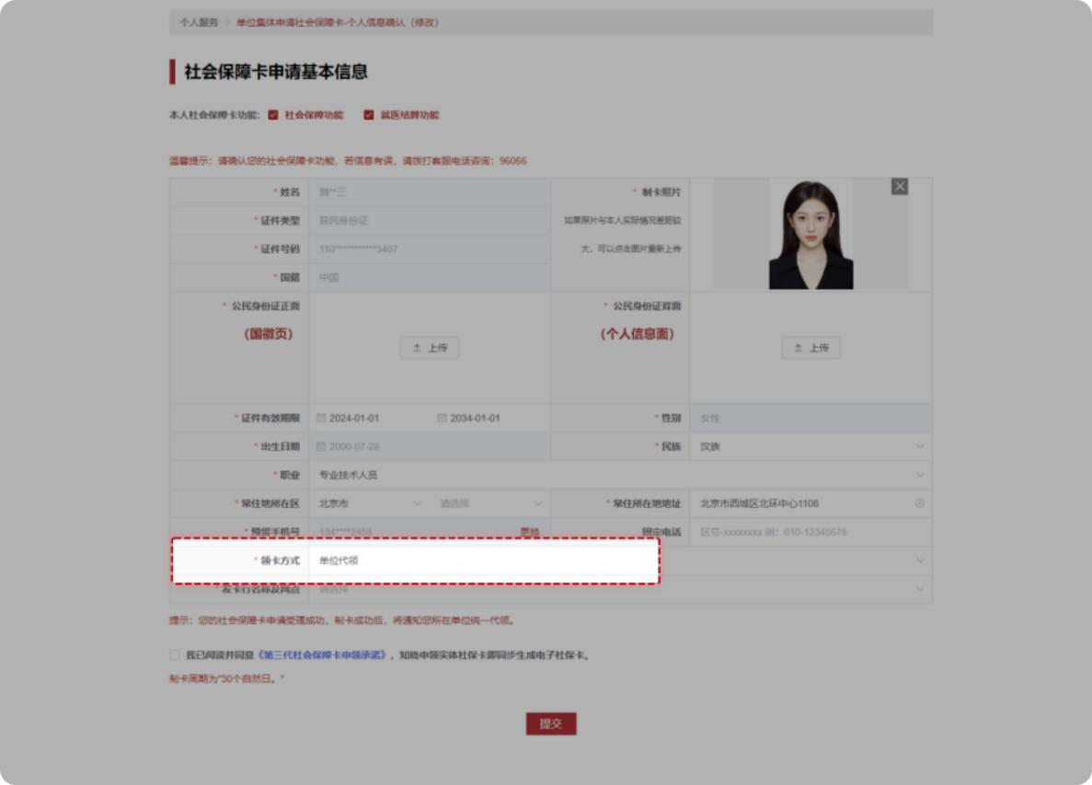
(1) Pick up the card personally at an available bank branch.
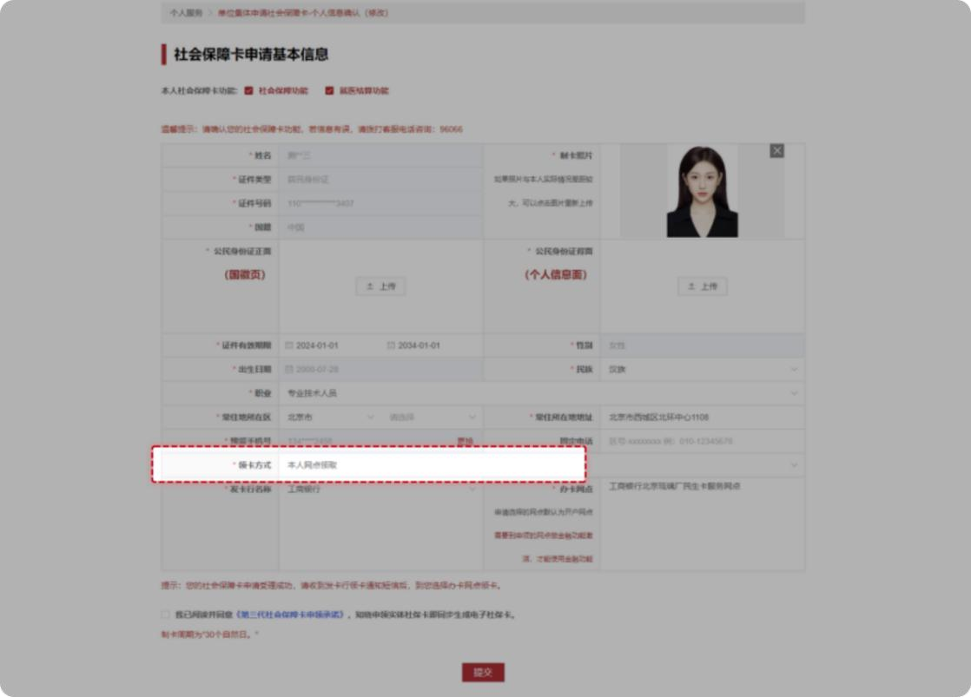

- 领卡方式选择银行网点邮寄：
(2) Delivery by an available bank branch:
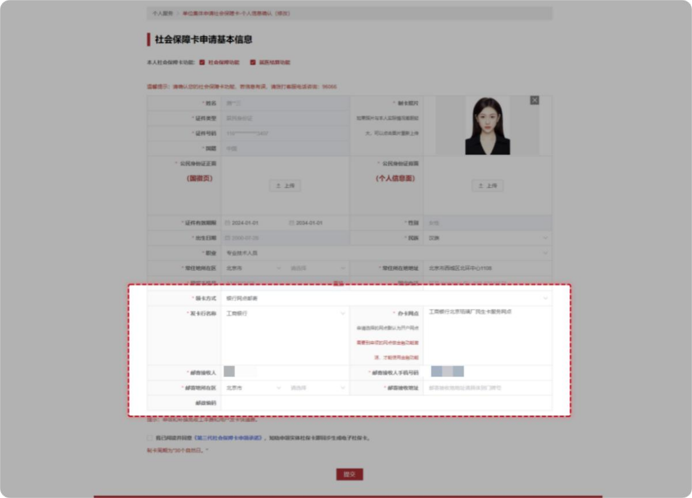

第五步：信息全部完善后勾选【申请人郑重承诺】，点击【提交】本人申领社会保障卡信息。
Step 5: After all information is completed, check the "Applicant Promises" (申请人郑重承诺) box and click the button at the bottom to submit the personal information for social security card application and collection.
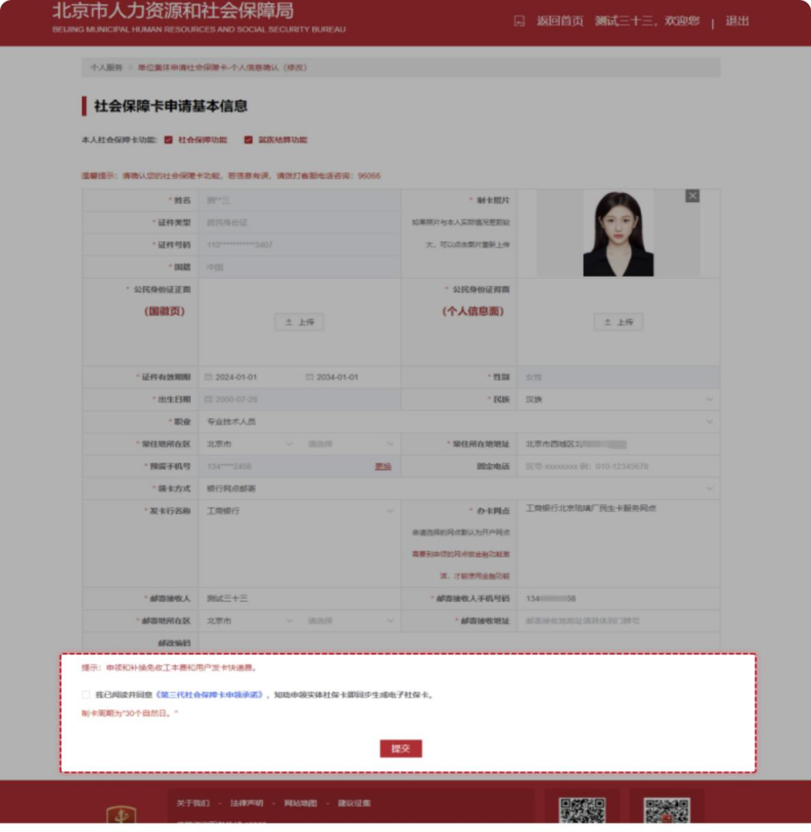

（二）通过“京通”小程序进行单位职工信息确认
2. Via the "Jingtong" Mini-Program
第一步：通过微信、支付宝、百度搜索京通，进入京通小程序或者直接扫描下方二维码进入京通-第三代社会保障卡专区。
Step 1: Search for "Jingtong" (京通) on WeChat, Alipay, or Baidu to enter the Jingtong Mini-Program, or directly scan the QR code below to enter the Jingtong - Third-Generation Social Security Card section (京通-第三代社会保障卡专区).

京通-第三代社会保障卡专区
Jingtong - Third-Generation Social Security Card Section

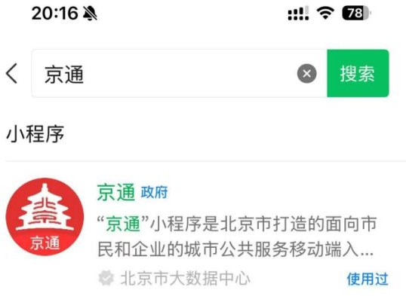
微信：WeChat
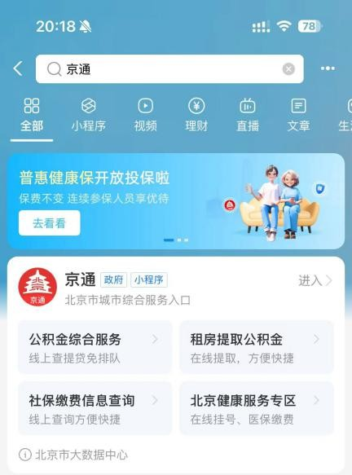
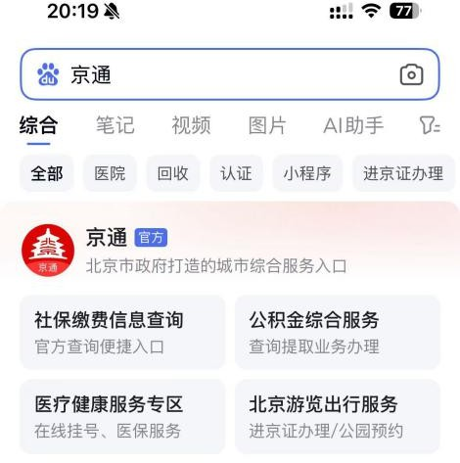
支付宝：Alipay
百度：Baidu

第二步：进入京通小程序后，首页特色服务找到第三代社会保障卡图片，点击【第三代社会保障卡】图片。
Step 2: After entering the Jingtong Mini-Program, find the Third-Generation Social Security Card image in the Featured Services section on the homepage and click it.
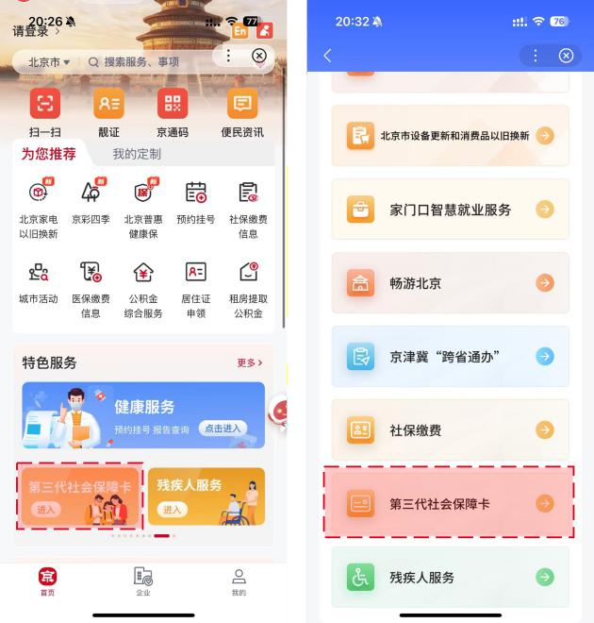

- 登录：第三代社会保障卡页面需要登录认证后进入，在此页面【勾选】同意，点击开始人脸识别，识别成功进入第三代社会保障卡页面。
Login: To enter the Third-Generation Social Security Card section, login and authentication are required. Check the agreement box on this page and click to start facial recognition. Upon successful recognition, enter the Third-Generation Social Security Card section.

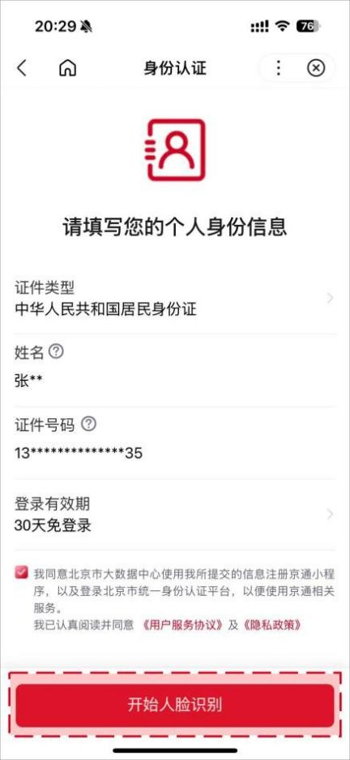
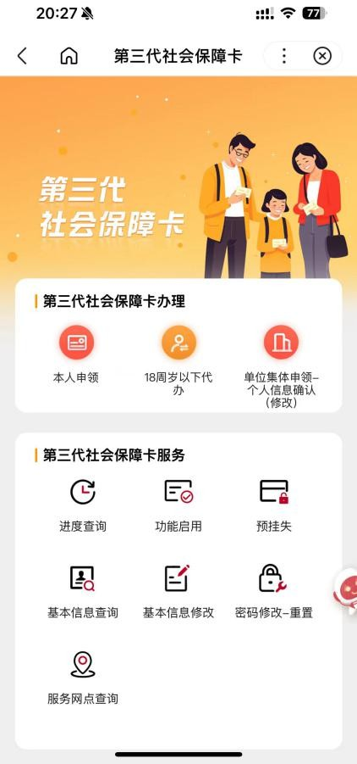

第三步：完成登录进入页面的用户，点击【单位集体申领-个人信息确认（修改）】按钮，进入免责声明页，阅读后勾选【我同意】并点击【确定申领】，进入个人信息确认详情页。
Step 3: Users who have logged in and entered the section may click the "Collective Application and Collection by Entity - Personal Information Confirmation (Modification)" (【单位集体申领-个人信息确认（修改）】) button to enter a disclaimer page. After reading it, check "I Agree" (我同意) and click "Confirm Application" (确定申领) to enter the detailed page for personal information confirmation.
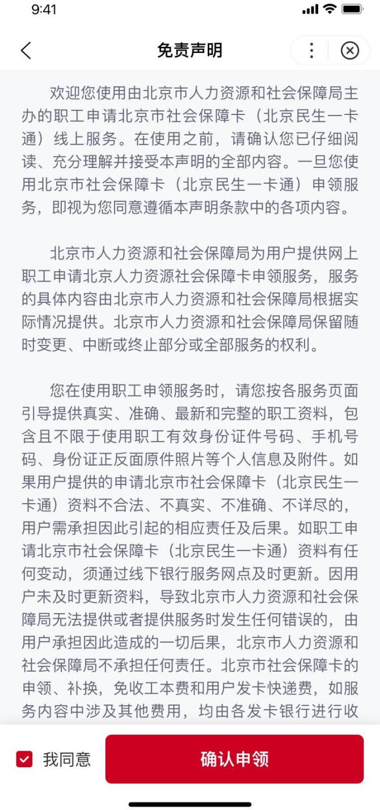

第四步：用户个人基本信息（姓名、证件类型、证件号码、证件有效期限开始日期、性别、出生日期、国籍、常住所在地地址、卡预留手机号），检查反显信息是否正确。
Step 4: Check the displayed basic personal information including the name, ID type, ID number, starting date of the ID validity, gender, date of birth, nationality, permanent residence address, and the reserved mobile number for the card.
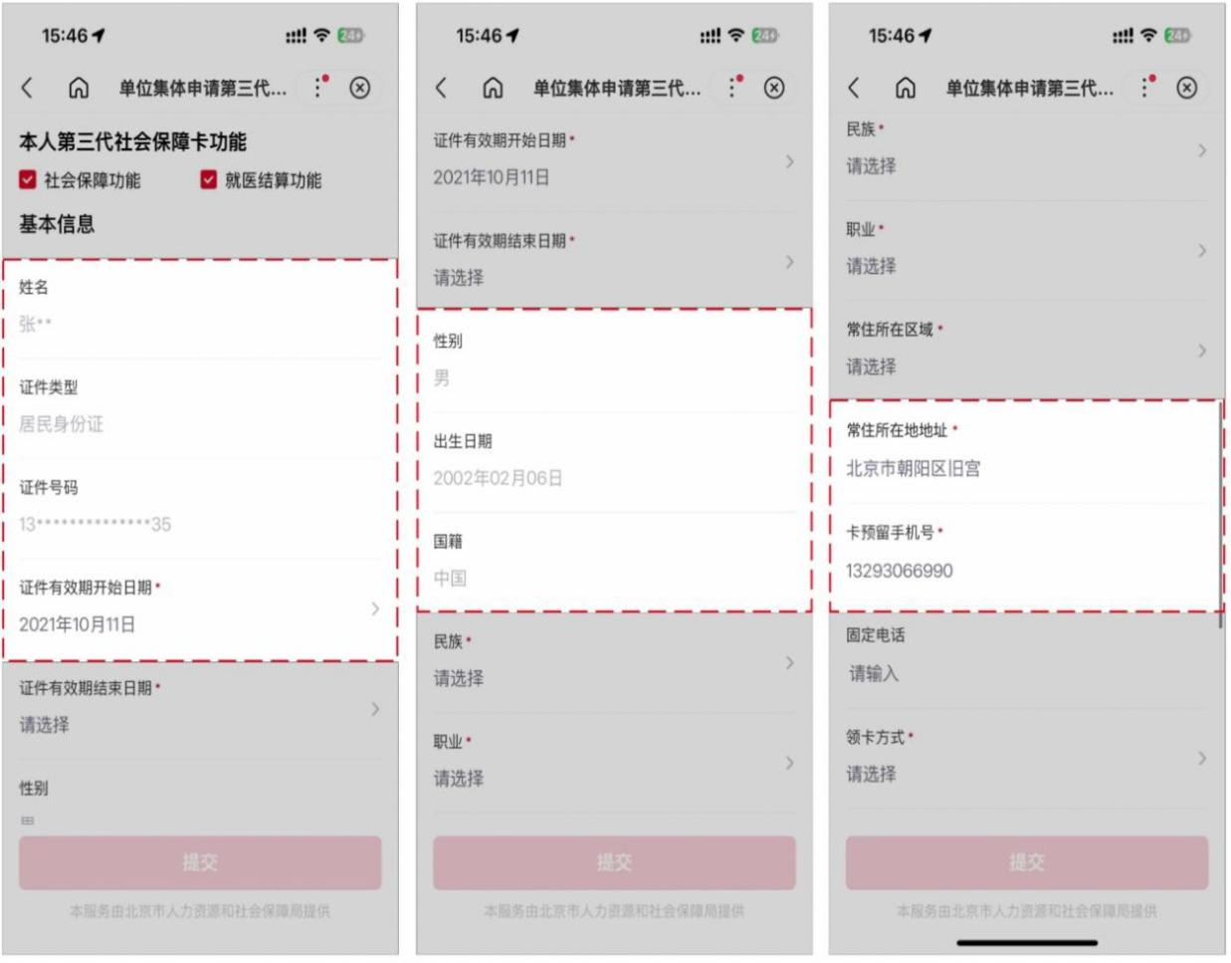

第五步：补充民族、职业、常住地所在区等相关社保卡预留信息。
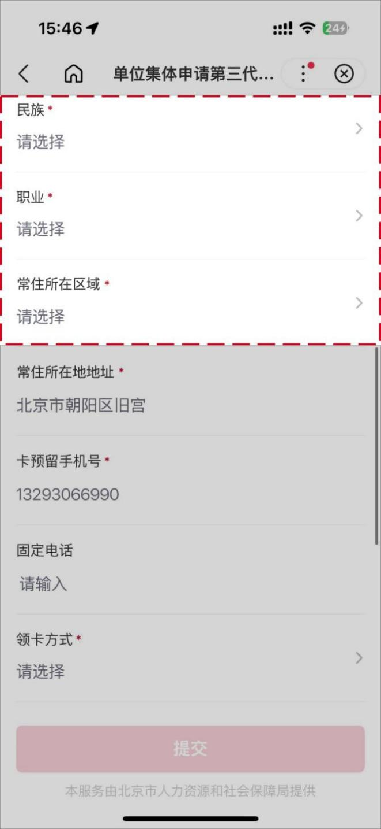
Step 5: Supplement the reserved information for the social security card such as the ethnicity, occupation, and the district of the permanent residence, etc.
第六步：根据单位经办人在“单位开通集体申请”页面 “是否支持单位代领”的不同选择，选择不同的领卡方式（单位代领、个人网点领卡或银行邮寄）。
Step 6: Choose the corresponding card collection method (entity collection, self collection at a bank branch, or bank delivery) according to the designated person's selection for "Whether to support the entity to collect the cards on the employees' behalf" on the page of entity collective application.
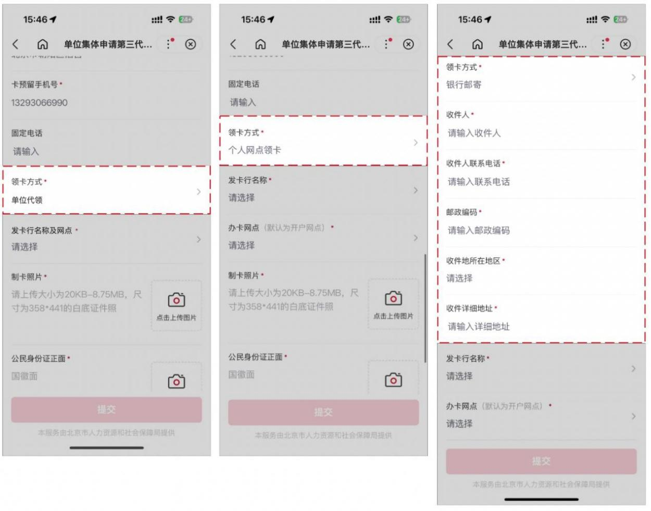
若选择银行邮寄，需补充物流涉及相关信息，如收件人人姓名、收件人联系电话、收件地所在区、邮政编码、收件地所在区、收件详细地址。

If applicants select "bank delivery", relevant logistics information such as the name and contact number of the recipient, the district, postal code of the delivery address, and the detailed address need to be complemented.
第七步：补充发卡行名称、办卡网点等金融开户关键要
素。
Step 7: Supplement the key information for financial account opening, such as the name of the card issuing bank, the card application branch, etc.
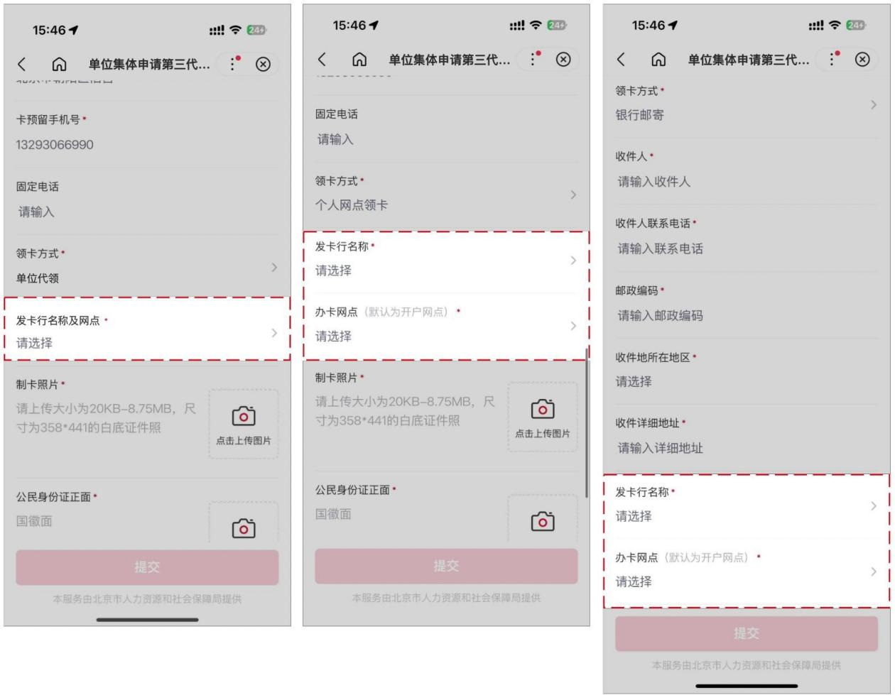

第八步：上传身份证正、反面原件照片，补充实体卡的制卡照片（照片要求：大小为 20KB-8.75M 以内，尺寸为 358*441）。
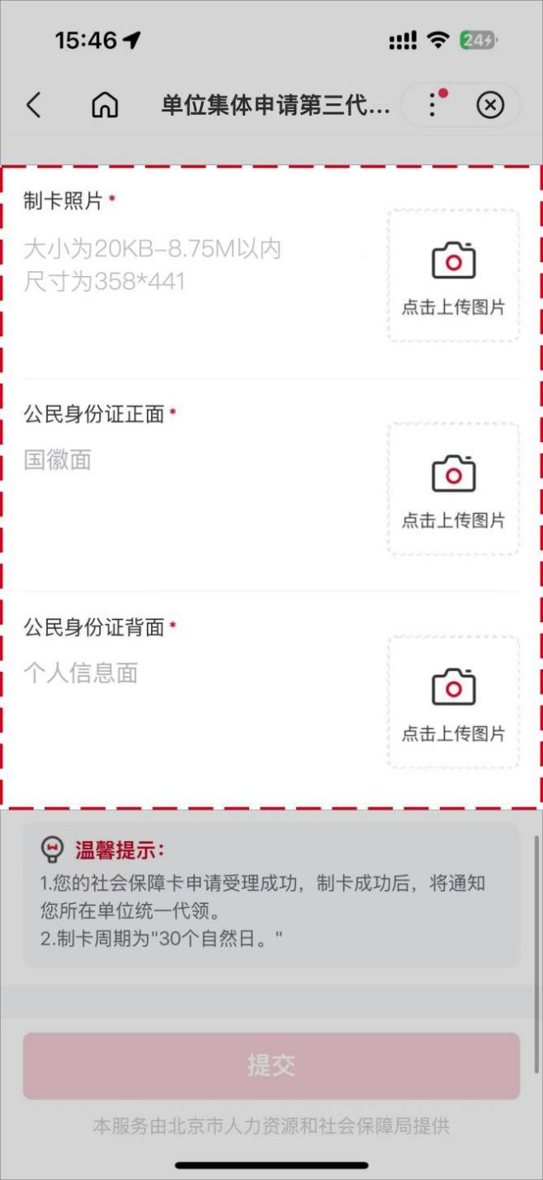
Step 8: Upload the photos of the front and back of the original ID card and the photo for physical card making (The file size should be within 20KB-8.75M, the photo dimension should be 358*441 pixels).

第九步：确认信息无误后勾选【我已阅读并同意】，并点击【提交】按钮，完成个人信息确认。
Step 9: After confirming the information, check "I have read the Promises and agree to it" (我已阅读并同意), and click the "Submit" (提交) button to complete the personal information confirmation.
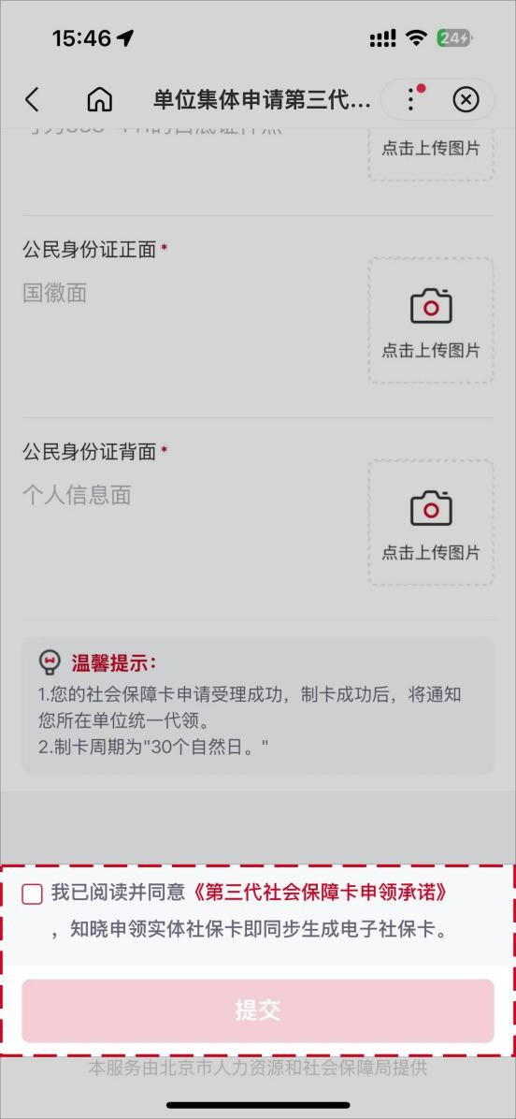
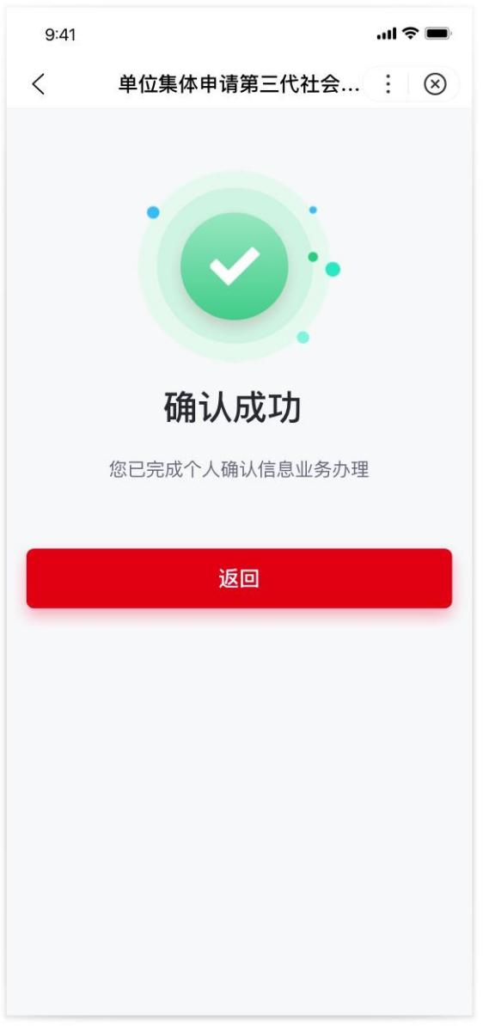
（三）通过北京民生一卡通小程序进行单位职工信息
确认
(3) Via the "Beijing Minsheng Yikatong" (北京民生一卡通) WeChat Mini-Program
第一步：通过微信扫描下方二维码或者微信搜索框选择
小程序，输入“北京民生一卡通”，找到如下产品图标 icon，点击图标直接进入小程序。

Step 1: Scan the QR code below on WeChat, or search for mini-programs in the WeChat search box, enter "Beijing Minsheng Yikatong" (北京民生一卡通), find the product icon shown below, and click it to enter the mini-program directly.
北京民生一卡通微信小程序
"Beijing Minsheng Yikatong" (北京民生一卡通) WeChat Mini-Program

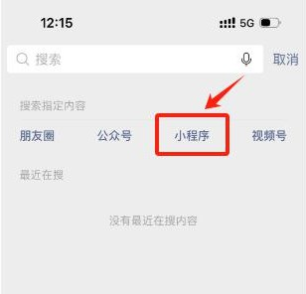


第二步：进入北京民生一卡通小程序后，展示首页社保卡页，顶部找到申请本人社会保障卡按钮，点击【申请本人社会保障卡】按钮，进行申请第三代社会保障卡。
Step 2: The mini-program displays the entrance of the Social Security Card section on its homepage. Find the "Apply for My Social Security Card" (申请本人社会保障卡) button at the top and click it to apply for the Third-Generation Social Security Card.

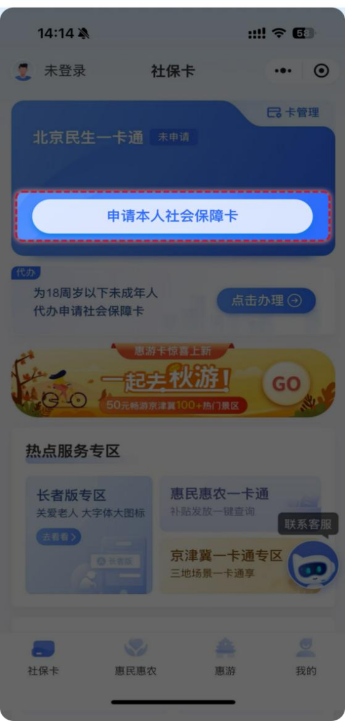
申请第三代社会保障卡前，用户需要完成登录和实名认证，才可以进行第三代社会保障卡的线上申领；若用户已完成上述操作，无需进行登录和实名认证，直接进入第三步申领卡流程页。
To proceed with the online application for the Third-Generation Social Security Card, the user needs to complete the login and real-name authentication. If the user has already completed these steps, proceed directly to Step 3.
登录：目前支持微信授权用户手机号快捷登录和手机号验证码登录两种方式。
Login: Two login methods are supported currently: quick login via WeChat-authorized mobile number and mobile number login with verification code.

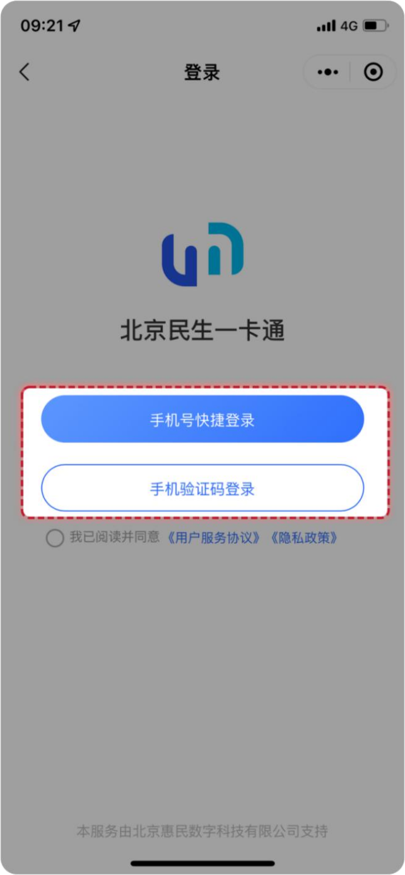

实名认证：需要输入姓名、身份证号并使用手机摄像头进行人脸核验，以上信息保持一致才可通过实名认证。
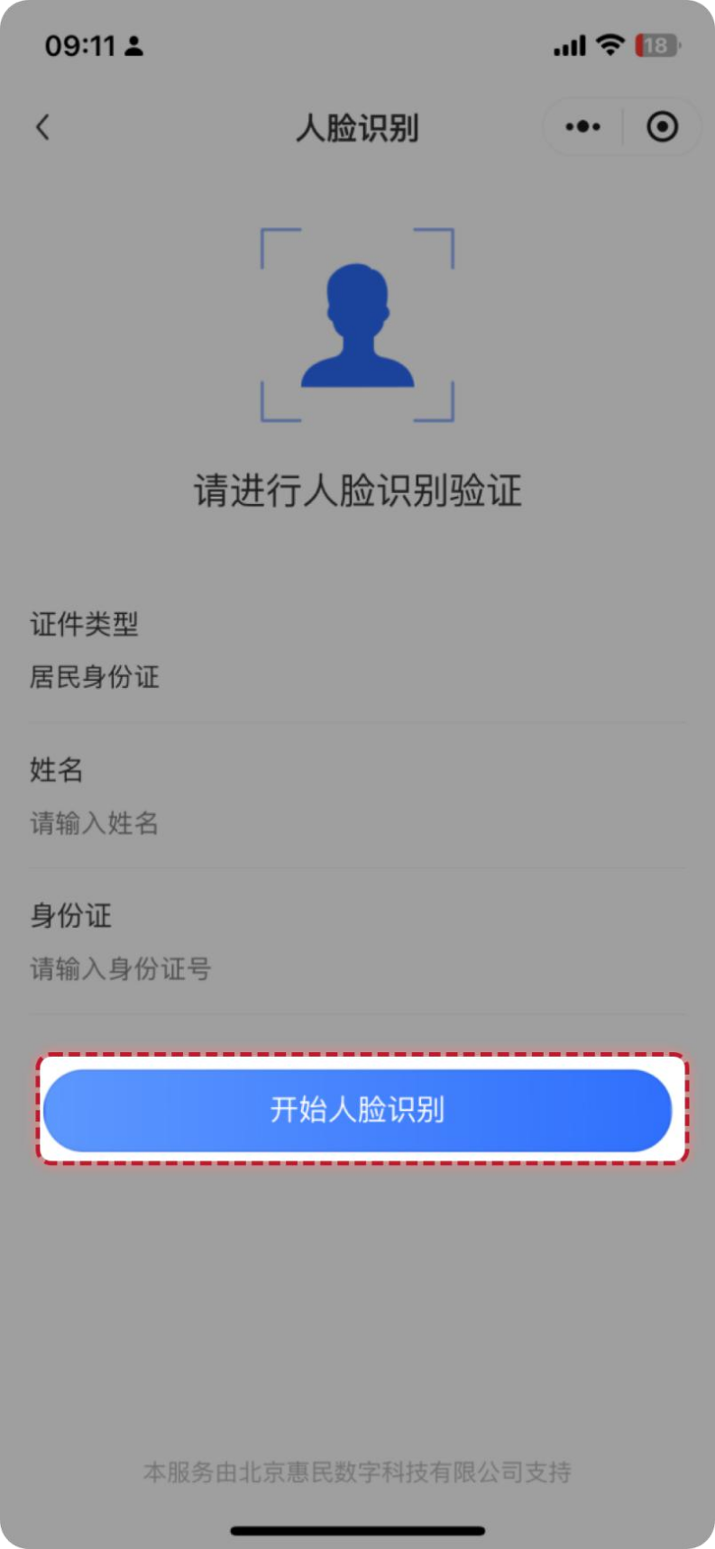
Real-Name Authentication: Users should input their name and ID number, and use the mobile phone camera for facial verification. The information above must be consistent to pass the authentication.

第三步：完成登录和身份认证的用户，点击【申请本人社会保障卡】按钮后，用户需要点击【确认信息】的二次弹框确认。
Step 3: After completing the login and identity authentication and clicking the "Apply for My Social Security Card" (申请本人社会保障卡) button, users need to click "Confirm Information" (确认信息) on the secondary pop-up to confirm.
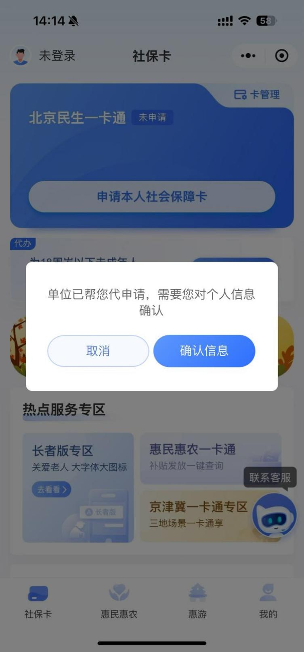

第四步：点击完【确认信息】后，出现免责声明条款，阅读后勾选【我已阅读并同意免责声明】并点击【确定】，进入个人信息确认详情页。
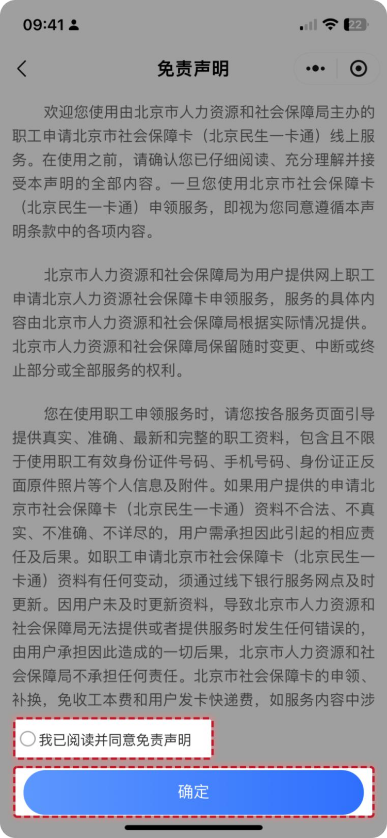
Step 4: After "Confirm Information" (确认信息) is clicked, the disclaimer terms will appear. After reading, check "I have read the disclaimer and agree to it" (我已阅读并同意免责声明) and click "Confirm" (确定) to enter the detailed page for personal information confirmation.

第五步：上传身份证正、反面原件照片，根据识别结果反显用户个人基本信息（姓名、性别、民族、证件有效期限），检查反显信息是否正确。
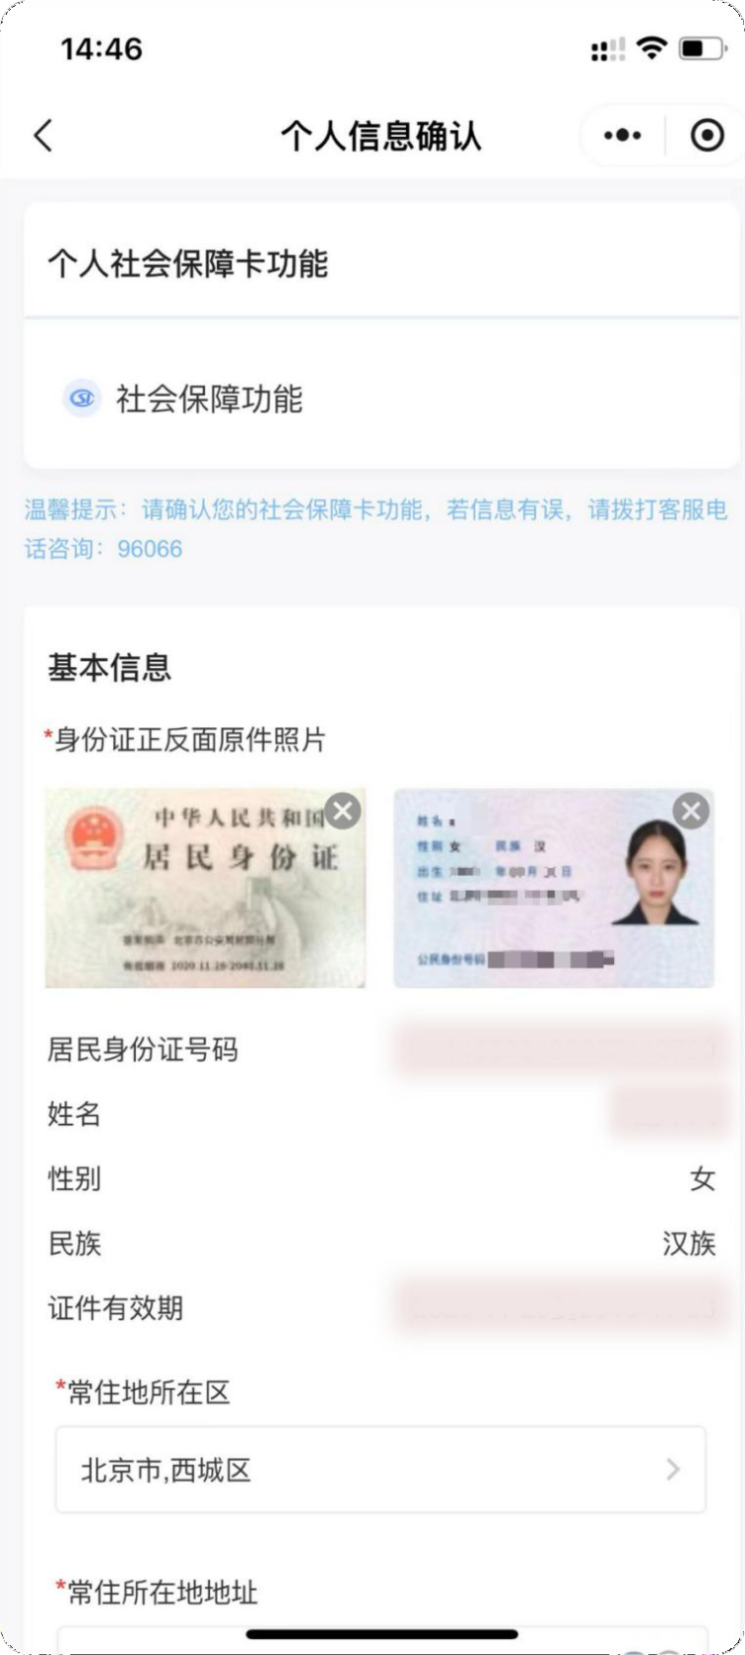
Step 5: Upload original photos of the front and back of the ID card. Check if the basic personal information (name, gender, ethnicity, ID Validity) displayed based on the recognition result is correct.

第六步：补充常住地所在区、常住所在地地址、职业等相关社保卡预留信息。
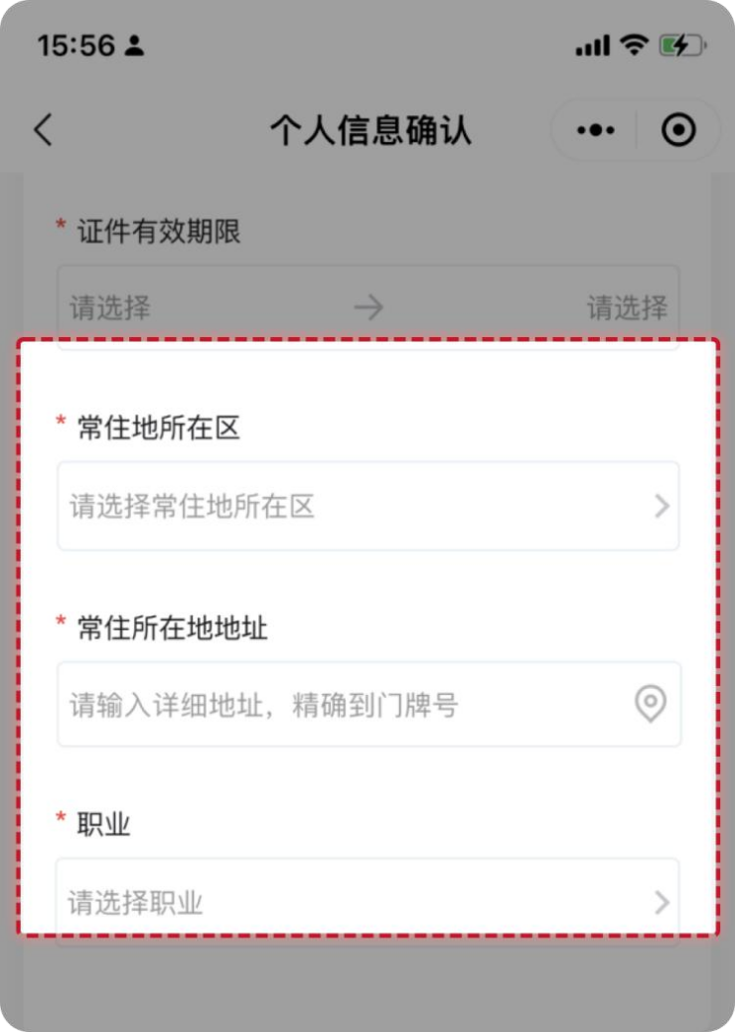
Step 6: Supplement the reserved information for the social security card such as the ethnicity, occupation, and the district of the permanent residence, etc.
第七步：补充实体卡的制卡照片（照片要求：上传本人近期彩色免冠照片，保证真实有效，照片保持清晰完整，五官无任何遮挡，避免反光）。
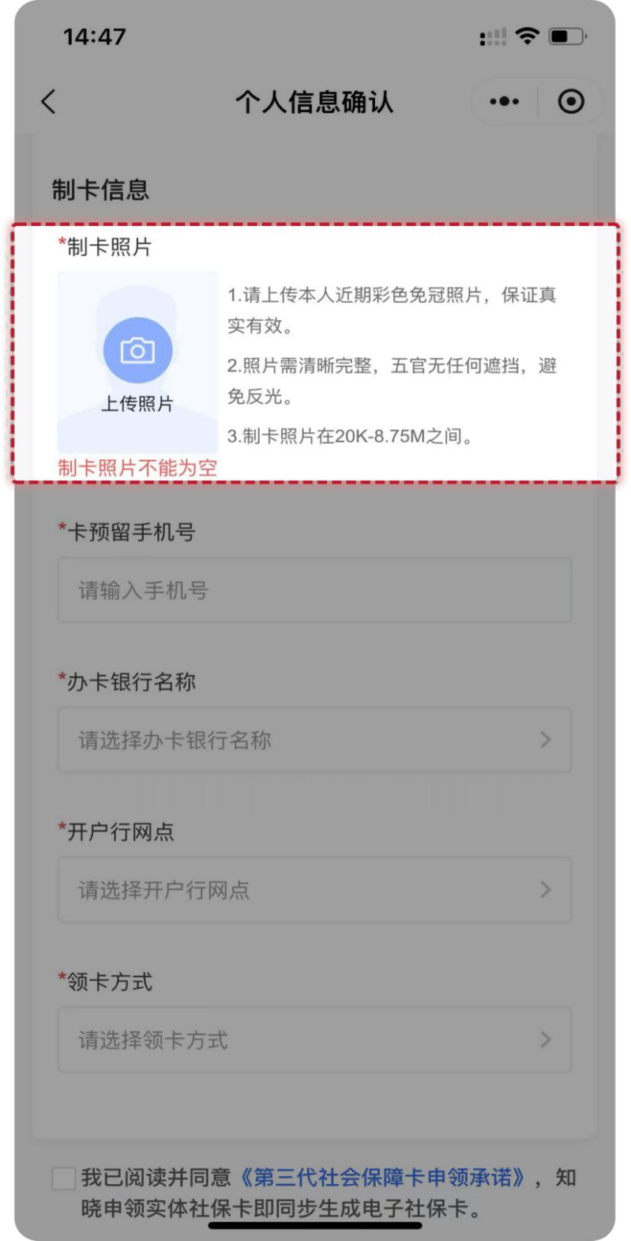
Step 7: Supplement the photo for physical card making (The photo should be a recent bareheaded color photo of yourself. Ensure that the photo is authentic and valid, keep the photo clear and complete with facial features unobstructed, and avoid glare).
第八步：补充卡预留手机号、办卡银行名称、开户行网点等金融开户关键要素。
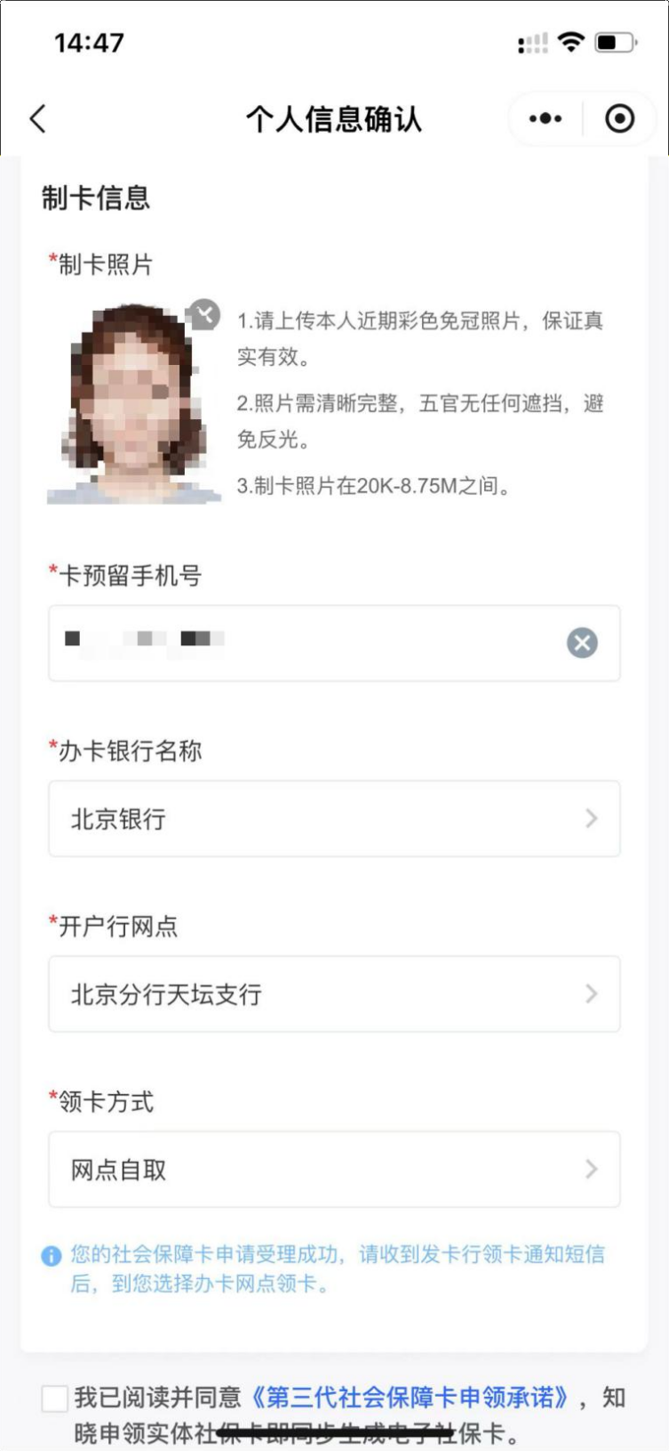
Step 8: Supplement the key information for financial account opening, such as the name of the card issuing bank, the card application branch, etc.
第九步：根据单位经办人在“单位开通集体申请”页面 “是否支持单位代领”的不同选择，选择不同的领卡方式（单位代领、网点自取或银行邮寄）。
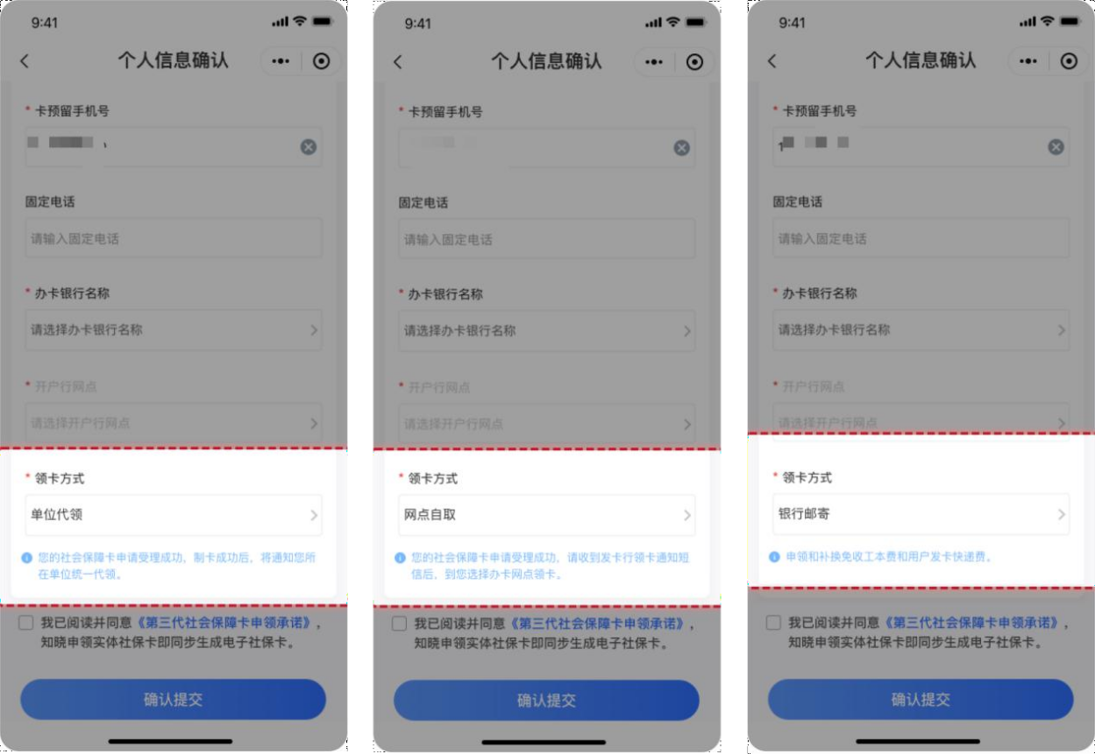
Step 9: Choose the corresponding card collection method (entity collection, self collection at a bank branch, or bank delivery) according to the designated person's selection for "Whether to support the entity to collect the cards on the employees' behalf" on the page of entity collective application.
若选择银行邮寄，需补充物流涉及相关信息，如邮寄接收人、接收人联系电话、邮寄地址所在区、邮寄接收地址。
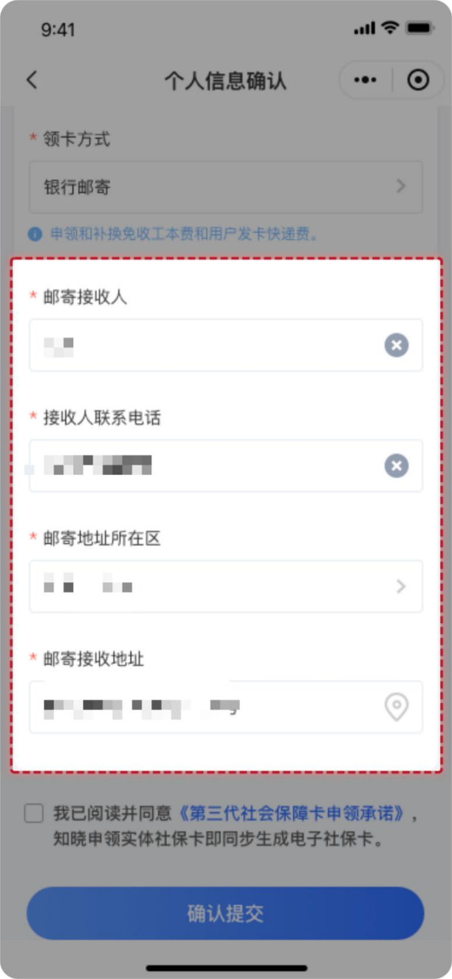
If applicants select "bank delivery", relevant logistics information such as the name and contact number of the recipient, the district, postal code of the delivery address, and the detailed address need to be complemented.
第十步：确认信息无误后勾选【我已阅读并同意】，并点击【确认提交】，完成个人信息确认。
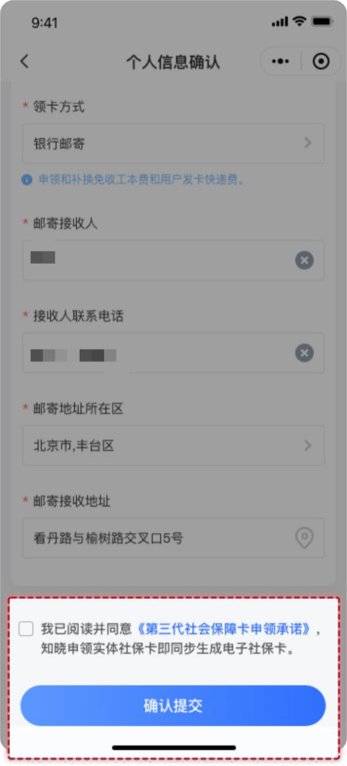
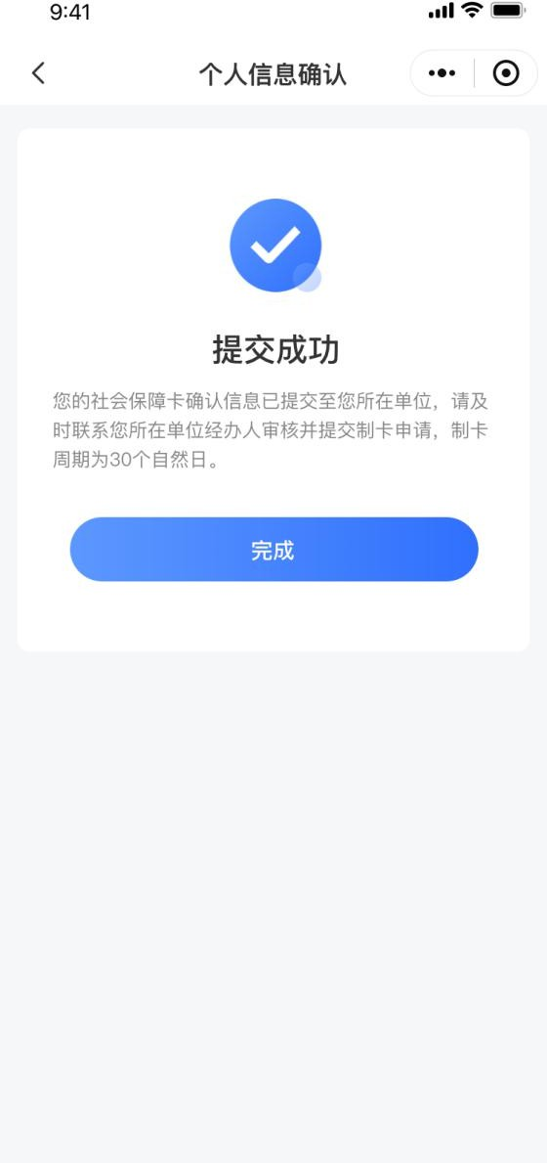
Step 10: After confirming the information, check "I have read the Promises and agree to it" (我已阅读并同意), and click the "Submit" (确认提交) button to complete the personal information confirmation.

三、单位经办人线上提交职工确认的申领信息
III. Entity's Designated Person Submits Employees' Confirmed Application Information Online
单位职工提交成功后，单位经办人按照之前的方式登录办理页面，点击【职工申请信息提交】进入职工申请信息提交页面，勾选信息已确认的员工提交申请社会保障卡。
After the employees of an insured entity successfully submit their information, the entity's designated person logs in to the processing page through the former-mentioned method. Click "Submit the Employees' Application Information" (职工申请信息提交) to enter the submission page of the employees' application information, and select the employees whose information has been confirmed to submit the social security card application for them.
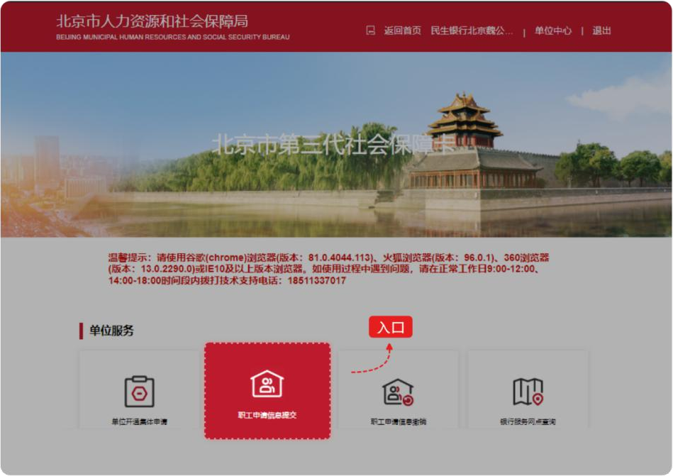

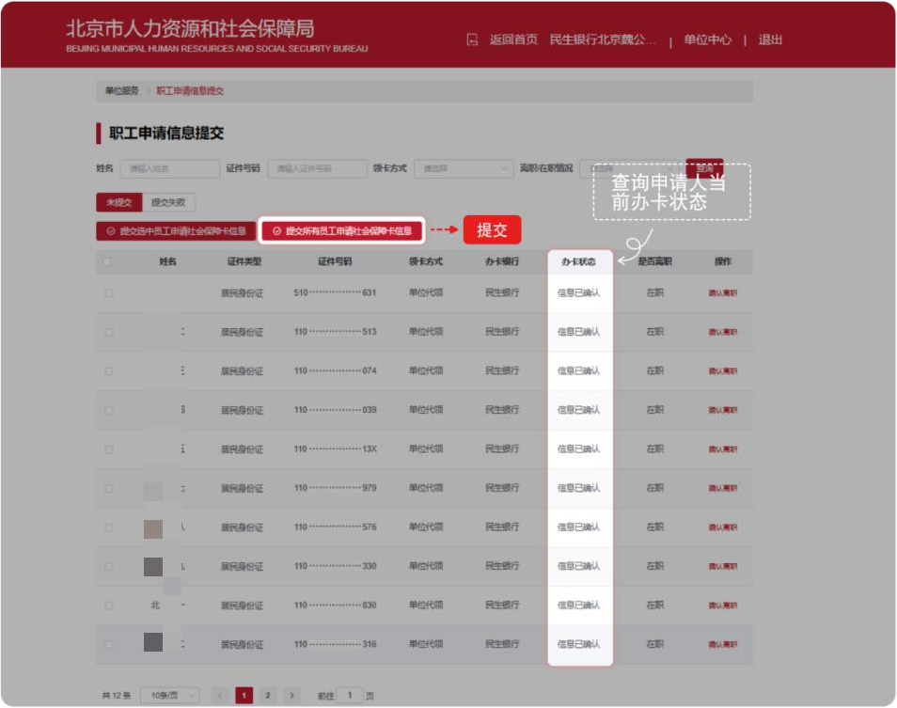

单位经办人登录网厅后，点击【社会保障卡服务】－【职工申请情况查询】，可以查询到申请人当前“办卡状态”为 “信息已确认”。
After logging in to the web portal, when the entity's designated person click "Social Security Card Services" - "Employee Application Status Query" (社会保障卡服务－职工申请情况查询), the applicants' current "Card Application Status" will be displayed as "Information Confirmed".
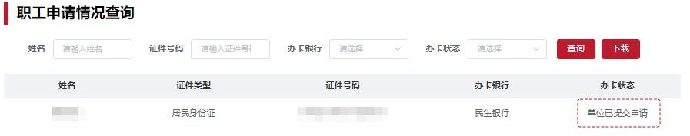

京通小程序 Jingtong Mini-Program
北京民生一卡通微信小程序 Beijing Minsheng Yikatong WeChat Mini-Program

